Matlab Assignment:

General Policy

• Though the students are allowed to discuss with each other, each student should work

individually and independently on Matlab implementation and report writing.

• A brief report is required, with free form. Contents to be included in the report:

results (e.g. figures) and brief discussions of results, and also the codes at the end.

• If a student has a very special situation requiring an unavoidable late submission,

she/he should inform the instructor before the due day as early as possible.

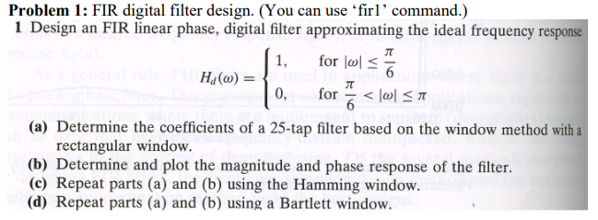

a)h(n)=

|  |  |  |  |
| --- | --- | --- | --- |
| n | h(n) | 12 | 0.521712310915330 |
| 0 | 0.0205324282502707 | 13 | 0.316291824121900 |
| 1 | -0.0197648351352712 | 14 | -0.0234276859280113 |
| 2 | -0.0214181617586661 | 15 | -0.103116894665481 |
| 3 | 0.0276824426998558 | 16 | 0.0231706213464450 |
| 4 | 0.0221592252488131 | 17 | 0.0591241459224475 |
| 5 | -0.0393433242650942 | 18 | -0.0227459412948728 |
| 6 | -0.0227459412948728 | 19 | -0.0393433242650942 |
| 7 | 0.0591241459224475 | 20 | 0.0221592252488131 |
| 8 | 0.0231706213464450 | 21 | 0.0276824426998558 |
| 9 | -0.103116894665481 | 22 | -0.0214181617586661 |
| 10 | -0.0234276859280113 | 23 | -0.0197648351352712 |
| 11 | 0.316291824121900 | 24 | 0.0205324282502707 |

b)



c)

|  |  |  |  |
| --- | --- | --- | --- |
| n | h(n) | 12 | -0.0220510047293028 |
| 0 | 0.00164760990838365 | 13 | 0.312284884706658 |
| 1 | -0.00189675730868747 | 14 | 0.523305355260709 |
| 2 | -0.00304268066231678 | 15 | 0.312284884706658 |
| 3 | 0.00596242609641815 | 16 | -0.0220510047293028 |
| 4 | 0.00689033536211566 | 17 | -0.0894963089899393 |
| 5 | -0.0166118761748928 | 18 | 0.0178958569423255 |
| 6 | -0.0123203137555855 | 19 | 0.0390851509744693 |
| 7 | 0.0390851509744693 | 20 | -0.0123203137555855 |
| 8 | 0.0178958569423255 | 21 | -0.0166118761748928 |
| 9 | -0.0894963089899393 | 22 | 0.00689033536211566 |
| 10 | 0.00164760990838365 | 23 | 0.00596242609641815 |
| 11 | -0.00189675730868747 | 24 | -0.00304268066231678 |



d)

|  |  |  |  |
| --- | --- | --- | --- |
| n | h(n) | 12 | -0.0201189969220820 |
| 0 | 0 | 13 | 0.298784168487494 |
| 1 | -0.00169734500656137 | 14 | 0.537637139738222 |
| 2 | -0.00367865551743664 | 15 | 0.298784168487494 |
| 3 | 0.00713185648619527 | 16 | -0.0201189969220820 |
| 4 | 0.00761187231118796 | 17 | -0.0796983382604626 |
| 5 | -0.0168934358738242 | 18 | 0.0159185900300799 |
| 6 | -0.0117201209963527 | 19 | 0.0355418353926514 |
| 7 | 0.0355418353926514 | 20 | -0.0117201209963527 |
| 8 | 0.0159185900300799 | 21 | -0.0168934358738242 |
| 9 | -0.0796983382604626 | 22 | 0.00761187231118796 |
| 10 | 0 | 23 | 0.00713185648619527 |
| 11 | -0.00169734500656137 | 24 | -0.00367865551743664 |



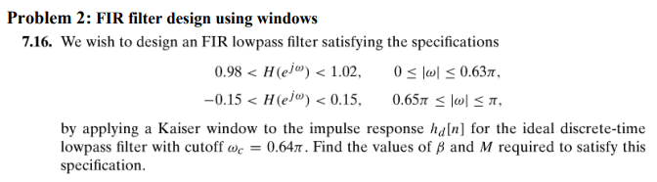



M = 182

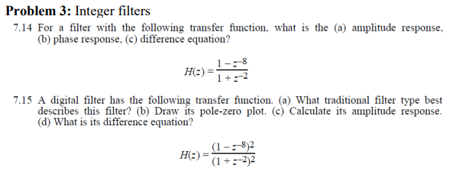

7.14 a)b)





c) y(n) = x(n) - x(n-8) – y(n-2)

7.15 a) bandpass filter

b)



c)





d) y(n) = x(n) - 2x(n-8)+ x(n-16)- y(n-2) – y(n-4)

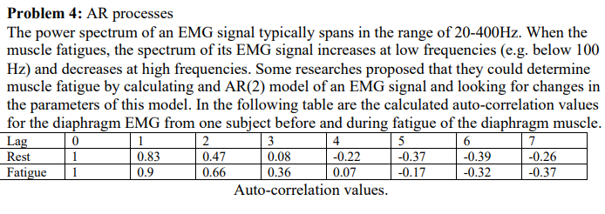

(a) Calculate the AR(4) or AR(3) models of both conditions, then compute the power spectrums correspondingly. Comment on your results.

Rest AR(3) model: ${ σ}^{2}= 0.157072811361683$

|  |  |
| --- | --- |
| a(1) | -1.41145172512585 |
| a(2) | 0.698481561822126 |
| a(3) | 0.00364261449678638 |



$${\hat{S}}_{xx}\left(ω\right)=\frac{0.157}{{\left|1-1.41e^{-jωk}+0.698e^{-2jωk}+0.0036e^{-3jωk}\right|}^{2}}$$

Fatigue AR(3) model: ${ σ}^{2}= 0.070776470588235$

|  |  |
| --- | --- |
| a(1) | -1.69411764705883 |
| a(2) | 0.960000000000004 |
| a(3) | -0.105882352941180 |



$${\hat{S}}_{xx}\left(ω\right)=\frac{0.0708}{{\left|1-1.69e^{-jωk}+0.960e^{-2jωk}-0.105e^{-3jωk}\right|}^{2}}$$

Rest AR(4) model: ${ σ}^{2}=0.157056381847745$

|  |  |
| --- | --- |
| a(1) | -1.41141447094138 |
| a(2) | 0.705625156341200 |
| a(3) | -0.0107927541065640 |
| a(4) | 0.0102273201033936 |



$${\hat{S}}_{xx}\left(ω\right)=\frac{0.157}{{\left|1-1.411+0.706e^{-2jωk}-0.010e^{-3jωk}+0.010e^{-4jωk}\right|}^{2}}$$

Fatigue AR(4) model: ${ σ}^{2}= 0.070741356382985$

|  |  |
| --- | --- |
| a(1) | -1.69647606382979 |
| a(2) | 0.981382978723411 |
| a(3) | -0.143617021276594 |
| a(4) | 0.0222739361702135 |



$${\hat{S}}_{xx}\left(ω\right)=\frac{0.0708}{{\left|1-1.696e^{-jωk}+0.981e^{-2jωk}-0.147e^{-3jωk}+0.022e^{-4jωk}\right|}^{2}}$$

From these results we see that the magnitude of the power spectrum at rest is higher at Rest than it is when fatigued and between the AR3 and AR4 models the 4th coefficient is very small in both cases and the first 3 coefficients are very similar causing the power spectrum to be very similar

(b) Calculate the AR(2) parameters for both condition. Do the changes in AR(2) parameters qualitatively reflect the expected changes in the power spectrum?

Rest AR(2) model: ${ σ}^{2}= 0.157074895531983$

|  |  |
| --- | --- |
| a(1) | -1.41401478624237 |
| a(2) | 0.703632272581164 |



$${\hat{S}}_{xx}\left(ω\right)=\frac{0.0708}{{\left|1-1.414e^{-jωk}+0.704e^{-2jωk}\right|}^{2}}$$

Fatigue AR(2) model: ${ σ}^{2}= 0.070741356382985$

|  |  |
| --- | --- |
| a(1) | -1.61052631578947 |
| a(2) | 0.789473684210527 |



$${\hat{S}}_{xx}\left(ω\right)=\frac{0.0708}{{\left|1-1.611e^{-jωk}+0.789e^{-2jωk}\right|}^{2}}$$

In the AR(2) models the changes to the 2nd coefficient is more dramatic. I don’t see any dramatic changes in the power spectrum so I will say that the observed changes weren’t dramatic enough to qualitatively affect the power spectrum.

Matlab Code:

Assignment3_q1.m

clear; close all;

% Assignment 3 q1

% Andrew Munro-West 18363572

%

% Problem 1: Design an FIR linear phase, digital filter aproximating the

% ideal frequency response H_d(w) = 1 for |w| <= pi/6 and 0 elsewhere

wm= 1/6;

b = fir1(24,wm,'low',rectwin(25));

% (a) Determine the coefficients of a 25-tap filter based on the window

% method with a rectangular window

h_a = impz(b);

% (b) Determine and plot the magnitude and phase response of the filter

freqz(b,1)

% (c) repeat parts (a) and (b) using the Hamming window

figure

b = fir1(24,wm,'low',hamming(25));

h_c = impz(b);

freqz(b,1)

% (d) repeat parts (a) and (b) using the Bartlett window

figure

b = fir1(24,wm,'low',bartlett(25));

h_d = impz(b);

freqz(b,1)

Assignment3_q2.m

clear; close all;

% Assignment 3 q2

% Andrew Munro-West 18363572

%

% Problem 2: Design an FIR low pass filter with specifications

% L=30;

% wm= 0.63;

% b = fir1(30,wm,'low');

% freqz(b,1)

fcuts = [0.63 0.65];

mags = [1 0];

devs = [0.02 0.15];

[n,Wn,beta,ftype] = kaiserord(fcuts,mags,devs);

hh = fir1(n,Wn,ftype,kaiser(n+1,beta),'noscale');

[H,f] = freqz(hh,1,1024);

plot(f/pi,abs(H))

xlabel('Normalized Frequency (x \pi rad/sample))')

ylabel('Magnitude')

grid

Assignment3_q3.m

clear; close all;

% Assignment 3 q3

% Andrew Munro-West 18363572

%

% Problem 3: Integer filters

%

% ts = -1;

% z = tf('z',ts);

% sys = (1-(z^-8))/(1+(z^-2))

% part 1

b = [1 0 0 0 0 0 0 0 -1];

a = [1 0 1];

[h,f] = freqz(b,a)

freqz(b,a)

figure

plot(f/pi,abs(h))

ylabel('magnitude')

xlabel('Normalized Frequency (\times \pi rad/sample))')

% part 2

b1 = [1 0 0 0 0 0 0 0 -2 0 0 0 0 0 0 0 1];

a1 = [1 0 2 0 1];

figure

zplane(b1,a1)

title('Pole-Zero Plot')

figure

[h,f] = freqz(b1,a1)

freqz(b1,a1)

figure

plot(f/pi,abs(h))

ylabel('magnitude')

xlabel('Normalized Frequency (\times \pi rad/sample))')

Assignment3_q4.m

clear; close all;

% Assignment 3 q3

% Andrew Munro-West 18363572

%

% Problem 3: Integer filters

%

Rest = [1 0.83 0.47 0.08 -0.22 -0.37 -0.39 -0.26];

Fatigue = [1 0.9 0.66 0.36 0.07 -0.17 -0.32 -0.37];

Rest = toeplitz(Rest);

Fatigue = toeplitz(Fatigue);

%AR(3) models

%solve for coefficients

a_Rest3 = inv(Rest(2:4,2:4))*-Rest(2:4,1)

omega_Rest3 = Rest(1,1:4)*[1;a_Rest3]

[H,F] = freqz(omega_Rest3,[1;a_Rest3]); % frequency domain magnitude response

plot(F/pi,20*log10((abs(H).^2))) % plot w=0 to 2=pi of omega^2*|H(w)|^2

xlabel('Normalized Frequency (\times \pi rad/sample)) ')

ylabel('Magnitude(dB)')

figure

a_Fatigue3 = inv(Fatigue(2:4,2:4))*-Fatigue(2:4,1)

omega_Fatigue3 = Fatigue(1,1:4)*[1;a_Fatigue3]

[H,F] = freqz(omega_Fatigue3,[1;a_Fatigue3]); % frequency domain magnitude response

plot(F/pi,20*log10((abs(H).^2))) % plot w=0 to 2=pi of omega^2*|H(w)|^2

xlabel('Normalized Frequency (\times \pi rad/sample)) ')

ylabel('Magnitude(dB)')

%

% %AR(4) models

figure

a_Rest4 = inv(Rest(2:5,2:5))*-Rest(2:5,1)

omega_Rest4 = Rest(1,1:5)*[1;a_Rest4]

[H,F] = freqz(omega_Rest4,[1;a_Rest4]); % frequency domain magnitude response

plot(F/pi,20*log10((abs(H).^2))) % plot w=0 to 2=pi of omega^2*|H(w)|^2

xlabel('Normalized Frequency (\times \pi rad/sample)) ')

ylabel('Magnitude(dB)')

figure

a_Fatigue4 = inv(Fatigue(2:5,2:5))*-Fatigue(2:5,1)

omega_Fatigue4 = Fatigue(1,1:5)*[1;a_Fatigue4]

[H,F] = freqz(omega_Fatigue4,[1;a_Fatigue4]); % frequency domain magnitude response

plot(F/pi,20*log10((abs(H).^2))) % plot w=0 to 2=pi of omega^2*|H(w)|^2

xlabel('Normalized Frequency (\times \pi rad/sample)) ')

ylabel('Magnitude(dB)')

%b) calculate the AR(2) parameters do the changes qualitatively reflect the

%expected changes in the power spectrum?

%AR(3) models

%solve for coefficients

figure

a_Rest2 = inv(Rest(2:3,2:3))*-Rest(2:3,1)

omega_Rest2 = Rest(1,1:3)*[1;a_Rest2]

[H,F] = freqz(omega_Rest2,[1;a_Rest2]); % frequency domain magnitude response

plot(F/pi,20*log10((abs(H).^2))) % plot w=0 to 2=pi of omega^2*|H(w)|^2

xlabel('Normalized Frequency (\times \pi rad/sample)) ')

ylabel('Magnitude(dB)')%AR(2) models

%solve for coefficients

figure

a_Fatigue2 = inv(Fatigue(2:3,2:3))*-Fatigue(2:3,1)

omega_Fatigue2 = Fatigue(1,1:3)*[1;a_Fatigue2]

[H,F] = freqz(omega_Fatigue2,[1;a_Fatigue2]); % frequency domain magnitude response

plot(F/pi,20*log10((abs(H).^2))) % plot w=0 to 2=pi of omega^2*|H(w)|^2

xlabel('Normalized Frequency (\times \pi rad/sample)) ')

ylabel('Magnitude(dB)')