**Homework 3**

Ashmitha Murali

Prof. Alex Yang

Digital Design and HDL EE461

18th October 2025

**Q1.**

**Result:**

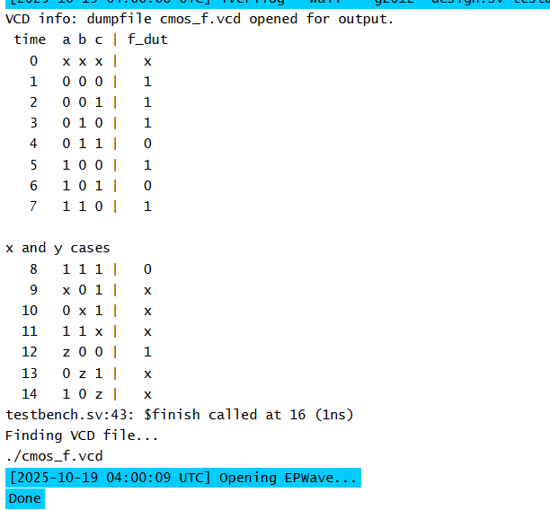

**Waveform:**

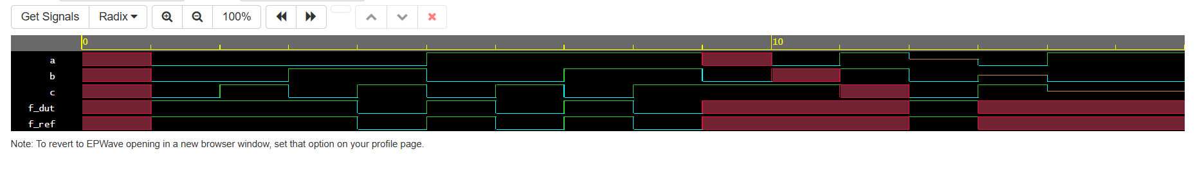

**Design Code:**

module cmos_f_not_or_and (

input wire a,

input wire b,

input wire c,

output wire f

);

supply1 VDD;

supply0 GND;

//pull up

wire p_mid;

pmos p_c (f, VDD, c);

pmos p_a (p_mid, VDD, a);

pmos p_b (f, p_mid, b);

//pull down

wire n_bot;

nmos n_a (n_bot, GND, a);

nmos n_b (n_bot, GND, b);

nmos n_c (f, n_bot, c);

endmodule

**Testbench Code:**

module tb_f;

reg a, b, c;

wire f_dut;

// DUT

cmos_f_not_or_and dut(.a(a), .b(b), .c(c), .f(f_dut));

initial begin

// Waveform dump

$dumpfile("cmos_f.vcd");

$dumpvars(0, tb_f);

$monitor("%4t %b %b %b | %b",$time,a,b,c,f_dut);

$display(" time a b c | f_dut");

#1 a = 0; b = 0; c = 0;

#1 a = 0; b = 0; c = 1;

#1 a = 0; b = 1; c = 0;

#1 a = 0; b = 1; c = 1;

#1 a = 1; b = 0; c = 0;

#1 a = 1; b = 0; c = 1;

#1 a = 1; b = 1; c = 0;

#1 a = 1; b = 1; c = 1;

$display("\nx and y cases");

// Some x/z stimulus to observe 4-state behavior

#1 a = 1'bx; b = 0; c = 1;

#1 a = 0; b = 1'bx; c = 1;

#1 a = 1; b = 1; c = 1'bx;

#1 a = 1'bz; b = 0; c = 0;

#1 a = 0; b = 1'bz; c = 1;

#1 a = 1; b = 0; c = 1'bz;

#2 $finish;

end

endmodule

**Q2.**

**Waveform:**

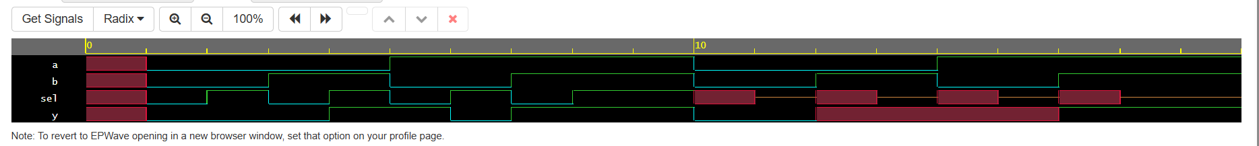

**Result:**

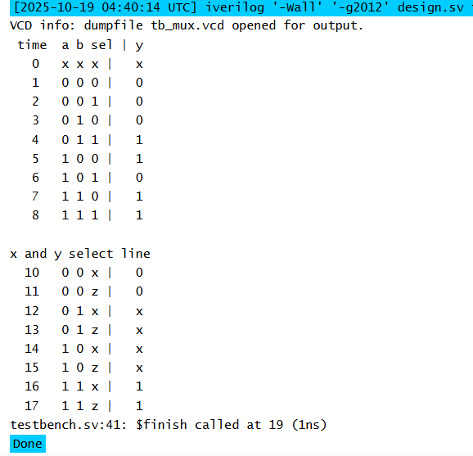

**Design Code:**

primitive udp_mux2 (y, a, b, sel);

output y;

input a, b, sel;

table

// a b sel : y

0 ? 0 : 0;

1 ? 0 : 1;

? 0 1 : 0;

? 1 1 : 1;

0 0 x : 0;

1 1 x : 1;

0 1 x : x;

1 0 x : x;

endtable

endprimitive

module mux2_udp (

input wire a,

input wire b,

input wire sel,

output wire y

);

udp_mux2 U (y, a, b, sel);

endmodule

**Testbench Code:**

module tb_mux;

reg a, b, sel;

wire y;

// DUT

mux2_udp dut(.y(y), .a(a), .b(b), .sel(sel));

initial begin

$dumpfile("tb_mux.vcd");

$dumpvars(0, tb_mux);

$monitor("%4t %b %b %b | %b",$time,a,b,sel,y);

$display(" time a b sel | y");

#1 a = 0; b = 0; sel = 0;

#1 a = 0; b = 0; sel = 1;

#1 a = 0; b = 1; sel = 0;

#1 a = 0; b = 1; sel = 1;

#1 a = 1; b = 0; sel = 0;

#1 a = 1; b = 0; sel = 1;

#1 a = 1; b = 1; sel = 0;

#1 a = 1; b = 1; sel = 1;

#1 $display("\nx and y select line");

#1 a = 0; b = 0; sel = 1'bx;

#1 a = 0; b = 0; sel = 1'bz;

#1 a = 0; b = 1; sel = 1'bx;

#1 a = 0; b = 1; sel = 1'bz;

#1 a = 1; b = 0; sel = 1'bx;

#1 a = 1; b = 0; sel = 1'bz;

#1 a = 1; b = 1; sel = 1'bx;

#1 a = 1; b = 1; sel = 1'bz;

#2 $finish;

end

endmodule

**Q3.**

The longest path is from or_gate-> mux->or_gate->mux which results in longest path of (5+8+5+8 = 26). Hence, the delay time of the longest path is **26ns.**

If we consider that D is either 0 or 1, then the output would go only through one or gate and one not gate. The output would never go through 2 ‘or’ gates and thus the worst case path would be or_gate-> mux->not_gate->mux or not_gate-> mux->or_gate->mux (5+8+3+8 =24). Hence the time delay when D is 0 or 1 is **24ns.**

**Result:  
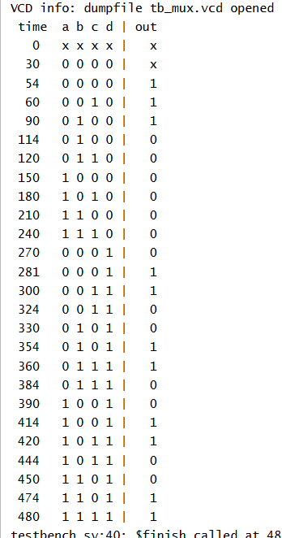**

**Design Code:**

`timescale 1ns/1ns

primitive udp_mux2 (y, a, b, sel);

output y;

input a, b, sel;

table

// a b sel : y

0 ? 0 : 0;

1 ? 0 : 1;

? 0 1 : 0;

? 1 1 : 1;

0 0 x : 0;

1 1 x : 1;

0 1 x : x;

1 0 x : x;

endtable

endprimitive

module top_two_mux_net (

input wire A, B, C, D,

output wire OUT

);

wire ab_or, m1_out, rhs_inv, rhs_or, d_inv, c_inv;

or #(5) g_or (ab_or, A, B);

not #(3) g_c (c_inv, C);

udp_mux2 #(8) M1 (m1_out, ab_or, c_inv, D);

// Right-hand gates

or #(5) g_or2 (rhs_or, m1_out, m1_out);

not #(3) g_inv (rhs_inv, m1_out);

not #(3) d_invt (d_inv, D);

udp_mux2 #(8) M2 (OUT, rhs_or, rhs_inv, d_inv);

endmodule

**Testbench code:**

`timescale 1ns/1ns

module tb_mux;

reg a, b, c, d;

wire out;

// DUT

top_two_mux_net dut(.OUT(out), .A(a), .B(b), .C(c), .D(d));

initial begin

// Waveform dump

$dumpfile("tb_mux.vcd");

$dumpvars(0, tb_mux);

$monitor("%4t %b %b %b %b | %b",$time,a,b,c,d,out);

$display(" time a b c d | out");

#30 a = 0; b = 0; c = 0; d=0;

#30 a = 0; b = 0; c = 1; d=0;

#30 a = 0; b = 1; c = 0; d=0;

#30 a = 0; b = 1; c = 1; d=0;

#30 a = 1; b = 0; c = 0; d=0;

#30 a = 1; b = 0; c = 1; d=0;

#30 a = 1; b = 1; c = 0; d=0;

#30 a = 1; b = 1; c = 1; d=0;

#30 a = 0; b = 0; c = 0; d=1;

#30 a = 0; b = 0; c = 1; d=1;

#30 a = 0; b = 1; c = 0; d=1;

#30 a = 0; b = 1; c = 1; d=1;

#30 a = 1; b = 0; c = 0; d=1;

#30 a = 1; b = 0; c = 1; d=1;

#30 a = 1; b = 1; c = 0; d=1;

#30 a = 1; b = 1; c = 1; d=1;

#2 $finish;

end

endmodule

**Q4. The primitive has the following issues:**

1. A primitive can’t have multibit outputs. Here, ‘a’ and ‘r’ are defined as 2 bits which is not allowed in UDP.
2. UDP cannot have inout ports. It should either be input or output. Here ‘c’ is defined as inout which is wrong.
3. We should not instantiate anything inside a UDP. We should not use the ‘basicPrimitive’ block inside UDP.
4. The table syntax is invalid. The table should have inputs: outputs. Here the table order is wrong.

**Corrected UDP:**primitive example(r, c, b, d, e, f, g, h, i, j, k, l, m, n, o, p, q);

output r; // single-bit only

input c, b, d, e, f, g, h, i, j, k, l, m, n, o, p, q;

// Combinational table: inputs (in the *declared* order) : output ;

table

// c b d e f g h i j k l m n o p q : r

0 ? ? ? ? ? ? ? ? ? ? ? ? ? ? ? : 0;

1 ? ? ? ? ? ? ? ? ? ? ? ? ? ? ? : 1;

x ? ? ? ? ? ? ? ? ? ? ? ? ? ? ? : x;

z ? ? ? ? ? ? ? ? ? ? ? ? ? ? ? : x;

endtable

endprimitive

**Q5.**

**Design and primitive code:**primitive udp_dff_async_rstn (q, d, clk, rst_n);

output q;

input d, clk, rst_n;

reg q;

table

// d clk rst_n : q(t) : q(t+)

? ? 0 : ? : 0;

? (01) 1 : ? : d;

? ? x : ? : x;

? (0x) 1 : ? : -;

? (1x) 1 : ? : -;

? ? 1 : ? : -;

endtable

endprimitive

module counter3_udp (

input wire clk,

input wire rst,

output wire [2:0] q

);

wire rst_n;

wire [2:0] q_bar;

not not_rst (rst_n, rst);

assign qbar = ~q;

//gates

wire xor1_out, xor2_out, nand_out;

xor xor1_g(xor1_out, q_bar[2], nand_out);

xor xor2_g(xor2_out, q[0], q[1]);

nand nand_g(nand_out, q[0], q[1]);

//DFF

udp_dff_async_rstn ff0(q[0], qbar[0], qbar[0], clk, rst_n);

udp_dff_async_rstn ff1(q[1], qbar[1], xor2_out, clk, rst_n);

udp_dff_async_rstn ff2(q[2], qbar[2], xor1_out, clk, rst_n);

endmodule

**Testbench Code:**

module tb_counter3_udp;

reg clk, rst;

wire [2:0] q;

counter3_udp dut(.clk(clk), .rst(rst), .q(q));

initial begin

clk = 0;

forever #5 clk = ~clk;

end

initial begin

$display(" time rst | q2 q1 q0");

$monitor("%6t %b | %b %b %b", $time, rst, q[2], q[1], q[0]);

rst = 1'b1; #12;

rst = 1'b0;

repeat (20) @(posedge clk);

rst = 1'b1; #7;

rst = 1'b0;

repeat (10) @(posedge clk);

$finish;

end

endmodule