Jazayeri (Removal Directions) Iran * [2001] UKIAT 00014
Appeal No: HX/59198/00
*(01 TH 0110)*
STARRED
IMMIGRATION APPEAL TRIBUNAL

Dates of hearing: 26 March 2001

Date determination notified: 16/5/2001

Before:
Mr C. M. G. Ockelton (Deputy President)
Mr J. Barnes
Mr D. K. Allen

Between
SHOHREH JAZAYERI
Appellant

and

The Secretary of State for the Home Department
Respondent

DETERMINATION AND REASONS

INTRODUCTION

- The Appellant, a citizen of Iran, appealed on asylum grounds to an Adjudicator (Mrs J. E. Nichols) against the decision of the Respondent on 5 August 2000 directing her removal as an illegal entrant. The Adjudicator dismissed her appeal. The Appellant applied for, and was granted, leave to appeal to the Tribunal. She then sought to amend her grounds to include a claim that the notice of the Respondent’s decision was invalid and that there was accordingly no decision against which she could appeal. That question comes before us as a preliminary issue. The Appellant is represented by Mr D. Jones of counsel, instructed by Irving & Co and much assisted at the hearing by Mr A. Caskie, a member of that firm. The Respondent is represented by Mr W. Nicholls of counsel, instructed by the Treasury Solicitor.
- The form and terms of the notice of decision are clearly of some importance. We reproduce it here.
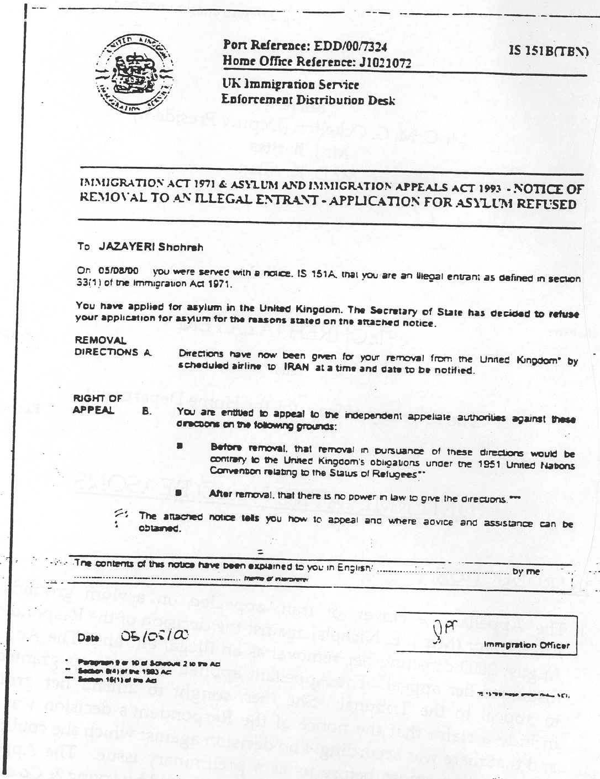

- There is evidence before us further to that which was before the Adjudicator. It consists of two notes of telephone conversations between Mr Caskie and members of the Respondent’s staff. Both conversations were initiated by Mr Caskie on 26 February 2001. The first was to the Enforcement Directorate at Croydon and the note reads as follows:
Phoned E[nforcement] D[istribution] D[esk] @ Croydon to ask which airline Removal Directions served on. They say need to contact Status Park + to simply quote their ref [the appropriate telephone number follows].
- The second call was to Status Park, which is another of the Immigration and Nationality Department’s offices. The note is:
Phoned Status Park who say that no removal directions have been given to any airline company. They will only do this after appeal process ended. Richard Murray, I[mmigration] O[fficer], advised of this.
- On the basis of that evidence, and on the basis of the notice which we have reproduced above, the Appellant’s representatives now argue that the Appellant has in fact never been subject to any decision carrying a right of appeal and that the Appellate Authorities therefore have no jurisdiction to decide her case. We should perhaps add at this stage that we call her ‘the Appellant’ without prejudice to the success of those arguments: she is in any event appealing to the Tribunal against the Adjudicator’s determination.
THE LEGISLATION
- Before we give our views on the arguments advanced on the Appellant’s behalf, we must set out the relevant legislation. The law for the purposes of this appeal is that in force before 2 October 2000, but the primary and delegated legislation that came into force on that date contains no material differences. The starting point is section 8 of the Immigration and Asylum Appeals Act 1993. It is to be noted that that section does not give a right of appeal against the refusal of asylum. It gives a right of appeal against the consequent immigration decision. Section 8(4) is as follows:
Where directions are given as mentioned in section 16(1)(a) or (b) of the 1971 Act for a person’s removal from the United Kingdom, the person may appeal to a Special Adjudicator against the directions on the ground that his removal in pursuance of the directions would be contrary to the United Kingdom’s obligations under the Convention.
- Section 16(1) of the 1971 Act mentions two circumstances in which directions for removal may be given. Only one is relevant for present purposes: a person who is an illegal entrant may be the subject of removal directions. There is in the present appeal no doubt that the Appellant is an illegal entrant and, anyway, nobody subject to immigration control has an in-country right of appeal against being treated as an illegal entrant. The power to give directions for removal of an illegal entrant is contained in paragraphs 8, 9 and 10 of Schedule 2 to the 1971 Act:
8(1) Where a person arriving in the United Kingdom is refused leave to enter, an immigration officer may, subject to sub-paragraph (2) below-
  - give the captain of the ship or aircraft in which he arrives directions requiring the captain to remove him from the United Kingdom in that ship or aircraft; or
  - give the owners or agents of that ship or aircraft directions requiring them to remove him from the United Kingdom in any ship or aircraft specified or indicated in the directions, being a ship or aircraft of which they are the owners or agents; or
  - give those owners or agents directions requiring them to make arrangements for his removal from the United Kingdom in any ship or aircraft specified or indicated in the directions to a country or territory so specified, being either-
    - a country of which he is a national or citizen; or
    - a country or territory in which he has obtained a passport or other document of identity; or
    - a country or territory in which he embarked for the United Kingdom; or
    - a country or territory to which there is reason to believe that he will be admitted.
(2) No directions shall be given under this paragraph in respect of anyone after the expiration of two months beginning with the date on which he was refused leave to enter the United Kingdom [except that directions may be give under sub-paragraph (1) (b) or (c) after the end of that period if the immigration officer has within that period given written notice to the owners or agents in question of his intention to give directions to them in respect of that person].
9(1) Where an illegal entrant is not given leave to enter or remain in the United Kingdom, an immigration officer may give any such directions in respect of him as in a case within paragraph 8 above are authorised by paragraph 8(1)
…
10.(1) where it appears to the Secretary of State either-
(a) that directions might be given in respect of a person under paragraph 8 or 9 above, but that it is not practicable for them to be given or that, if given, they would be ineffective; or
(b) that directions might have been given in respect of a person under paragraph 8 above [but that the requirements of paragraph 8(2) have not been complied with];
then the Secretary of State may give to the owners or agents of any ship or aircraft any such directions in respect of that person as are authorised by paragraph 8(1)(c).
(2) Where the Secretary of State may give directions for a person’s removal in accordance with sub-paragraph (1) above, he may instead give directions for his removal in accordance with arrangements to be made by the Secretary of State to any country or territory to which he could be removed under sub-paragraph (1).
(3) The cost of complying with any directions given under this paragraph shall be defrayed by the Secretary of State.”
- There is one other section of the 1971 Act to which we need to make reference. Section 18(1) enables the Secretary of State to make regulations prescribing the form and contents of the notice of any decision that is subject to the statutory appellate system, or would be so subject but for the ground upon which the decision was made. The Regulations are the Immigration Appeals (Notices) Regulations 1984 (SI 1984/2040). They require the giving of a notice detailing the decision, the ground on which t was made, and any right of appeal. Although it was not referred to at the hearing, we had better set out the relevant part of Regulation 3. Paragraph 1 of that Regulation requires the giving of the notice to the person affected by the decision.
3(2) Any such notice as is referred to in paragraph (1) shall be given-
  - in the case of a decision or action taken by an immigration officer in the exercise of powers conferred on him as such, by the immigration officer;
  - [relates to entry clearance decisions]
  - where the officer required by sub-paragraph (a) or (b) of this paragraph to give the notice is for any reason unable to do so, by such an immigration officer or entry clearance officer as may be designated for the purpose by the Secretary of State;
  - in the case of a decision or action other than one mentioned in subparagraph (a) or (b) of this paragraph, by the Secretary of State.
- Section 18(2) of the Act is as follows
For the purpose of any proceedings under this Part of this Act a statement included in a notice in pursuance of regulations under this section shall be conclusive of the person by whom and of the ground on which any decision or action was taken.
- We need only add that one of the effects of paragraph 4 of Schedule 2 to the 1993 Act is that the present appeal is governed by section 18 of the 1971 Act in the same manner as if it were an appeal under that Act.
CONTEXT
- We shall consider the Appellant’s case on its own merits, but we nevertheless think it right to record three aspects of the context in which this preliminary issue is raised for our decision. First, it appears to be a new point. There have been notices of removal of illegal entrants since the coming into force of the 1971 Act and there have been in-country rights of appeal against such notices on asylum grounds since 1993. To our own knowledge notices in the form used in this case have been issued in many cases; the total number of such notices is probably many tens of thousands. Until recently it has not, so far as we are aware, been suggested that the notices are invalid.
- Secondly, it is by no means clear that those who raise these arguments have any faith in them. If they be well-founded, one would not expect appellants’ representatives to give notice of appeal against the decision invalidly made: one would expect them simply to advise their client that the notice of decision could be safely ignored. It is true that in this case the issue is said to have come to notice only after the Adjudicator hearing. But in other cases of which we are aware the representatives have expended resources in giving notice of appeal to an adjudicator, only to argue before the adjudicator that there was nothing to appeal against.
- Thirdly, it has to be said that the arguments now put to us are very unlikely indeed to be put by anybody who had, or whose representatives had, any confidence at all in the substantive merits of the appeal. A person who is genuinely a refugee and has been refused refugee status will wish to take every possible opportunity to reverse the refusal by succeeding in an appeal against the consequential immigration decision. It is only a person who is not actually a refugee who is likely to seek to delay an appeal on technical grounds and so remain in a state limbo rather than have the refusal confirmed.
- The arguments are, of course, none the worse for any of these factors. We record them for two reasons. The first is that this determination may be read by those outside this specialised jurisdiction. The second is that, if any of the legislation is capable of more than one interpretation, we should incline towards that which makes sense of the appeal process and gives a right of appeal to those who may need it.

THE POWER TO MAKE REMOVAL DIRECTIONS
- The statutory provisions for making removal directions against an illegal entrant have a coherent structure. First, the power is by paragraph 9(1) of Schedule 2 to the 1971 Act equated with the power to remove those refused leave to enter. The various powers to give directions then comprise a series in which each envisages directions less specific than the last. The first is directions for the person’s removal in the very vessel (ship or aircraft) in which he arrived (paragraph 8(1)(a)). The second is directions for the person’s removal in any specified vessel owned or operated by the same carrier as brought him (paragraph 8(1)(b)). The third is directions to those carriers to remove him in any specified or indicated vessel (even if they are not the owners or agents of it) to a specified country or territory (paragraph 8(1)(c)). The fourth is directions to any carrier to remove him in a specified or indicated vessel to a specified country or territory (paragraph 10(1)). The fifth is directions for removal ‘in accordance with arrangements to be made by the Secretary of State’ to any country or territory to which he could have been removed under the previous two powers paragraph 10(2).
- There are two differences between the first three powers and the last two. The powers under paragraph 9 by reference to paragraph 8 – the first three powers – are exercisable by an immigration officer, but the powers under paragraph 10 are exercisable by the Secretary of State. Further, the Secretary of State’s powers are exercisable only (for present purposes) if ‘it appears to the Secretary of State… that directions might be given [under one of the first three powers] but that it is not practicable for them to be given or that, if given, they would not be effective’ (paragraph 10(1)(a)).
WAS THERE A DECISION BY THE SECRETARY OF STATE?
- It is not suggested in the present case that directions have been given to any carrier, nor has any ship or aircraft been specified or indicated. If the directions are valid they must have been given under the fifth power, that is to say under paragraph 10(2). The first question that arises is accordingly whether the notice is good on its face. For under paragraph 10(2) the decision has to be made by the Secretary of State, whereas the notice is signed in a box also containing the words ‘Immigration Officer’. Mr Jones argues that a removal decision under paragraph 10(2) by an immigration officer is bad: and, he submits, it follows that if this decision was made by an immigration officer it is bad because it does not specify enough to be an exercise of power under paragraph 8 or 9. On the other hand, if the decision was actually by the Secretary of State, he says that there is no reason to think it was actually ever made, because the only evidence of it is a notice signed by somebody else.
- As we remarked at the hearing, this may not be the ideal case for taking these points. The signature on the notice is not legible. One interpretation of it is that it is that of an immigration officer avowedly signing on behalf of the Secretary of State (in which case it may read ‘SS pp’). Let us suppose, however, that the signature on the notice is that of an immigration officer. Can it be said that the decision was that of the Secretary of State?
- In our view that answer to that question is in the affirmative, even if the notice of decision constitutes the decision itself. The reason is as expressed by Lord Greene MR in Carltona Ltd v Commissioners of Works [1943] 2 All ER 560 CA:
In the administration of government in this country the functions which are given to ministers (and constitutionally properly given to ministers because they are constitutionally responsible) are functions so multifarious that no minister could ever personally attend to them. … The duties imposed upon ministers and the powers given to ministers are normally exercised under the authority of the ministers by responsible officials of the department. Public business could not be carried on if that were not the case. Constitutionally, the decision of such an official is, of course, the decision of the minister. The minister is responsible.
- In the specific context of immigration decisions to be taken by the Secretary of State the Carltona principle was applied by the House of Lords in Oladehinde v Immigration Appeal Tribunal [1991] Imm AR 111, which, for some reason we are not immediately able to appreciate, those acting for the Appellant did not cite to us. There Lord Griffiths, with whom all the other members of the House agreed, noted that immigration officers are required, by paragraph 1(3) of Schedule 2 to the 1971 Act, to act in compliance with instructions (not inconsistent with the immigration rules) given to them by the Secretary of State. He held that immigration officers are civil servants, not office-holders. It followed that there was no reason why an immigration officer could not be authorised to exercise on the Secretary of State’s behalf the powers given to him by the statute.
- In Oladehinde there was an express process of delegation which was explained to the court. That, however, does not appear to have been an essential feature of the decision. No such arrangements were published in Carltona, where the position was simply that the official had been ‘entrusted with the work’. We doubt whether it can be necessary for there to be express delegation. In any event, the Secretary of State is a party to this appeal, and accepts the decision as his. There is no basis to treat it as a decision not made by him.
- Mr Jones submitted that if that were the position, there would be no reason for the Act to make the distinction it does in paragraphs 8, 9 and 10 of Schedule 2 between decisions by immigration officers and decisions by the Secretary of State. That argument was also dealt with by Lord Griffiths. He pointed out that there are in the 1971 Act three express limitations on the Secretary of State’s power to devolve decision-making on an official, and expressed himself unwilling in that context to regard any other restrictions as implicit. In fact it is right to say that the distinction between decisions made by immigration officers, the Secretary of State, and indeed entry clearance officers pervades the Act. It appears to be related to the position of the person affected by the decision at the relevant time – at a port, or within the United Kingdom, or abroad. An immigration officer does not have a power ‘conferred on him as’ an immigration officer (to use the words of the Notices Regulations) to make a decision in relation to a person within the United Kingdom. But that does not mean that he cannot, as an official within the Secretary of State’s department exercise a power conferred on the Secretary of State.
- The foregoing discussion is based, as we said in paragraph 18, on the assumption that the notice incorporates the decision. Under the Carltona principle, the decision of the Secretary of State may be made by an immigration officer and so the decision would not be bad for want of authority.
- Mr Jones’ alternative (or perhaps additional) argument is that the notice does not incorporate the decision. He submits that the documents we reproduced in paragraph 2 is not itself the decision to remove, but merely purports to be the record of a decision, of the taking of which there is no other evidence. He prays in aid the notes of the telephone calls made by Mr Caskie. He says that the true position is that no actual decision to give removal directions can be shown to have been made.
- That is an argument without substance. In the first place, the fact that no arrangements have been made with a carrier is entirely irrelevant. If the decision is made under paragraph 10(2), it will not incorporate such arrangements. The argument appears to depend on a confusion between directions for removal and the arrangements for the process of removal. In paragraph 8 (as applied by paragraph 9) and in paragraph 10(1) there is no material difference between them, but the distinction has to be made where the direction is under paragraph 10(2). If the decision could not have been made under paragraph 10(2) the absence of arrangements might be fatal to it. But if it is a decision under paragraph 10(2), the absence of travel arrangements is precisely what one would expect.
- Secondly, there is no basis at all for disbelieving the statement in the notice. It says ‘Directions have now been given for your removal.’ Even if Mr Caskie’s interlocutor had professed ignorance of that decision there would have been no basis for thinking that it had not been made.
- Thirdly, we remind ourselves of the provision of section 18(2). The notice is conclusive of the person by whom and the ground on which the decision was taken. That provision would not make any sense except in the context that the notice is also conclusive that the decision has been taken: one could not sensibly have a position in which it was unarguable that the decision had been taken by X, but arguable whether X had taken the decision.
DOES THE NOTICE GIVE SUFFICIENT INFORMATION?
- Mr Jones also argues that the notice is defective in that it does not state the reason for which the decision was taken, as required by the Notices Regulations. There is no merit in that argument either. It is true that the notice does not state why the directions are in the form they are: that is, why they are subject to arrangements yet to be made, or, to put it another way, why they have been given under paragraph 10 rather than paragraph 9. That, however, is not required by the Notices Regulations. The notice states that the Appellant is an illegal entrant and that her asylum claim has been refused. No other reason is required.
- Mr Jones submits that even if the Notices Regulations do not require a reason why the directions are in a particular form, the Appellant is entitled under the general law to know the reason for an executive decision affecting her. To that we would reply that she does know the reason for the decision. The form of the decision – with arrangements yet to be made – is of itself incapable of affecting her, because if arrangements had been made they would have been suspended for the period while her appeal was pending (paragraph 9 of Schedule 2 to the 1993 Act; paragraph 28 of Schedule 2 to the 1971 Act).. For an actual or intending appellant the position is always that, if the appeal is unsuccessful, arrangements for removal will in due course be made. To require more in the notice would be to impose a burden on one party where there would be no advantage to the other. We see no justification for doing that.
- We are not at all persuaded by Mr Nicholls’ suggestion that in cases where there is an in-country right of appeal the removal directions should be in the form permitted by paragraph 10(2) simply because otherwise effort would be wasted in making and re-making the arrangements.
- Mr Nicholls also pointed out that the 1993 Act produced a great increase in in-country appeals against removal directions in respect of illegal entrants. It followed that it was now very likely that, following refusal of asylum, any arrangements actually made ‘would be ineffective’ for the reason mentioned in paragraph 29. That would not assist him if it were right that the Secretary of State is required to indicate his reasons for acting under paragraph 10. We are, however, not persuaded that there is any such obligation. Mr Nicholls’ explanation would no doubt assist in rebutting any claim that the Secretary of State’s decision to act under paragraph 10 was irrational: but that is not a matter for us. So far as we are concerned, the giving of directions in this form indicates of itself that it did appear to the Secretary of State that more precise directions would be impracticable or ineffective. His conclusion to that effect is not reviewable here or, perhaps, anywhere.
- In our judgement the notice contains all that it is required to contain. It is a valid notice of a decision that gives the Appellant a right of appeal.
- It follows that paragraph 10(2) read in its legislative context and in the light of the Carltona principle means that a decision may be routinely made in the vaguest form allowed by the statute. We are not troubled by that conclusion because it means that those affected by such decisions have the right of appeal. We refer to the principle we set out at the end of paragraph 14 of this determination.
CONCLUSIONS
- (1). Save in the few cases where the statute prohibits delegation, the Secretary of State’s power to make a decision can be exercised by an immigration officer.
(2) The notice of a decision to remove to a specified destination ‘at a time and date to be notified’, and without nominating any carrier, is capable of being a decision under paragraph 10 of Schedule 2 to the 1971 Act and is not rendered invalid by either
(a) the fact that no arrangements for removal have yet been made, or
(b) the absence of any explanation of why the Secretary of State considers that more particular directions would be impracticable or ineffective.
(3) The notice of a decision to remove in the form used in this case is conclusive that the decision has been taken.
- We have before us a decision in appropriate form, complying with the Notices regulations, and giving a right of appeal. The Appellant’s appeal will now proceed to hearing on the merits.

C.M.G. Ockelton
Deputy President

