

Upper Tribunal
(Immigration and Asylum Chamber) Appeal Number: AA/00433/2015

THE IMMIGRATION ACTS

Determined at Field House | Decision & Reasons Promulgated
On: 25 November 2015 | On 3 December 2015

Before

UPPER TRIBUNAL JUDGE O’CONNOR

Between

NADER CHEGENI
Appellant
and

SECRETARY OF STATE FOR THE HOME DEPARTMENT
Respondent

NOTICE OF DECISION
- The appellant brings an appeal to the Upper Tribunal against the decision of FTTJ Bannerman, dismissing his appeal against a decision refusing him leave to enter. Permission to appeal to the Upper Tribunal was granted on the 22 September 2015.
- The Secretary of State has now granted the appellant leave to remain (as a Refugee). The appellant’s section 82 appeal is to be treated as abandon pursuant to section 104(4A) of the Nationality, Immigration and Asylum Act 2002 from the point in time that the grant of leave was made.
- This, however, does not bring the proceedings before the Upper Tribunal to an end. The appellant has not withdrawn his appeal before the Upper Tribunal.
- Given the circumstances of this appeal it is prudent for the Tribunal to bring the proceedings to an end and I do so by dismissing the appellant’s appeal hereto. Such decision is no reflection on the merits of the appellant’s case, which I have not considered – it is made in order to dispose of the appeal which, for the reasons given above, has become unnecessary.

Signed
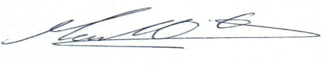

Upper Tribunal Judge O’Connor
Date: 25 November 2015

