
Upper Tribunal
(Immigration and Asylum Chamber) Appeal Number: AA/07840/2014
AA/07843/2014

THE IMMIGRATION ACTS

Heard at Bradford | Decision Promulgated
On 17 June 2015 | On 19 June 2015

Before

UPPER TRIBUNAL JUDGE CLIVE LANE

Between

ANTHONY RABEL LAWRENCE
JENOVAH ANTHONY LAWRENCE
Appellant
and

Secretary of State for the Home Department
Respondent

Representation:
For the Appellant: Ms Patel, instructed by Legal Justice, solicitors
For the Respondent: Mrs Pettersen, a Senior Home Office Presenting Officer

DECISION AND REASONS
- The appellants are citizens of Sri Lanka. They have appealed against decisions dated 18 September 2014 of the respondent to remove them from the United Kingdom having refused their claims for asylum.
- In a determination dated 8 January 2015 the First-tier Tribunal (Judge R Handley) dismissed their appeals. Unfortunately, the judge’s determination bears no relation whatever to the claim for asylum made by the appellants. The accounts of past events in Sri Lanka which the judge purports to analyse at [35-47] bears no resemblance to the accounts provided by the appellants to either the First-tier Tribunal or the respondent. It is not clear how this has occurred but it is clear that the determination must be set aside and the appeal heard again by the First-tier Tribunal (not Judge Handley). None of the findings of fact shall stand.
NOTICE OF DECISION
The determination of the First-tier Tribunal dated 8 January 2015 is set aside. The appeal is remitted to the First-tier Tribunal for that Tribunal (not Judge Handley) to remake the decision. None of the findings of fact shall stand.
Anonymity
The First-tier Tribunal did not make an order pursuant to rule 45(4)(i) of the Asylum and Immigration Tribunal (Procedure) Rules 2005.
We continue that order (pursuant to rule 14 of the Tribunal Procedure (Upper Tribunal) Rules 2008).

Signed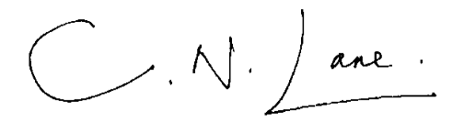

Upper Tribunal Judge CLIVE LANE
Judge of the Upper Tribunal

Date 17 June 2015

