
Upper Tribunal
(Immigration and Asylum Chamber) Appeal no: AA 09728-11

THE IMMIGRATION ACTS

At North Shields | signed: 15.07.2013
on 07.09.2012 & 05.07.2013 | Date sent out: 16.07.2013

Before:
Upper Tribunal Judge
John FREEMAN

Between:
Bahman Ali AHMADI
appellant
and

respondent
Representation:

For the appellant: Miss Susan Harrison, solicitor, hallidayreeves, Gateshead
For the respondent: Mr Clive Dewison

DETERMINATION & REASONS
1. This is an appeal, by the , against the decision of the First-tier Tribunal (Judge Laurence Sacks), sitting at North Shields on 21 September 2011, to what had been an asylum and human rights appeal by a citizen of Afghanistan, born 21 August 1989. Permission to appeal was asked for and given solely on the issue of the appellant’s son L, born in 2009 to a British citizen, SH, as to whom I make an order forbidding publication of any information that might lead to the child’s identification.
- At the date of the judge’s decision, L’s situation was this: he had only seen the appellant once, when he was a fortnight old. Since then his mother had taken to drink, and so on 11 April 2011 a district judge had made a final residence order for him to go and live with his maternal grandparents, with no direct contact with the appellant. If things had stopped there, there could have been no possible challenge to the judge’s decision on this front; but they did not.
- Some time after 11 April, and before 21 September last year (I have not been given the date), L’s grandparents decided they couldn’t cope with him, and returned him to the care of the local authority. This led to further public law proceedings about him, to which the appellant would automatically have been made a party, if he had been lawfully resident in this country. The judge was aware of this position (see his paragraph 19 (g)); but he did not accept, in view of the appellant’s past conduct and immigration history, that he would be likely to seek direct contact with L for his and the child’s sake, rather than to prevent his own removal to Afghanistan.
- At the time permission to appeal was given on 19 October 2011, the appellant had applied to be made a party to the proceedings about L, and a final hearing was expected in January 2012. It is not clear from the grant whether that was to be a final hearing of his application, or of the proceedings as a whole.
- RS (immigration and family court proceedings) India [2012] UKUT 218 (IAC) poses the following questions for judges in situations of this kind: see the judicial head-note
1. Where a claimant appeals against a decision to deport or remove and there are outstanding family proceedings relating to a child of the claimant, the judge of the Immigration and Asylum Chamber should first consider:
- Is the outcome of the contemplated family proceedings likely to be material to the immigration decision?
- Are there compelling public interest reasons to exclude the claimant from the United Kingdom irrespective of the outcome of the family proceedings or the best interest of the child?
- In the case of contact proceedings initiated by an appellant in an immigration appeal, is there any reason to believe that the family proceedings have been instituted to delay or frustrate removal and not to promote the child’s welfare?
- The action to be taken by judges is set out as follows:
2. In assessing the above questions, the judge will normally want to consider: the degree of the claimant’s previous interest in and contact with the child, the timing of contact proceedings and the commitment with which they have been progressed, when a decision is likely to be reached, what materials (if any) are already available or can be made available to identify pointers to where the child’s welfare lies?
3. Having considered these matters the judge will then have to decide:
- Does the claimant have at least an Article 8 right to remain until the conclusion of the family proceedings?
- If so, should the appeal be allowed to a limited extent and a discretionary leave be directed as per the decision on MS (Ivory Coast) [2007] EWCA Civ 133?
- Alternatively, is it more appropriate for a short period of an adjournment to be granted to enable the core decision to be made in the family proceedings?
- Is it likely that the family court would be assisted by a view on the present state of knowledge of whether the appellant would be allowed to remain in the event that the outcome of the family proceedings is the maintenance of family contact between him or her and a child resident here?
ERROR OF LAW
- The judge in this case cannot of course be blamed for failing to anticipate the decision in RS, and to construct his own in accordance with it; but the principles set out in it still have to guide my decision as to whether he was entitled or not in law to decide as he did. If he had given detailed consideration to the history of the appellant’s attempts to maintain indirect contact with L, or to be joined in the proceedings about him, and then given reasons for concluding that whatever apparent enthusiasm the appellant showed was no more than a sham, then that would most likely have been an end of this appeal, whatever was going on in the care proceedings.
- However, the judge gave no more than general consideration to this question, and, even if it is assumed, in favour of the validity of his decision, that he took the view that the answer provided ‘compelling public interest reasons’ for the appellant’s removal before the care proceedings were resolved, I do not consider that his consideration of the question provided a satisfactory basis for that.
- It follows that I need to re-make the decision which was before the judge, but on the basis of the present state of affairs about L, and in line with RS. Since the position at the date of the first hearing before me was that an interim hearing of the care proceedings had been listed for 10 September, with a full hearing on the 24th, there seemed no need for any limited period of discretionary leave to remain, as in MS (Ivory Coast) [2007] EWCA Civ 133. On the other hand, neither were there any ‘compelling public interest reasons’ for the appellant to be removed before the decision in those proceedings was available.
- In the circumstances, the right decision for me as of 7 September was to adjourn the hearing of this appeal, as happened in RS. What happened to it from there on depended of course on the decision reached in the care proceedings. I shall go on to explain what happened there: it seems that HH Judge Matthews QC heard them in full on 24 September 2012, and gave a reasoned judgment; but it seems to have taken a considerable time, for one reason or another, for the appellant’s solicitors not only to get a copy of her order and judgment, but permission to use them in these proceedings. Eventually the process was helped by direct e-mail contact between Judge Matthews, to whom I am grateful, and me.
CARE PROCEEDINGS
- The orders made by Judge Matthews about L were that there should be
        - a special guardianship order in favour of his maternal grandparents;
        - continued indirect contact for the appellant, by way of writing, or passing on presents through the grandparents once a quarter; and
        - no contact, direct or indirect, with him for his mother SH.
- Judge Matthews set out L’s general situation as follows:
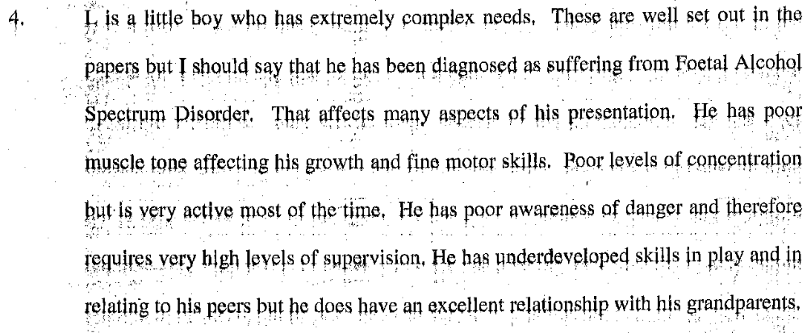
- Judge Matthews went on to set out the position for the future as follows:
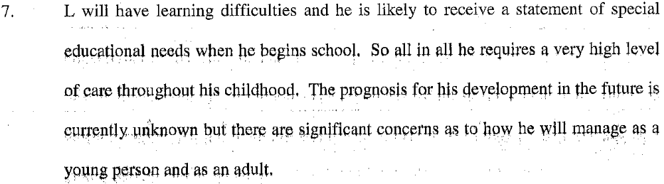
- Dealing with the appellant’s own position, Judge Matthews said this:
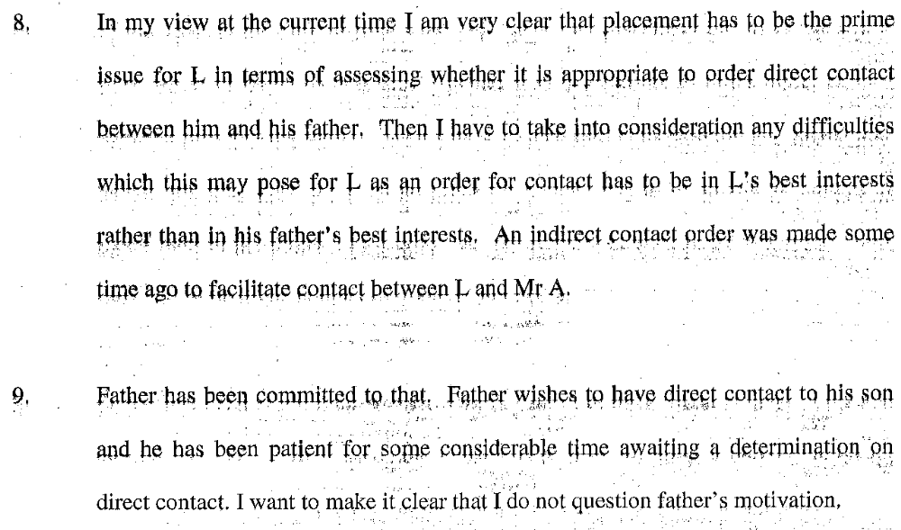
- However, the reasons why Judge Matthews was unwilling to order direct contact between the appellant and L were these:
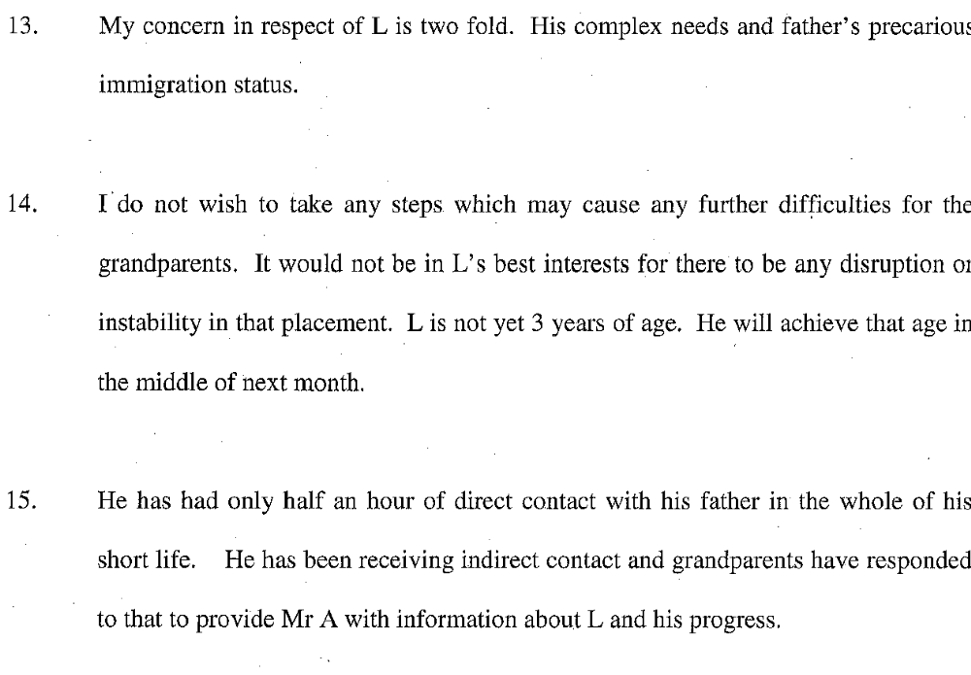
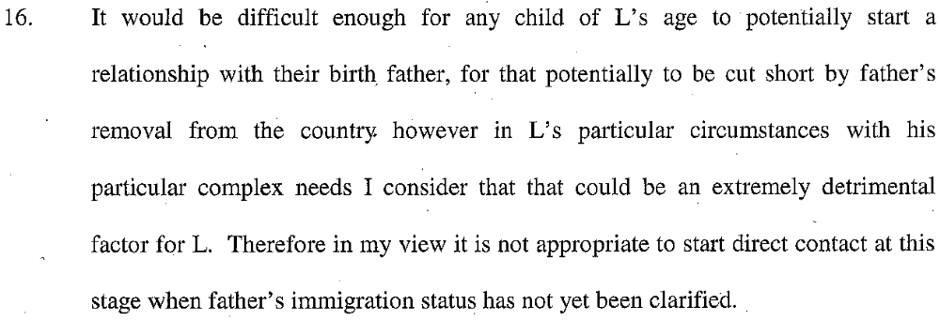
- Judge Matthews certainly recognized the difficulties in the appellant’s way, as shown in this passage:
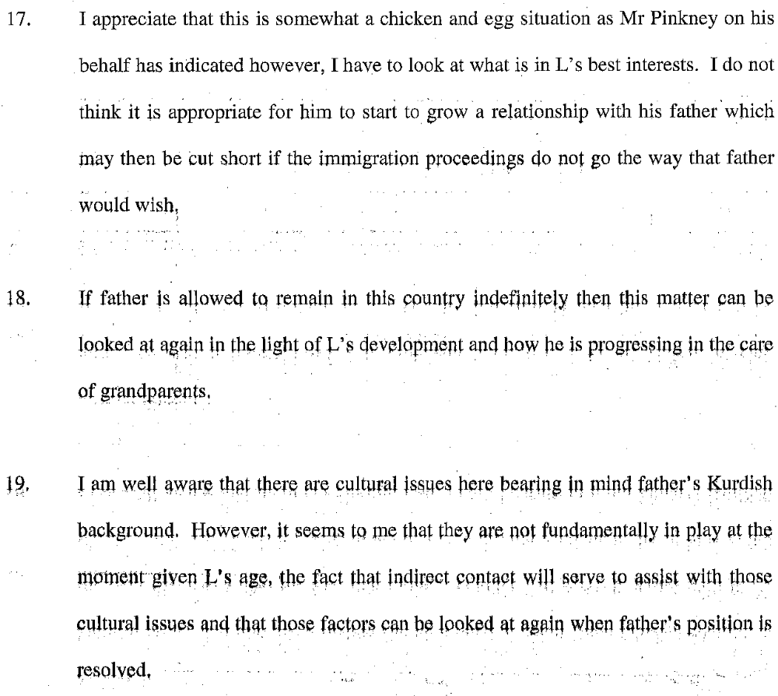
- Finally Judge Matthews said this:
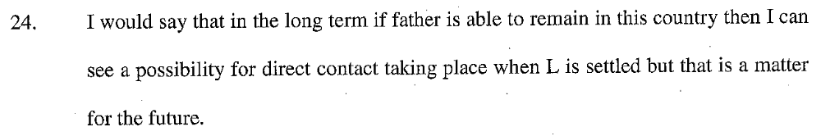
FINAL HEARING
- Since the previous hearing, the final decision in RS (immigration/family court liaison: outcome) India [2013] UKUT 82 had become available. In that case the family court had taken the view that the children’s best interests would be served by annual visits to their father in India. While recognizing that the result of every case about children must depend on the individual best interests of each child, I plan to follow the general approach taken at this stage of RS too.
- The appellant has also met a British citizen, Gemma Crooks, who was present in court and is expecting his child. The judge’s treatment of this is relationship, which had not got so far at the date of the first-tier hearing, was not challenged in the proceedings before me, and both sides agreed that I was not concerned with it; so I simply record it, without dealing with it.
- What I am concerned with is the appellant’s relationship with L. Judge Matthews accepted that he genuinely wished to pursue it: however they had only spent half an hour together in L’s first three years of life; L’s special needs made it imperative for him to be allowed to settle down with his grandparents, and the appellant’s precarious immigration status made it undesirable for him now to have direct contact with L, which might be cut short by his removal.
- Miss Harrison in her skeleton argument pointed to Judge Matthews’ recognition that this was a ‘chicken and egg’ situation for the appellant, and that the question of direct contact could be looked at again if he were allowed to stay in this country. She also pointed to L’s likely long-term need for care and attention, and to the fact that, so far as his family members are concerned, he now has direct contact only with his grandparents, who in the nature of things are likely to die many years before him.
- Miss Harrison recognized herself that the authorities, including RS (immigration/family court liaison: outcome) India [2013] UKUT 82, do not favour fathers who have indirect contact with children living here being allowed to stay in this country where otherwise the public interest would require their removal. She suggested that L’s special needs, and Judge Matthews’ not excluding direct contact for the future, might provide a reason for not following those authorities in the present case.
CONCLUSIONS
- If L’s best interests had required the appellant to be allowed direct contact with him now, then it would have been open to Judge Matthews to say so, and to make an order to that effect. He is a child with serious problems, who is likely to need all the help he can get in future; but at present his needs are best met by his grandparents, and above all by stability: he has seen the appellant for no more than half an hour in his life. In my view L’s best interests, so far as the appellant is concerned, lie in keeping in touch with him in some way which will allow his father to come back into his life in future if he needs more than the indirect contact he is now getting, and with which his grandparents have promised to help. I do not think they provide compelling reasons why the appellant should now be allowed to stay in this country.
- So far as the public interest is concerned, the appellant arrived in this country by way of Turkey and claimed asylum in 2004. He did not appear for an interview which had been arranged, but instead made his way in the back of a lorry to Germany, where he made another claim, but was eventually identified as an asylum-seeker from this country, and sent back here in 2007, when he claimed again. His appeal against refusal was finally dismissed on 20 September 2008. The Home Office however took no action against him before he made a fresh claim on 18 December 2009, with further representations following before the decision now under appeal was made on 10 August 2011. The appellant has wisely not relied in these proceedings on the history of events in Iran which was rejected in his first appeal.
- The appellant is a man of 33, who first came here in 2004, but has not been here continuously since then, having absconded to Germany soon after. Since 2007 he has been here as a refused asylum-seeker, staying on despite his lack of success on appeal the following year, and only remaining on the strength of a second application and appeal since the end of 2009. Despite Judge Matthews’ acceptance of his genuine wish to pursue direct contact with L, and her not excluding it for the future, I have no doubt on the issues before me that the balance comes down firmly on the side of his removal.
Appeal dismissed
 (a judge of the Upper Tribunal)

