

Upper Tribunal
(Immigration and Asylum Chamber) Appeal Number: DA/01126/2014

THE IMMIGRATION ACTS

Heard at Field House | Decision & Reasons Promulgated
On 29 June 2015 | On 1 September 2015

Before

UPPER TRIBUNAL JUDGE O’CONNOR
DEPUTY UPPER TRIBUNAL JUDGE MURRAY
DEPUTY UPPER TRIBUNAL JUDGE SYMES

Between

BINOD GURUNG
(ANONYMITY ORDER NOT MADE)
Appellant
and

THE SECRETARY OF STATE FOR THE HOME DEPARTMENT
Respondent

Representation:
For the Appellant: Mr C Howells (counsel instructed by N C Brother Solicitors)
For the Respondent: Mr S Kandola (Senior Home Office Presenting Officer)

DECISION AND REASONS
- This is the appeal of Binod Gurung, a citizen of Nepal born 11 February 1988, against the decision of 5 June 2014 to make a deportation order against him under the UK Borders Act 2007.
- The Appellant arrived in the United Kingdom when he was aged sixteen, being granted indefinite leave to enter on 13 November 2006, to join his father who had himself been granted indefinite leave here earlier in 2006 having served as a Gurkha soldier in the British Army for fifteen years, retiring on 2 May 1995.
- The Appellant has a history of drug offences in the United Kingdom arising particularly from incidents in July and November 2013. The sentencing judge noted that he had pleaded guilty to offences committed in July 2013 on the basis that he was a heroin user awaiting rehabilitation, in debt to his supplier who was threatening him. During the period between entering the plea and sentencing he was again arrested, on 21 November 2013, for possession of heroin and crack cocaine with intent to supply. On 10 January 2014 he was sentenced to 36 months imprisonment, receiving consecutive sentences of 15 and 21 months for the two offences.
- This criminality having come to the attention of the Secretary of State, she wrote to him on 24 February 2014 to say that in the light of the severity of his offending, she deemed his deportation as conductive to the public good, and intended to pursue automatic deportation proceedings against him under the UK Borders Act 2007 unless he could establish that one of the exceptions provided for in section 33 thereof applied to him.
- On 11 March 2014 the Appellant's representatives wrote to the Respondent putting a human rights claim based on the Appellant’s private and family life here. He lived in Basingstoke with his family. He had no close family remaining in Nepal, and no social or economic support network there; he had lost whatever social contacts he may have previously held there, not least because many of his former schoolmates were now based in the United Kingdom where they had moved and settled. His family had retained no property in the country and he would accordingly struggle to establish himself on a return given that he lacked resources of his own and there were limited economic and employment opportunities in Nepal. He had consistently lived with his parents and been financially supported by them. His offending had been motivated by his own addiction and his fear of his own drug dealer who supplied him, to whom he had fallen into debt. It was argued that the legality of his expulsion should not be assessed without regard to the historic injustice that had afflicted Gurkhas and their dependants, for had he been able to come to the United Kingdom before 2006, he would have had the opportunity to obtain British citizenship sooner: his father had, because of the timing of his own arrival here, been unable to naturalise as a British citizen until the Appellant was an adult, by which time his offending precluded any application for citizenship in his own right.
- Unswayed by those representations, on 5 June 2014 the Secretary of State made a deportation order against the Appellant, giving reasons dated 11 June 2014 in which she found that the Appellant’s departure from the United Kingdom would not disproportionately interfere with his private and family life. He presented a significant and escalating risk of harm to potential victims, bearing in mind his conduct between plea and sentencing; this was of grave concern and it was not considered reasonable for the public to face the risks he posed. Drugs offending had a wide impact on the health and morals of the community at large bearing in mind the crimes and anti-social behaviour that followed in its wake. He had spent his youth and formative years in Nepal, where he spoke the language, and the seven and a half years he had lived in this country were not accepted as implying that he had severed all of his social ties abroad, albeit that it was accepted that he lacked family support in Nepal now; any friendships established here could be maintained via modern means of communication. The decision maker concluded that there were no exceptional circumstances present to suggest that his removal would be disproportionate to any private and family life established here and so he did not fall within the human rights exception to deportation under section 33 of the UK Borders Act 2007.
- The Appellant brought an appeal against that decision which was determined on 17 December 2014 by Judge Rothwell and Ms Singer as a Panel in the First-tier Tribunal. He gave evidence stating that he was single and had no children, was educated with qualifications from Nepal, where he still had friends; his father had no siblings and his mother’s siblings were in Hong Kong and the United Kingdom; his grandparents were either deceased or in this country. He had worked in the United Kingdom for a Sainsbury’s warehouse and McDonalds, and paid tax and national insurance. When he had lived at home and worked he had given his parents some money; he had a good relationship with them and they still saw one another for meals and on Sundays. His father had helped him with attending a detoxification centre for three to four weeks. He had taken drugs courses in prison; he felt that he was a changed person. He had taken cannabis for around two years before coming to the United Kingdom. Once here, he sold cocaine to close friends to fund his own habit.
- His father gave evidence and said that he had been discharged from the British Army in the United Kingdom and then went to Nepal for four months, and then onto Hong Kong, before returning to settle here. He had arrived in 2006, the Appellant arriving some eight months later, and his own wife some six or seven months thereafter. He had last been in Nepal in 2009 when he sold his property. His wife had been there some years ago. He and the Appellant had previously lived separately for many years as his son had been at boarding school. The Appellant had first gone to rehabilitation for drug use in 2010, paid for by the local council; he could not say when he resumed his addiction or why he had taken drugs in the first place. He did not know the Appellant's friends. The Appellant had been in trouble for shoplifting in 2009, for possessing drugs in 2011, and for supplying Class A drugs in 2012. The family had had to pay £400 to a gangster; a CCTV camera was subsequently installed at their home for security reasons after they told the police.
- The Panel observed that very little information had been forthcoming about the Appellant's personal circumstances. They nevertheless found that he had formed a private life here given his lawful residence since 2006, his relationships with his parents and brother, and his work. They did not accept that he could be said to have maintained family life here, however, as whilst he had intermittently cohabited with his parents he had not continuously been emotionally and financially dependent on them. Whilst he had sometimes contributed to the family income, he had retained a degree of financial independence, and had not lived with his parents whilst at boarding school or whilst his father was moving around and settling his affairs after leaving the Army. He retained social and cultural ties in Nepal where he had lived for most of his life and been educated; and his social links in the United Kingdom included socialising with members of the diaspora community.
- They noted that an OASys report of 18 June 2014 confirmed that the Appellant had used cannabis before arriving here. He had begun to smoke and inject heroin and cocaine. He had bought and sold drugs for his dealer when he could not afford to otherwise fund his habit. He had told the report’s writer that his use of drugs was a big mistake and he appeared motivated to avoid reoffending. The writer of the report gave him a low score for re-offending risks.
- Central to the Appellant’s case before the First-tier Tribunal was his contention that he was only liable to deportation because he was not a British citizen, and he had been preparing a citizenship application up to the time that he offended, his parents having lacked the means to support an earlier one. The Panel found that in reality he had spent funds that would otherwise have been available for other purposes on drugs. He was still dealing in 2013 whilst awaiting a place in rehabilitation. He had repeatedly supplied drugs to individuals whose existence was already a miserable one. A drug rehabilitation report in November 2013 recorded his claim to have learned a lot regarding relapse prevention during his time at the Baytrees institution; he had learned to be more honest, to be a better role model and to respect his parents. They observed that only two weeks after that report was written he was arrested for possessing heroin and crack cocaine with intent to supply. In all the circumstances they found that the public interest was in favour of his deportation and outweighed the limited private life he had established in the United Kingdom.
- The Panel concluded at [60]
“… [t]he issue of the historical injustice towards Ghurkhas [was] part of [the] balancing exercise in relation to proportionality. The countervailing public interest is now contained in s.117 and this was not the case when the cases of Ghising and Dewan which is an unreported decision based upon the historical injustice in deportation appeals [were decided]. The issue in Dewan was but for the historical injustice the Appellant would have not been liable to deportation as he would have been a British citizen. But [this] Appellant was allowed to enter the United Kingdom in 2006 and he came to the United Kingdom when he was over eighteen. Therefore … the historical wrong was corrected.”
- Grounds of appeal argued that the relevance of historic injustice had been misunderstood by the First-tier Tribunal. Permission to appeal having been refused by Judge Ransley for the First-tier Tribunal, it was granted in the Upper Tribunal by Judge Allen on 27 April 2015 on the grounds that there was an arguable issue as to whether the historic injustice to the Gurkhas had been appropriately treated in the proportionality balance.
- The appeal came on for hearing on 29 June 2015 and the parties were agreed that it was appropriate for the Upper Tribunal to proceed to determine the substance of the appeal based on the findings of the First-tier Tribunal in the event that an error of law was detected in the decision below.
- The useful skeleton argument provided by Mr Howells forms the basis of the Appellant’s case. The Appellant had lived in a close family unit for most of his life. The case did not fall within the highest band of offending where the public interest would require deportation only where there are “very compelling circumstances” over and above those otherwise required by the Rules. Relevant considerations here were the Appellant’s guilty plea, remorse, low risk of re-offending according to the OASys report, detoxification, attempts at rehabilitation, connections in this country and lack of links abroad, all read in the light of the historic wrong whereby the Appellant had lost out on the ability to acquire British citizenship by naturalisation following five years’ lawful residence in this country at the time his father retired from the British Army in 1995.
- For the Respondent it was submitted that the Appellant had not, on the findings below, established family life in the United Kingdom, and his private life was not strong enough to outweigh the public interest in removing him from the country given his repeated offending. The high threshold required by the Immigration Rules on deportation, given the public policy expressed by the UK Borders Act 2007 and its automatic deportation provisions, had not been crossed here and any historic injustice was too remote to the Appellant’s offending to be relevant.
Findings and Reasons
Error of law
- As already noted, permission to appeal was granted on the question of the relevance of the historic injustice, and all turns for this Appellant on that factor’s impact on the assessment of proportionality. Mr Howells argued that, but for the failure to permit his father to access the right to indefinite leave to remain sooner after his discharge from the British Army than 2006, the Appellant would have been living in the United Kingdom and obtained nationality. The Respondent contended that there was no material causative effect.
- In years past, soldiers of the British Army who were Commonwealth citizens were frequently discharged in the United Kingdom and thus able to access the Armed Forces Concession permitting them to then apply for indefinite leave to remain here. Driven by the considerations identified in Limbu [2008] EWHC 2261 (Admin), domestic immigration policy has recognised that the failure to give Gurkhas access to that migration route (because they were discharged in Nepal, and that Concession did not apply to those who would have to seek leave to enter rather than leave to remain) was a matter which required the exercise of discretion outside the Rules in order to avoid the disadvantage that otherwise attended the applications of their dependent children and other relatives who might have become adults at a time when a potential Gurkha sponsor was unable to facilitate their settlement here. A series of judicial decisions has recognised that the Gurkhas’ treatment amounted to a historic wrong which demanded attention when such applications were considered and when, if relevant family life links were established, the balance of proportionality came to be assessed. As the Court stated in Gurung and others [2013] EWCA Civ 8 at [42]:
“If a Gurkha can show that but for the historic injustice he would have settled in the UK at a time when his dependent (now) adult child would have been able to accompany him as a dependent child under the age of 18 that is a strong reason for holding that it is proportionate to permit the adult child to join his family now.”
- Nevertheless, whilst the proportionality balance may often swing in favour of the dependents of Gurkhas because of this feature of their cases, the historic wrong does not immunise them from the invocation of other public interest considerations beyond immigration control. As was noted by the Upper Tribunal in Ghising & Ors (Ghurkhas/BOCs: historic wrong; weight) (Nepal) [2013] UKUT 567 (IAC):
“If the Respondent can point to matters over and above the “public interest in maintaining of a firm immigration policy”, which argue in favour of removal or the refusal of leave to enter, these must be given appropriate weight in the balance in the Respondent’s favour. Thus, a bad immigration history and/or criminal behaviour may still be sufficient to outweigh the powerful factors bearing on the Appellant’s side. Being an adult child of a UK settled Gurkha ex-serviceman is, therefore, not a “trump card”
- Nevertheless, sounding as it does in the context of Article 8(2) and the assessment of proportionality rather than arising vis-á-vis Article 8(1) and the original existence of private and family life (see Sedley LJ in Patel v ECO Mumbai [2010] EWCA Civ 17 at [14]), Article 8, and with it the historic injustice principle, has no purchase where the foundational Article 8 rights are not established in the first place.
- Given the importance attributed to the historic injustice by the authorities, we accept that in principle it may bear not only on the grant of leave to enter the country, indefinite or otherwise, but also upon the subsequent attainment of citizenship, given the close link between attaining citizenship and prior residence in the United Kingdom. A similar principle can be seen in Johnson [2014] EWHC 2386 (Admin) where Dingemans J recognised that there might be unlawful discrimination with respect to a person’s attempted deportation where on balance of probabilities an application for British citizenship would have been made during their minority had the law permitted it where their current treatment was materially due to their being born out of wedlock.
- In SL Vietnam [2010] EWCA Civ 225, Patten LJ at [55] and Ward LJ at [61] left open the possibility that a lack of immigration status might be relevant to a young person’s offending. It seems to us that there might be cases where a delay in gaining settlement, and thus in having an opportunity to seek citizenship, materially caused by the historic injustice, should be taken into account. We accept that where, on balance of probabilities, an application for citizenship would have been made and granted had an Appellant arrived in this country earlier than they did, the historic injustice that delayed their arrival may be relevant to the assessment of the public interest in their deportation.
- However the link between the loss of an opportunity to settle as a dependent relative and the wrongful delay in permitting access to such settlement due to the timing of a Gurkha’s discharge from the British Army is a much more direct one than that between the same injustice and liability to deportation based on such a dependent’s criminality. A migrant can normally be assumed to be responsible for their own adherence to the laws of this country.
- It is our view that for a causative link between the attainment of nationality and the ‘historic wrong to Gurkhas’ to be demonstrated, it would be necessary for the relevant dependent to establish that the established historic wrong i.e. the delay in obtaining settlement in this country, contributed towards their offending, and thus to their liability to deportation; a matter of fact to be determined in each case.
- In our conclusion the First-tier Tribunal, in stating that “the historical wrong was corrected” by the Appellant’s admission to the United Kingdom in 2006, failed to have regard to the breadth of the principles identified above, which potentially extend beyond a wrongful delay in being able to apply for settlement to the subsequent ability to apply for British citizenship. That was an error of law which we find to be a material one given that it is not possible to know what weight they would have afforded this issue had they properly taken it into account.
Remaking the Decision on Appeal
- The relevant Immigration Rules are at Part 13 of HC 395:
“A398. These rules apply where:
(a) a foreign criminal liable to deportation claims that his deportation would be contrary to the United Kingdom’s obligations under Article 8 of the Human Rights Convention;
398. Where a person claims that their deportation would be contrary to the UK's obligations under Article 8 of the Human Rights Convention, and ...
(b) the deportation of the person from the UK is conducive to the public good and in the public interest because they have been convicted of an offence for which they have been sentenced to a period of imprisonment of less than 4 years but at least 12 months;
The Secretary of State in assessing that claim will consider whether paragraph 399 or 399A applies and, if it does not, the public interest in deportation will only be outweighed by other factors where there are very compelling circumstances over and above those described in paragraph 399 and 399A.
...
399A. This paragraph applies where paragraph 398(b) or (c) applies if –
(a) the person has been lawfully resident in the UK for most of his life; and
(b) he is socially and culturally integrated in the UK; and
(c) there would be very significant obstacles to his integration into the country to which it is proposed he is deported.”
- The sentence imposed on the Appellant for his offending falls within the range of 12 months and 4 years, and so the question, in so far as his private life stands to be assessed under the Rules, is whether he has lived here lawfully for most of his life, been socially and culturally integrated here, in circumstances where the destination of deportation would involve very significant obstacles to his integration. The Appellant does not satisfy those criteria, having lived here only some eight and a half of his twenty six years, whatever level of integration he has here and whatever difficulties he would face abroad.
- Nevertheless, that is not an end to the analysis, and as stated by Pitchford LJ in AQ & Ors [2015] EWCA Civ 250 at [36], “The factual circumstances to which the rules refer do not themselves exhaust the proportionality analysis but they are of substantial weight. To that extent only, therefore, the decision maker will be applying a two-stage test.” And as the Upper Tribunal put in in MAB (para 399; "unduly harsh") [2015] UKUT 435 (IAC):
“... if an individual cannot succeed under para 399 or 399A either because those provisions are not applicable … because the relevant requirements of those rules are not met, the court or tribunal should move to consider Stage 2. That second stage is to consider the issue of proportionality on the basis that only “very compelling circumstances over and beyond those falling within para 399 or para 399A” can outweigh the public interest.”
So it is necessary to evaluate any other factors beyond those identified in Part 13 of the Rules, having regard to the “very compelling circumstances” threshold and the general policy regarding offenders as expressed in the Rules and the statutory provisions of ss.117A–117D of Part 5A of the Nationality Immigration and Asylum Act 2002. This remains an assessment within the Rules.
- As was stated in Gurung [2012] EWCA Civ 62 (a case involving much more serious offending), in relation to section 32 of the UK Borders Act 2007, “the nature and seriousness of the offence, as measured by the sentence, do by themselves justify deportation unless an exception recognised by the Act itself applies”. However that does not exclude the possibility that the strength of private and family life in the United Kingdom might still outweigh the public interest in deportation: historic injustice must duly take its place amongst the potential factors for which the Rules themselves do not cater.
- It has not been suggested that the factual findings made generally by the First-tier Tribunal (summarised at [9]-[12] above) are unlawful and so we adopt them as the basis for our own decision making.
- We agree with the conclusions of the First-tier Tribunal as to the establishment of Article 8 rights in the United Kingdom. The circumstances in which family life will be recognised between adults has often received discussion in the courts. As was stated by Sir Stanley Burnton in Singh [2015] EWCA Civ 630:
“In the case of adults, in the context of immigration control, there is no legal or factual presumption as to the existence or absence of family life for the purposes of Article 8. I point out that the approach of the European Commission for Human Rights cited approvingly in Kugathas did not include any requirement of exceptionality. It all depends on the facts. The love and affection between an adult and his parents or siblings will not of itself justify a finding of a family life. There has to be something more. A young adult living with his parents or siblings will normally have a family life to be respected under Article 8. A child enjoying a family life with his parents does not suddenly cease to have a family life at midnight as he turns 18 years of age. On the other hand, a young adult living independently of his parents may well not have a family life for the purposes of Article 8.”
- Within this fact-sensitive enquiry, it is clearly possible for factors such as enduring cohabitation or emotional vulnerability to provide the additional element that elevates natural familial affection to a protected right of family life. The First-tier Tribunal was alive to this possibility, though nevertheless did not accept that family life was established in this case. They concluded that in the light of the Appellant having lived away from his parents at boarding school, having been separated from them for a while during the migration of the various family members to this country, and then having lived sufficiently independently from them in this country that his father did not know who his friends were, the ties between them were not sufficient to establish family life. We agree.
- The First-tier Tribunal did however accept that the Appellant had established some degree of private life here, given his length of residence, history of work and extant if intermittent relationship with his parents. We agree with the decision below that the evidence put forward was very scant. It would seem that he has worked at certain times, though he has a history of drugs use and criminality that has precluded holding down any particular job in recent years for any extended period. There is a rather vague history, alluded to only by his father, to prior offending and drug addiction in years past. It is very difficult to see that his connections with this country are in any way central to the Appellant's identity or that he would be unable to form relationships with other people in Nepal.
- As to the factors identified in section 117B of the NIAA 2002, the appellant is unlikely to be consistently financially independent given his chequered past; however, even if he were this would not alter our conclusion in this appeal. Whatever proficiency the appellant has in the English language it is not a matter which can be weighed in his favour in our proportionality assessment. Whilst the appellant has had the advantage of settled status, his own offending has rendered that precarious. Following the requirement laid down in section 117B(5) we are required to, and do in any event, attach little weight to those parts of his private life which have been built up during the time of such precarious leave. Absent evidence on this issue we treat this as being the limited private life developed by the appellant since the date of his first conviction.
- Moving on, we note the OASys report and its assessment that there is a low risk of re-offending. As can be seen from our summary of their reasoning above, the First-tier Tribunal departed from that finding in their conclusions. That is understandable: it was a very generous finding by the probation service given that the Appellant had re-offended in the course of the very criminal proceedings that led to his deportation, particularly absent strong family connections that might ensure his rehabilitation. Although the specialist assessment of the probation service represents a view from which the Tribunal should not lightly deviate, see AM [2012] EWCA Civ 1634 at [34], we agree that this was one of those relatively rare cases where such a departure is appropriate. The Appellant does represent a sufficient offending risk to pose a real threat to the public given his past conduct. Of course, re-offending is not the only objective at which deportation aims. The three dimensions of the public interest were identified in SE Zimbabwe [2014] EWCA Civ 256:
“... the decision-maker must consider three separate aspects of the criminal offence. These are (i) the risk of re-offending, (ii) the need to deter others and (iii) the need to express society's revulsion at the criminality.”
- Whilst in the light of the judge’s sentencing remarks summarised above the Appellant's offending cannot be said to be especially serious on the scale of drug-related crime and is not of an order which necessarily demands a public expression of revulsion, nevertheless the need to deter other offenders is still a legitimate aim that in itself requires respect (and the deportation of foreign criminals is generally in the public interest, see section 117C(2) NIAA 2002), particularly when the limited nature of the Appellant's private life connections with this country is taken into account. So it seems to us that the balance of public interest and private right is to be resolved in favour of deportation, having regard to the fact that on our findings above it is clear that the private life exception countenanced by section 117C(4) is foreclosed to him.
- That provisional conclusion is not altered once the question of historic injustice is considered. On the facts of this particular case we do not accept that there is any causative link between the Appellant's liability to deportation and the failure to grant settlement to his father any sooner. It is clear that he has used his earnings not to save towards a nationality application but rather to fund his drug addiction. He used cannabis regularly in Nepal before moving on to crack cocaine and heroin in the United Kingdom, but there is no positive suggestion in the evidence before us that it was any disadvantage owing to his family not being able to migrate here sooner that led to his problems; indeed, his criminality only seemed to develop in this country after settlement was granted.
Decision:
The making of the decision of the First-tier Tribunal involved the making of an error on a point of law and its decision is set aside.
We re-make the decision in the appeal by dismissing the appeal. No question of fee award therefore arises.

Signed: Date: 25 August 2015

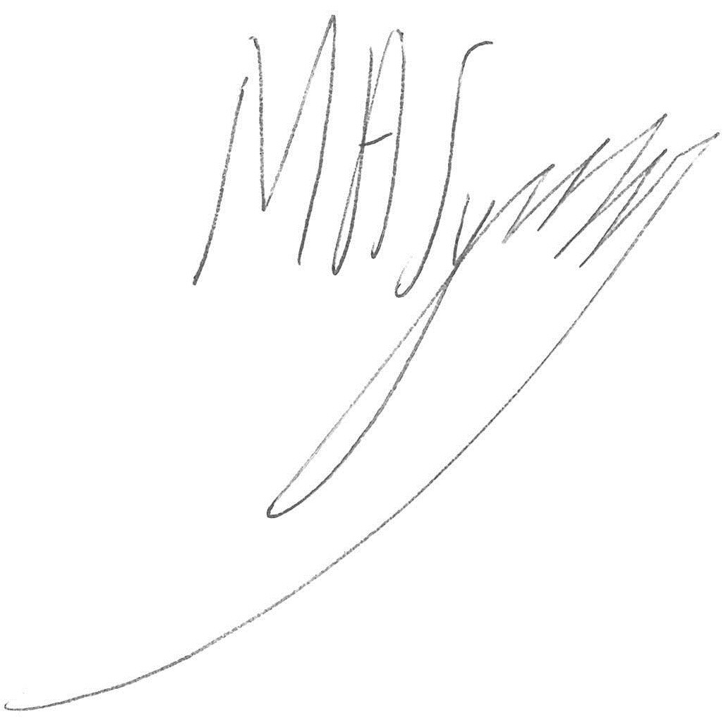
Deputy Upper Tribunal Judge Symes

