

Upper Tribunal
(Immigration and Asylum Chamber) Appeal Number: DA/01927/2014

THE IMMIGRATION ACTS

Heard at Field House | Decision & Reasons Promulgated
On 27 November 2018 | On 05 February 2019

Before

THE HON LORD MATTHEWS
(sitting as a judge of the Upper Tribunal)
UPPER TRIBUNAL JUDGE PERKINS

Between

mS J D o
(ANONYMITY DIRECTION MADE)
Appellant
and

SECRETARY OF STATE FOR THE HOME DEPARTMENT
Respondent

Representation:
For the Appellant: Ms Karen Reid, Counsel instructed by Charles Simmons, Immigration Solicitors
For the Respondent: Mr T Melvin, Senior Home Office Presenting Officer
DECISION AND REASONS
- Pursuant to rule 14 of the Tribunal Procedure (Upper Tribunal) Rules 2008 we make an order prohibiting the disclosure or publication of any matter likely to lead members of the public to identify the Appellant. Breach of this order can be punished as a contempt of court. We make this order because the decision touches on the welfare of children who might be harmed by publicity and we see no legitimate public interest in their identities rather than the facts of the case.
- This is a case where we do not think it will be of any value to anybody to set out a long explanation of its history. Suffice it to say it has been previously decided unsatisfactorily and comes before us on the direction of the Court of Appeal.
- The appellant is a foreign national and is a citizen of Brazil. However it is accepted that for reasons we need not explain the case is to be dealt with under the provisions relating to EEA nationals and the particular Rules that apply to deportation in such cases. As a consequence of this it is accepted that in order to justify the decision the Secretary of State has to show that the person to be removed represents a “genuine, present and sufficiently serious threat affecting one of the fundamental interests of society under Regulation 21(5)(c) of the EEA Regulations”.
- It is accepted that the appellant has behaved badly and as a result of that has been sent to prison for eighteen months. It is accepted too that she is the mother of two British citizen children who are small and their best interests lie in being in the care of their mother in the United Kingdom which is their country of nationality.
- The appellant was convicted in 2013. She has not been in any trouble since. We know from our experience that for many offenders this represents a significant break. It is wholly consistent with a person who is intent on living industriously and honestly and entirely inconsistent with a person who represents a genuine, present and sufficiently serious threat affecting one of the fundamental interests of society.
- We have been greatly assisted in this case by both parties and particularly Mr Melvin for the Secretary of State who narrowed the issues right down to this one point and to Mr Melvin’s realistic submissions limited to that point. We mean him no disrespect when we say we found his submissions unpersuasive. We are satisfied that this is not a case where the appellant represents a genuine, present and sufficiently serious threat and we have no hesitation in allowing her appeal.
Notice of Decision
- The appellant’s appeal against the Secretary of State’s decision is allowed.
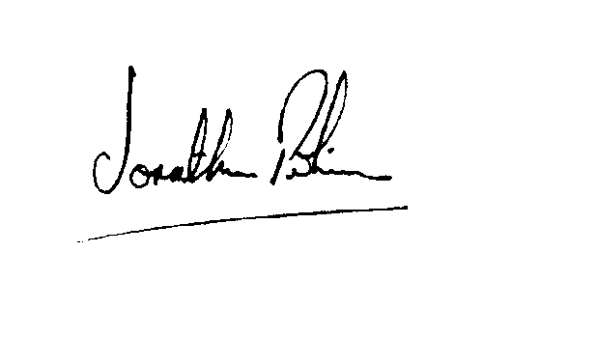

Signed
Jonathan Perkins
Judge of the Upper Tribunal | Dated 30 January 2019

