

Upper Tribunal
(Immigration and Asylum Chamber) Appeal Number: EA/00974/2016

THE IMMIGRATION ACTS

At Field House | Decision Promulgated
On 20 March 2018 | On 21 March 2018

Before

UPPER TRIBUNAL JUDGE BRUCE

Between

Muhammad Mujahid
(no anonymity direction made)

Appellant
And

Secretary of State for the Home Department

Respondent

DECISION AND REASONS
- The Appellant is a national of Pakistan born on the 3rd October 1989. On the 21st February 2017 his appeal under the Immigration (European Economic Area) Regulations 2006 was dismissed by the First-tier Tribunal on the grounds that pursuant to the decision in Sala (EFMs: right of appeal) [2016] UKUT 00411 (IAC) there was no jurisdiction.
- Permission to appeal was granted by Upper Tribunal Judge O’Connor on the 18th December 2017. Judge O’Connor indicated that the Upper Tribunal was minded, following the decision in Khan v Secretary of State for the Home Department [2017] EWCA Civ 1755 to find an error of law and remit the matter for hearing de novo before the First-tier Tribunal. Judge O’Connor directed that this would be the final disposal of the matter in the Upper Tribunal unless submissions were received to the contrary within 7 working days of his decision being sent.
- No such representations having been received I therefore set the decision of the First-tier Tribunal aside and remit the matter for hearing de novo in the First-tier Tribunal.

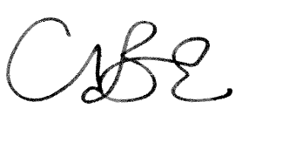
Upper Tribunal Judge Bruce
20th March 2018

