

Upper Tribunal
(Immigration and Asylum Chamber) Appeal Number: HU/09941/2017

THE IMMIGRATION ACTS

Heard at Birmingham Justice Centre | Decision & Reasons Promulgated
On 13 May 2019 | On 15 May 2019

Before

DEPUTY UPPER TRIBUNAL JUDGE McCARTHY

Between

s s

(anonymity order continued)

Appellant
and

SECRETARY OF STATE FOR the HOME DEPARTMENT

Respondent

Representation:

For the Appellant: Mr A W Khan, of Fountains Solicitors (Walsall)
For the Respondent: Mr D Mills, Senior Home Office Presenting Officer

DECISION AND REASONS

- The appellant appeals to the Upper Tribunal (with permission of UT Judge Martin) against the decision and reasons statement of FtT Judge Boylan-Kemp that was issued on 17 May 2018.
- As Mr Khan reminded me, the appellant’s grounds relate to whether Jude Boylan-Kemp made adequate findings about the reasonableness of expecting the appellant’s eldest child to leave the UK. Mr Khan raised concerns that the judge repeatedly described the children returning to the Gambia with the appellant, their mother, when in fact all three children were born in the UK, and although they could go to the Gambia they could not in fact return there. Mr Khan also argued that Judge Boylan-Kemp failed to explain what powerful reasons existed to outweigh the eldest child’s private life rights established in the UK, as described in the documentary and oral evidence.
- Mr Mills countered by arguing that the proper approach to the issues has been clarified by the Supreme Court in KO (Nigeria) and others v SSHD [2018] UKSC 53 and that what was important was to assess the reality of whether the best interests of the qualifying child was to remain with the parents wherever they might be and not to focus solely on whether there are powerful reasons to outweigh the child’s own private life. Mr Mills recognised that the KO (Nigeria) still required an assessment of the child’s best interests, including consideration of what ties the child had of their own to the UK.
- It was at this juncture that Mr Mills’s arguments became unstuck because Judge Boylan-Kemp failed to make adequate findings regarding the qualifying child’s private life rights. She has not made findings on the strength of the child’s friendships and schooling, which were evidenced before her. The failure to make findings on material matters is a legal error. It follows that I find Judge Boylan-Kemp’s decision is legally flawed. It is necessary to set it aside, which I do.
- I asked Mr Khan and Mr Mills for their submissions about whether the appeal needed to be remitted. Mr Mills advised me that because the remitted hearing will have to consider the facts at the date of hearing, and given that the eldest child of the appellant has now been resident in the UK for more than ten years and is eligible to register as a British citizen, the respondent would concede that appeal. Mr Mills said the fact the appellant is eligible for citizenship is a very weighty factor that would result in the appellant succeeding because it is not reasonable to expect the child to leave the UK.
Decision
There is legal error in the decision and reasons of Ft T Judge Boylan-Kemp.
I set aside her decision.
I remake the decision to allow the appeal against the original Home Office decision.

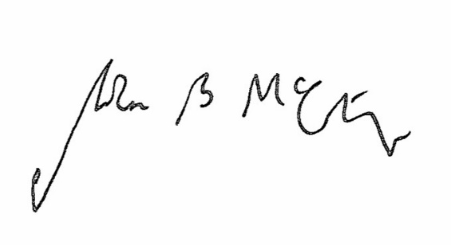

Signed Date 13 May 2019

Judge McCarthy
Deputy Judge of the Upper Tribunal

