

Upper Tribunal
(Immigration and Asylum Chamber) Appeal Number: HU/11611/2017

THE IMMIGRATION ACTS

Heard at Birmingham Justice Centre | Decision & Reasons Promulgated
On 13 May 2019 | On 16 May 2019

Before

DEPUTY UPPER TRIBUNAL JUDGE McCARTHY

Between

SECRETARY OF STATE FOR the HOME DEPARTMENT

Appellant
and

AKIL [Z]

(anonymity order NOT MADE)

Respondent

Representation:

For the Appellant: Mr D Mills, Senior Home Office Presenting Officer
For the Respondent: Mr A W Khan, of Fountain Solicitors (Walsall)

DECISION AND REASONS

- The Secretary of State appeals (with permission of FtT Judge Pickup) against the decision and reasons statement of FtT Judge Boylan-Kemp that was issued on 17 May 2018.
- Mr Mills conceded that he could no longer defend the grounds of appeal given the Court of Appeal’s judgment in SSHD v AB (Jamaica) & Anor [2019] EWCA Civ 661 because it is clear that the hypothetical question, “Is it reasonable to expect the qualifying child to leave the UK?” must be determined irrespective of whether the child would have to leave the UK.
- Mr Mills accepted that on the facts in this appeal, which in summary are that (i) the appellant has a genuine and subsisting relationship with his British citizen son, and (ii) the appellant’s son lives with his mother and not with the appellant, it would be unreasonable to expect the child to leave the UK. As a result, even though there might be some merit in the detailed grounds relating to suitability factors and as to whether Judge Boylan-Kemp should have applied paragraph EX.1 of appendix FM to the immigration rules, there could be no public interest in removing the appellant because of the application of s.117B(6) of the Nationality, Immigration and Asylum Act 2002. Although Judge Boylan-Kemp did not come at the relevant issue directly, her decision and reasons are sufficient to show that her decision is correct in law.
- Given this concession, there was no need to hear from Mr Khan.
Decision
There is no legal error in the decision and reasons of Judge Boylan-Kemp and I uphold her decision.
The Secretary of State’s appeal to the Upper Tribunal is dismissed.

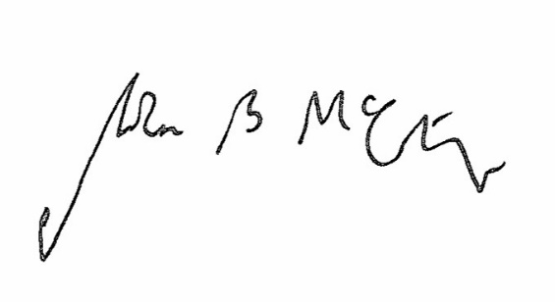

Signed Date 13 May 2019

Judge McCarthy
Deputy Judge of the Upper Tribunal

