

Upper Tribunal
(Immigration and Asylum Chamber) Appeal Number: HU/20894/2016

THE IMMIGRATION ACTS

Heard at Birmingham | Decision & Reasons Promulgated
On 30 October 2018 | On 09 November 2018

Before

DEPUTY JUDGE OF THE UPPER TRIBUNAL McCARTHY

Between

THE SECRETARY OF STATE FOR THE HOME DEPARTMENT
Appellant
and

gagandeep singh
(anonymity direction not made)
Respondent

Representation:
For the Appellant: Ms H Aboni, Senior Home Office Presenting Officer
For the Respondent: Mr O Sobowale, Counsel instructed by Bassi Solicitors

DECISION AND REASONS
- The Secretary of State appeals with permission against the decision and reasons statement of First-tier Tribunal Phull that was issued on 26 September 2017.
- In essence, the grounds of appeal argue that Judge Phull took the wrong approach to the concept of “insurmountable obstacles” and that as a result her assessment of proportionality was fundamentally flawed.
- After hearing from Ms Aboni and Mr Sobowale, I announced my decision. I concluded that there is no legal error because the case determined by Judge Phull was not solely about the assessment of insurmountable obstacles.
- The facts found by Judge Phull are not disputed, as confirmed by Ms Aboni. The appellant is an overstayer. He enjoys family life within the meaning of article 8(1) ECHR with his British citizen wife. The appellant’s presence will not undermine the economic wellbeing of the UK because his wife earns over the minimum income requirements. The appellant speaks English.
- The respondent justified the decision to refuse leave to remain and to expect the appellant to leave the UK because of his failure to comply with immigration controls. There can be no doubt that the appellant has a poor immigration history, as recorded by Judge Phull. He had overstayed and did not make his human rights claim until after he was encountered. I am satisfied Judge Phull was fully aware of the appellant’s poor immigration history when she made her decision.
- The issue for Judge Phull was to decide whether that poor immigration history was sufficient to conclude that the public interest outweighed the appellant and his wife’s right to enjoy family life. As is clear from all case law, Judge Phull had to consider all the factors to decide where a fair balance lies.
- Judge Phull considered that the public interest did not outweigh the family life of the appellant and his wife. Although not part of her decision, her conclusion is consistent with the guidance of the Supreme Court in R (Agyarko and Ikuga) v SSHD [2017] UKSC 11, paragraph 51, which reminded all who have to assess proportionality issues to consider the principle determined in Chikwamba v SSHD [2008] UKHL 40. The fact the Supreme Court’s judgment in Agyarko is the leading jurisprudence regarding the meaning of “insurmountable obstacles” means its reference to Chikwamba is particularly illuminating and the factors Judge Phull took into consideration when assessing proportionality cannot be said to be legally flawed.
- The fact is that the author of the grounds (and to the extent she relied on those grounds, Ms Aboni) has taken too narrow a view of the meaning of insurmountable obstacles and the assessment of proportionality. Judge Phull did not rely merely on the fact the appellant’s wife is a British citizen. Judge Phull relied on all the evidence, including the fact (and as I have indicated her findings are unchallenged) that the public interest would not be served by expecting the appellant to leave the UK merely to make what would be a successful entry clearance application as a spouse.
- It is for these reasons that I uphold Judge Phull’s decision and dismiss the Secretary of State’s appeal.

Notice of Decision
The decision of Judge Phull contains no legal error and is upheld.
No anonymity direction is made.
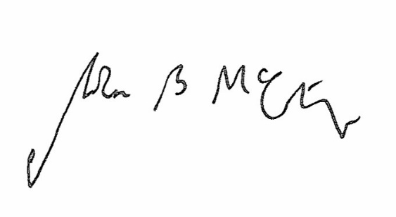

Signed Date 31 October 2018

Judge McCarthy
Deputy Judge of the Upper Tribunal

