

Upper Tribunal
(Immigration and Asylum Chamber) Appeal Numbers: IA/10220/2014

THE IMMIGRATION ACTS

Heard at Field House |  | Decision & Reasons Promulgated
On 8 October 2015 |  | On 8 December 2015

Before

UPPER TRIBUNAL JUDGE PERKINS
UPPER TRIBUNAL JUDGE S H STOREY

Between:

Jinali Bhadreshkumar Shah

(AnonYmity DIRECTIO not MADE)

Appellant
and

SECRETARY OF STATE FOR THE HOME DEPARTMENT

Respondent

Representation:

For the Appellant: Counsel Mr Z Malik, on the instructions of Vision Solicitors Ltd
For the Respondent: Ms. S Sreeraman, Senior Home Office Presenting Officer

DECISION AND REASONS

Background

- The appellant seeks to challenge the decision of the First-tier Tribunal (FtT), promulgated on 9 March 2015, dismissing the appellant’s appeal against the decision of the respondent dated 12 February 2014, refusing to vary her leave to remain in the United Kingdom and directing her removal under s47 of the Immigration, Asylum and Nationality Act 2006.

- The grounds, upon which the appellant challenges the FtT decision, are attached to her application for permission to appeal dated 16 March 2015. They are drafted by Vision Solicitors. It is not necessary for me to rehearse these here, as they are known to the parties. One ground, however, is central to whether this application can succeed. The appellant submits that the FtT erred in law in following EK (Ivory Coast) v SSHD [2014] EWCA Civ 1517 (EK) because EK was decided per incuriam, the suggestion being that the Court’s attention was not drawn to the fact that the SSHD was fully aware of why the appellant’s CAS had been withdrawn.

- On 6 May 2015, FtT Judge White granted Permission to Appeal on the grounds that the FtT Judge arguably made an error of law in finding that:

      - the appellant had not made false representations dishonestly during her interview;
      - the CAS had been withdrawn on 8 January 2014 given that the college continued to communicate with her subsequently;
      - the CAS could be validly withdrawn after the appellant had made her application; and
      - that the CAS was withdrawn by reason of the non-payment of fees when the CAS records show that fees were paid in full.

Proceedings before the Upper Tribunal

- At the hearing, Mr. Malik argued that the FtT decision was erroneous, firstly because the Judge wrongly found as fact that the CAS had been withdrawn on 8 January 2014 and therefore the decision of the SSHD was in accordance with the law; and secondly, because the decision of the SSHD was procedurally unfair. In relation to the first ground, Mr. Malik submitted that this was not a finding open to the FtT Judge to make. This is, he says, because there was no evidence before the FtT Judge that the CAS was in fact withdrawn other than the statement in the document headed “CAS Details”. Directing us to the Home Office Guidance for Tier 4 Sponsors (version 10/13), Mr Malik submitted that a CAS can only be cancelled by the Home Office, where there is evidence of misrepresentation or fraud (paragraph 481.a), or withdrawn where it has not been used to support an application for a visa or an extension of stay (paragraph 482).

- On the issue of procedural fairness, Mr. Malik drew our attention to paragraphs 27 and 39 in EK and the reference therein to Naved (Student – fairness – notice of points) [2012] UKUT 14 (IAC) and R v. SSHD, ex p. Doody [1994] 1 AC 531. He submitted the principles of fairness demand that a person should be informed of any factors that weigh against them and that they should be afforded the opportunity to make representations. This was not done in the instant case.

- On behalf of the Respondent, Ms. Sreeraman submitted that the FtT decision did not contain any material error of law and that the SSHD was not in breach of her public duty responsibilities. The decision was on all fours with EK.

Was there an error of law?

- The Judge found as fact that there was no evidence of deception or misrepresentation. He further found that there was no valid CAS on 8 January 2014, and that this was probably because fees had not been paid, causing the CAS to be withdrawn. Irrespective of whether the finding in relation to the payment of fees was correct, Mr. Malik does not dispute that on the date the SSHD checked the system, there was no valid CAS in place. In the absence of any evidence to show that on that date there was a valid CAS in place, the Appellant could not meet a mandatory requirement of the Rules.

- On the issue of fairness, the FtT Judge quoted at length from the Court of Appeal judgment in EK. That judgment is binding on the FtT in as much as it is binding upon us. As Sales LJ stated [at paragraph 26]:
“ 26. The Secretary of State accepts, correctly, that the Immigration Rules do not exclude the general public law duty to act fairly which rests upon the Secretary of State in exercising her functions: see, e.g., Alam v Secretary of State for the Home Department [2012] EWCA Civ 960, [44]. The question, therefore, is whether that duty imposed an obligation on the Secretary of State, when she saw that the CAS letter on which the Appellant’s application for leave to remain was based had been withdrawn, to adjourn any decision on the application to give the Appellant notice of the problem and an opportunity to rectify it. In my view, it did not.” (Emphasis added).

- Accordingly, the FtT Judge was bound to find, as he did, that the approach of the SSHD does not involve any unfairness to an Appellant.

- We have heard nothing to persuade us that the contention made by Vision Solicitors (but not relied upon by Mr. Malik) that EK was decided per incuriam. Accordingly, in the absence of the same, we reject their submission.

Decision

- For the above reasons, we concur with Ms. Sreeraman’s submissions that read in its entirety, the FtT Judge’s determination does not disclose any material error. The Appellant’s appeal is therefore dismissed.

Signed:
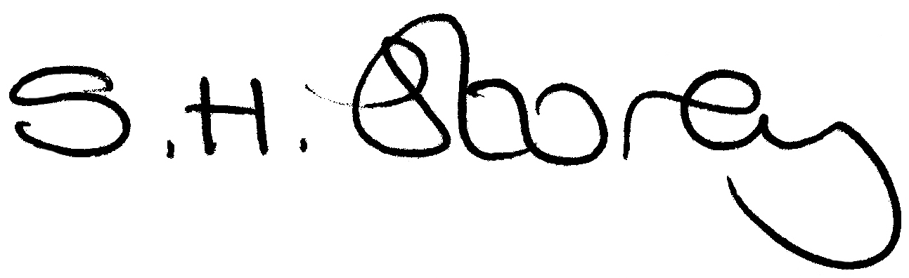
Sehba H Storey
Judge of the Upper Tribunal

