

Upper Tribunal
(Immigration and Asylum Chamber) Appeal Number: PA/01047/2016

THE IMMIGRATION ACTS

Heard at Field House | Decision & Reasons Promulgated
On 2 November 2016 | On 13 December 2016

Before:

UPPER TRIBUNAL JUDGE GILL

Between

 | LS  (ANONYMITY ORDER MADE) | Appellant
And

 | The Secretary of State for the Home Department | Respondent

Anonymity

I make an order under r.14(1) of the Tribunal Procedure (Upper Tribunal) Rules 2008 prohibiting the disclosure or publication of any matter likely to lead members of the public to identify the appellant. No report of these proceedings shall directly or indirectly identify her. This direction applies to both the applicant and to the respondent. Failure to comply with this direction could lead to contempt of court proceedings.

The parties at liberty to apply to discharge this order, with reasons.

Representation:
For the Appellant: Mr E Fripp, of Counsel, instructed by Duncan Lewis & Co Solicitors.
For the Respondent: Mr P Armstrong, Senior Home Office Presenting Officer.

DECISION AND REASONS
- The appellant and her adult son are both nationals of Pakistan born (respectively) on 25 August 1938 and 10 September 1966. They are aged 78 years and 50 years respectively. They had appeals before the First-tier Tribunal (“FtT”) on asylum and human rights grounds against decisions of the respondent of 20 January 2016 refusing their asylum and human rights claims of 11 September 2015.
- Their appeals were heard in a combined hearing on 19 August 2016 before Judge of the First-tier Tribunal O’Brien. I shall refer to the appellant’s son hereafter as her son or the son.
- The judge allowed the son's appeal on asylum grounds. He dismissed the appellant's appeal on asylum grounds stating, at [47] of his decision, that “there is no evidence that she would be individually persecuted or subjected to serious harm if she returned to Pakistan without [her son]” (my emphasis).
- The evidence before the judge was that the appellant was dependent upon her son and part of his family unit in Pakistan. The son, his wife and children and the appellant fled Pakistan together. The appellant continued to live with the son and his family in the United Kingdom.
- The judge allowed the appellant’s appeal on human rights grounds on the basis of Article 8, stating that there was no challenge to her evidence that she was wholly dependent on her son. He gave his reasons for allowing her appeal on the basis of Article 8 at [48]-[49] of his decision. The respondent has not challenged the judge's decision to allow the appellant's appeal on the basis of Article 8.
The issue
- The issue in this case is a narrow one. It relates to whether the appellant should have been successful in her appeal on asylum grounds in line with her son.
- Mr Fripp confirmed that it was not suggested that, if the appellant returned to Pakistan, she herself would be persecuted as a result of any act directed at her.
- The appellant’s case may be summarised as follows:
i) Notwithstanding the fact that the judge had allowed the son's appeal on asylum grounds, he should have presumed that the appellant, her son and his family would be returning to Pakistan as a family unit.
Mr Fripp submitted that the determination of the Immigration Appeal Tribunal (“IAT”) in Met Sula and dependants [2002] UKIAT 00295 was authority for the proposition, advanced at para 3.20 of ‘Asylum Law and Practice, second edition (2010), by Symes and Jorro, that it should be presumed that all members of a family group would face removal together.
It should be noted that para 3.20 of Asylum Law and Practice relies upon extracts from [82] and [85] of the decision in Met Sula, as does Mr Fripp in advancing the proposition that the judge should have presumed that the appellant would be returning to Pakistan with her son and his wife and children. These extracts are in bold at [16] below.
The decision in Met Sula is attached to this decision as an appendix.
ii) If the judge had presumed that the appellant’s son and his wife and children would be returning to Pakistan with her, he would (or should) have found that any acts of persecution perpetrated against the son would amount to persecution of the appellant. In this regard, Mr Fripp referred to, and relied upon, El Merhabi v Minister of Immigration and Multicultural Affairs [2000] FCA 42, Katrinak v SSHD [2001] EWCA Civ 832 at [23] and FM (FGM) Sudan CG [2007] UKAIT 00060.
iii) Such persecution would be for a Refugee Convention reason because a family is a “particular social group” (SSHD v Fornah; K v SSHD [2006] UKHL 46) and the persecution of the appellant would be by reason of her membership of a particular social group. The ground relied upon, i.e. membership of a particular social group, need not be the only, or even the primary, reason for the apprehended persecution. It is enough that the ground relied upon is the effective reason for the persecution.
Relevant factual background
- The judge accepted the son's evidence that he had given a speech advocating increased religious tolerance in Pakistan and the establishment of multi-faith prayer rooms in universities. He accepted the son's evidence that he had subsequently experienced problems which included being physically attacked in his office, being told that it was known where his children went to school, being shot at on one occasion by people on motorbikes whilst he was driving his car and on another occasion having his moving car bracketed by two people on motorcycles who told him he would be killed. His wife was with him on one occasion and his son on another occasion. The judge accepted that the son would, if he returned to Pakistan, continue to speak out about religious tolerance. The judge found that the son would not enjoy sufficient protection in his home area. In his consideration of an internal flight alternative, the judge found that the son was well-known academic who was physically distinct. He accepted that the Taliban would come to learn of his return to Pakistan wherever he went and whichever institution he worked for. He did not consider it reasonable for the son to give up his long and successful career in order to gain anonymity which he considered would in itself amount to persecution. He therefore found that the son had a well-founded fear of persecution in Pakistan on the ground of religion. He therefore allowed his appeal on asylum grounds.
- As stated at [3] above, the judge dismissed the appellant's appeal on asylum grounds stating that there was no evidence that she would be individually persecuted or subjected to serious harm if she returned to Pakistan without her son.
- It is important to note that there was no challenge to the judge’s finding that the appellant would not herself face any direct acts of persecution on account of her relationship with her son. There was no evidence before the judge to suggest that, even if the appellant’s son and his family were to return to Pakistan with the appellant and they experienced persecution, the appellant would herself experience any acts directed at her. In the account of events that had occurred in Pakistan, there was no mention of any acts having been perpetrated against the appellant directly notwithstanding that she had lived with the son as part of his family unit. This is the reason why reliance is placed on the argument that any acts of persecution of her son would also amount to persecution of the appellant herself.
The decision in Met Sula
- The case of Met Sula concerned an appeal under s.65(1) of the Immigration and Asylum Act 1999 (the “1999 Act”) by a man with his wife and children as his dependants. They were all citizens of the then Federal Republic of Yugoslavia. It is important to note that the wife and children did not have separate decisions and did not lodge separate notices of appeal. The wife had not claimed asylum in her own right. The adjudicator, Mr H W Turcan, accepted the wife’s evidence that she had been brutally raped by the Serbs and was a traumatised individual in respect of whom he said “it would be surprising if the [Secretary of State] felt able to conclude that it would be appropriate to return her to Kosovo.” Nevertheless, he proceeded to dismiss the appellant's appeal on asylum and human rights grounds.
- Leave to appeal to the IAT was granted limited to the human rights grounds. Nevertheless, the IAT made some observations in relation to the asylum grounds which I shall summarise at this point because these observations provide some clarity to the reasoning deployed by the IAT in relation to the human rights grounds and upon which Mr Fripp relies.
- In relation to the asylum case, the IAT reasoned as follows:
i) Having considered the relevant legislation as it then stood, the IAT concluded that, for a person to have a right of appeal on asylum grounds, he or she must have made an asylum claim in his or her own right. There could be no asylum claim without an individual asylum claim and only a person who has claimed in her or her own right was entitled to receive a corresponding decision. The right of appeal against it is only held by a person who has had such a decision ([14]). The then statutory framework made it clear that the appeal right against a claim for asylum was dependent upon the making of an individual asylum claim ([8]).
ii) If a family member has been included in another person's asylum claim as a dependant, the decision that is made in relation to the dependant is not the same as the decision made against the principal applicant. The decision made against the dependant is sometimes described as an “in line with” or “derivative” decision. ([17]). The then statutory scheme did not provide a person who is a dependant with a right of appeal against the derivative decision ([18]).
iii) In the case before it, the adjudicator was correct not to determine the wife’s asylum appeal given that she had not made an asylum claim and there was as yet no decision against which she could appeal ([42]).
iv) Given his finding that return of the appellant's wife would place her at real risk of serious harm against which there would be no effective protection, the adjudicator should have asked whether the principle set out by the Court of Appeal In Katrinak could have assisted the appellant, i.e. whether the persecution of the appellant’s wife could itself amount to persecution of the appellant ([44]).
v) However, even if the adjudicator had addressed this question, the IAT did not think that his conclusion would have been different ([45]). The IAT gave two reasons at [46]. First, that the adjudicator's conclusion may have been that, notwithstanding the situation of his wife, the appellant would not experience persecution himself. The IAT considered that Katrinak was not authority for the proposition that, in the case of return of every couple, risk of harm to one will inevitably entail risk of harm to the other. Whether the return together of the appellant and his wife would cause him as well as her persecutory harm was a question of fact needing further examination. However, the IAT considered (this was the IAT's second reason) that it was not necessary for it to conduct that examination because it took the view that there was no applicable Refugee Convention reason for any harm that the wife might face in Kosovo because the Serbs were no longer in control of Kosovo and thus any ill-treatment that the wife might face in Kosovo would not be for a Refugee Convention reason (47]).
- In relation to the human rights ground of appeal, the IAT’s reasoning (insofar as relevant to the issues in this case) may be summarised as follows:
i) In Kehinde (01TH2668), the IAT decided that, where the only appeal before the adjudicator is that of the appellant, that did not mean that the human rights of his dependants are irrelevant to his human rights appeal. Within the context of a s.65 appeal, it was essential to take account of the human rights not only of the appellant but also of any other person who stood to be directly affected by the decision made against the appellant. Thus, in the context of an appeal brought by an appellant with family dependants, the decision made on the appellant's appeal must not amount to an act which is incompatible with the human rights of any relevant members of his family ([71]).
ii) At [72], the IAT said that, in the context of a human rights appeal which involves a husband, wife and children, it seemed that “this requirement was similar (although not identical)” in effect to that identified by the Court of Appeal in Katrinak in the context of an asylum appeal and that, under both the Refugee Convention and the ECHR, risk to one member of the family can sometimes entail risk to the appellant. However, the IAT emphasised that it must be demonstrated that “the threatened well-being of a family member is in fact integrally related to the threatened well-being of the appellant”.
iii) Given that the adjudicator had found an apparent breach of the wife’s Article 3 right, he should have applied the principle in Katrinak and considered separately whether the appellant's Article 3 right would be violated because of the adverse impact on him of the traumatisation that would be caused to her by being returned along with him ([74]). The IAT said that it could not make a finding either way on the appellant's Article 3 claim “given the absence of wholly adequate evidence on this issue” ([76]). At [87], the IAT repeated that it did not consider that it had adequate evidence to decide the issue of the appellant’s Article 3 position and that one relevant area of evidence would be the likely impact on the appellant of circumstances in Kosovo insofar as they affected his wife.
iii) The IAT decided that it was not necessary to remit the appeal because it decided to allow the appellant's appeal under Article 8 for reasons which may be summarised as follows:

a) The adjudicator declined to find a breach of Article 8 because he considered that removal was too theoretical or speculative ([78]).

b) The adjudicator was wrong to consider that removal was too theoretical or speculative because what he had before him was a s.65 appeal against a decision to remove. It was an appeal brought by a claimant who had stated that his wife and children were his dependants. There was no undertaking from the respondent that the appellant’s wife and children would not be removed at the same time as the appellant. Integral to the appeal was that the appellant’s wife and children would be removed with him. Their situation would be dealt with “in line” with his. The derivative decisions against them were to the effect that they would be removed along with the appellant as members of his family under s.10 of the 1999 Act. The adjudicator should therefore have considered as a given fact that the appellant would be returned together with his family ([80]).
- It is at this point that I will set out the passages in Met Sula and upon which Mr Fripp relied. They are the extracts in bold in the following quote from Met Sula:
“82. Following Ravichandran principles the task of the adjudicator in asylum or asylum-related appeals is to decide the appeal on the assumption that removal will take place there and then, although for administrative reasons that rarely happens. In an appeal with family dependants this assumption is simply extended to cover removal of the family along with the appellant. Inevitably there will be many practical matters that will affect what the Secretary of State eventually decides administratively to do about implementing removal of families; there will quite often be complications of the kind noted in the Tribunal decision in the case of Milanovich (01TH1556) which concerned an appellant whose wife was and children were of a different nationality. However, Parliament has not allocated responsibility for those matters to adjudicators. Their task is to decide whether an appellant’s removal would be contrary to the Refugee Convention or the Human Rights Convention. Thus a decision on the appellant posits that his dependants will be removed along with him.
85. If the approach taken by the adjudicator were to be followed the result would be that in virtually every asylum appeal in which dependants were involved, it would be open to either party to seek to persuade the adjudicator to take a different view depending on the contingencies of what applications or claims had been made, or were going to be made. Issues of whether the Secretary of State was or was not minded to make one or other decision in response would besiege the adjudicator. The adjudicator’s task of prognosis is difficult enough without adding to it the need to make speculations of this kind.”
- Mr Fripp submitted, in reliance upon the text I have emboldened above, that the correct basis of assessment of the appellant's asylum case was not that the son's appeal on asylum grounds had been allowed so that his absence from Pakistan would mean that the family would not be targeted. The correct position was to decide the risk of persecution on the presumption that the entire family, including the appellant, would return to Pakistan together. On that basis, he submitted that the judge should have concluded that the appellant had a well-founded fear of persecution because persecution of her son, with whom she would live as she has done in the past, would amount to persecution of the appellant herself.
Discussion
- There are three main difficulties with the submission advanced on the appellant’s behalf. Each of these is determinative of the appellant's appeal to the Upper Tribunal with the consequence that, even if I am wrong in what I say about any one, the remaining difficulties are determinative.
The first difficulty
- The argument advanced, that the judge should have presumed that the appellant would be returning to Pakistan with her son, his wife and children, was not advanced before the judge. I have noted that the judge recorded at [21] of his decision as follows:
“21. In respect of the Second Appellant [i.e. LS], it was submitted that persecution of her son constituted persecution of her. In any event she was a long-term dependant of her son and also was an important carer for her granddaughter who suffered serious health problems.”
- It does not follow, from the mere fact that it was submitted that persecution of the appellant's son constituted persecution of her, that it was implicit that it was the appellant's case before the judge that the judge should presume that the appellant would be returning to Pakistan with her son and his family irrespective of any decision he made in relation to the son’s asylum claim, given that the appellant had a separate appeal from her son and that Met Sula was not argued before the judge.
- Furthermore, I am satisfied that it cannot be said that the judge was obliged to make such a presumption on the ground that it was a ‘Robinson obvious’ point, i.e. a point which is obvious in the context of international obligations under the Refugee Convention. This principle is derived from the judgment in R v SSHD ex parte Robinson [1997] EWCA Civ 3090, to the effect that “obvious points of Refugee Convention should not go unconsidered with the risk that this county might find itself to have breached its international obligations” (AM (Serbia and others v SSHD [2007] EWCA Civ 16 at [21]). Not only is it the case that Met Sula is a decision of some vintage and which is not available on the Tribunal's website, the submission that it is authority for the proposition that such a presumption should have been made is misconceived and wrong for the reasons given at [22]-[29] below.
The second difficulty
- There are five points here.
- Firstly, given that leave to appeal to the IAT was granted limited to the human rights grounds of appeal, anything the IAT said in relation to the asylum case or the Refugee Convention was strictly speaking obiter.
- Secondly, it is clear, in my view, that the IAT’s observation at [82] and [85] about it being necessary to decide an appeal on the assumption that removal will take place there and then and that the assumption extends to cover removal of the family relates only to cases in which there is one appellant with the family members being dependants in his or her claim in the sense that they do not have separate appeals. Mr Fripp submitted that this assumption applies to the appellant but did not engage with the fact that it is clear from the IAT's reasoning in Met Sula, in particular, the fact that it drew a clear distinction between individuals in a family unit who have made separate asylum claims and therefore have separate decisions and separate appeals and those who are dependants in the asylum claim of a member of their family and who therefore receive “in line” or “derivative decisions” so that they do not have an independent right to appeal. It is clear that the IAT’s obiter observations at [82] and [85] of Met Sula only concerned those who are dependants in an appeal on asylum grounds.
- Accordingly, the submission advanced on the appellant's behalf in reliance upon Met Sula is simply misconceived and wrong, in my view. The passages from [82] and [85] of Met Sula that I have quoted in bold at [16] above have been taken out of context.
- Thirdly, not only is it the case that the IAT's reasoning in relation to the asylum case was obiter, as were its observations at [82] and [85], my attention was not drawn to any authority for the proposition that these observations by way of obiter should be read across to those who have separate appeals regardless of the circumstances of the individual case. The decision in Met Sula was a decision to remove in circumstances where the IAT noted that there was no undertaking from the respondent that the wife and children of the appellant in Met Sula would not be removed at the same time as the appellant in that case and that the derivative decisions in the case of the wife and children in Met Sula were to the effect that they would be removed along with the appellant in Met Sula as members of his family under s.10 of the 1999 Act. In contrast, the appellant in the instant case has a separate decision to refuse her asylum and human rights claims. It was part of the respondent's case before the judge that the appellant had not explained why she would be unable to return to Pakistan without her son (the judge’s decision at [5] and the “Detailed Reasons for Refusal” attached to the decision letter dated 20 January 2016, at [52]).
- Fourthly, the IAT decided in Met Sula that it was necessary for a judge to decide whether a decision was incompatible with the human rights of anyone affected directly by it. It therefore followed, in the IAT’s view, that the human rights of dependants in an appeal brought on human rights grounds fell to be considered notwithstanding that they do not have a separate appeal on human rights grounds. It is clear from the obiter reasoning of the IAT in Met Sula that, given the then statutory framework, this principle could not be read across and applied to dependants in an asylum claim precisely because the then statutory framework made it necessary for an individual to have a right of appeal on asylum grounds before it was necessary for a judge to consider whether the individual was a refugee. That is the reason why, in my view, the IAT was careful to ensure that its obiter comments at [82] and [85] concerned asylum appeals with dependants – see the parts of the sentences underlined below from [82] and [85] of Met Sula:
“82. … In an appeal with family dependants this assumption is simply extended to cover removal of the family along with the appellant.
85. If the approach taken by the adjudicator were to be followed the result would be that in virtually every asylum appeal in which dependants were involved, …”
- Accordingly, it cannot be said that the IAT intended its obiter observations at [82] and [85] to apply to claimants who have separate appeals on asylum grounds.
- Fifthly, as a result of the fact that the appeal of the appellant’s son in the instant case had been allowed on asylum grounds, there is simply no basis for any presumption that he will return to Pakistan with or without his wife and children. Any such presumption would be based on pure speculation. No authority is given for the proposition that judges should embark upon such speculation. I have dealt with (above) the arguments advanced in reliance upon Met Sula.
The third difficulty
- The IAT in Met Sula considered that Katrinak was not authority for the proposition that, in the case of return of every couple, risk of harm to one will inevitably entail risk of harm to the other and that whether the return together of the appellant in that case and his wife would cause him as well as her persecutory harm was a question of fact needing further examination. In applying this concept in the human rights context, it said, at [72], that, under both the Refugee Convention and the ECHR, “it has to be demonstrated that the threatened well-being of a family member is in fact integrally related to the threatened well-being of the appellant” and, at [87], that in the particular circumstances of that case, one relevant area of evidence would be the likely impact on the appellant in that case of circumstances in Kosovo insofar as they affected his wife.
- It is therefore clear that the IAT in Met Sula considered that the question whether acts perpetrated against one individual would amount to persecution of another is a question of fact in each case. Although the adjudicator in the Met Sula case had found that the wife was at real risk of serious harm, the IAT considered that he (the adjudicator) may nevertheless have found that notwithstanding the situation of the wife the appellant in that case would not experience persecution himself.
- In the instant case, I have noted that the judge’s Record of Proceedings, which I have consulted, shows that the appellant gave very limited oral evidence at the hearing. She did not give any oral evidence about the impact upon her of any difficulties her son may experience if he were to return to Pakistan with her. I have also noted that she said in her witness statement at [25] as follows:
“… Any threat directed at my son is a threat to me not only because we live together but also because if anything happens to my son, my grandchildren or my daughter-in-law would cause me harm and great pain….”
- The appellant does not explain precisely how she will suffer harm. In stating that she will experience great pain, she is saying no more than that she will be very upset if anything happens to the son. In my judgment, this evidence in the appellant's witness statement does not amount to evidence that the impact upon the appellant of any persecutory acts against her son would be such as to reach the threshold for persecution. To decide otherwise would effectively mean that the mere existence of a family relationship or a close bond, with little more, is sufficient in itself to establish persecution under the Katrinak principle, which cannot be right.
- On this basis alone, the appellant's appeal to the Upper Tribunal stands to be dismissed. Even if I am wrong in everything I have said at [19]-[29] above so that it is shown that the judge should have presumed that the appellant's son and his wife and children would return to Pakistan with her, any such error (if he did err in that way, which I do not accept, for the reasons given above) is not material. There was simply insufficient evidence before him upon which he could have properly found, without embarking upon speculation, that the impact upon the appellant of any acts perpetrated against her son would be such as to reach the threshold for persecution.
- I have therefore concluded that the judge did not materially err in law. I therefore dismiss the appellant's appeal to the Upper Tribunal.

Decision

The making of the decision of the First-tier Tribunal did not involve the making of an error on a point of law.


Signed Date: 12 December 2016
Upper Tribunal Judge Gill
Appendix
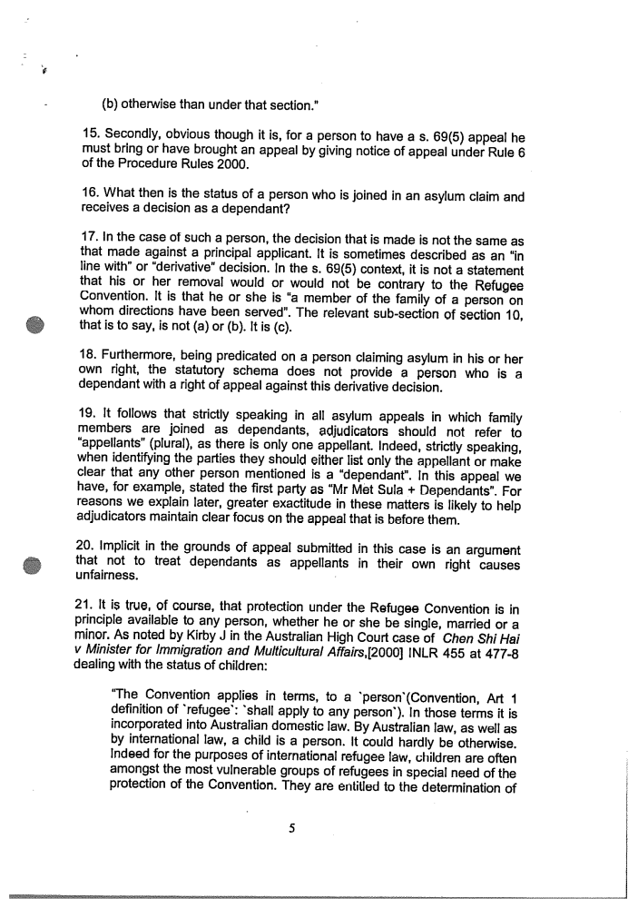
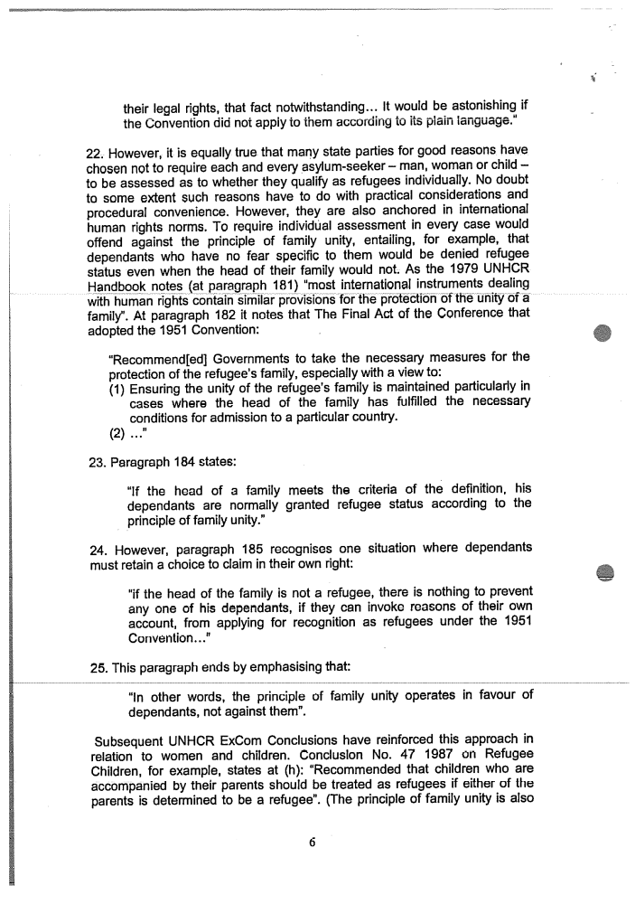
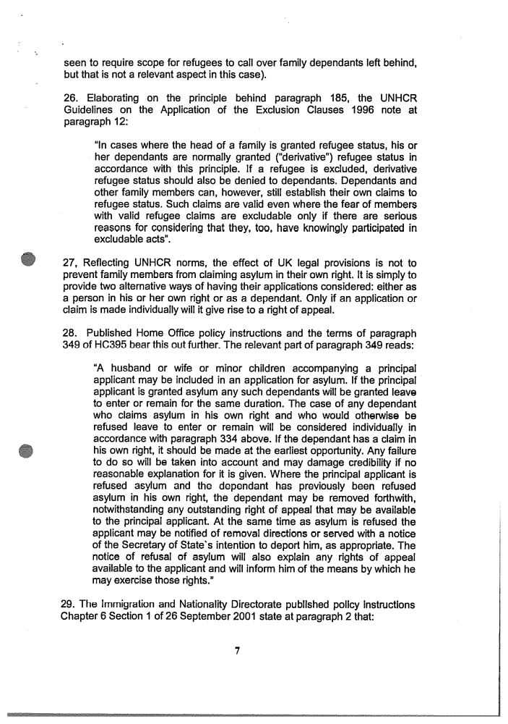
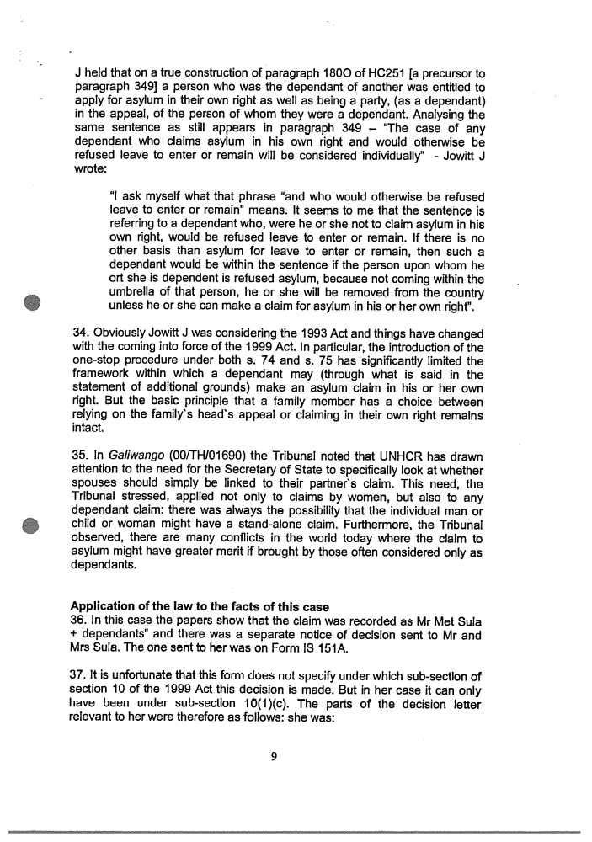
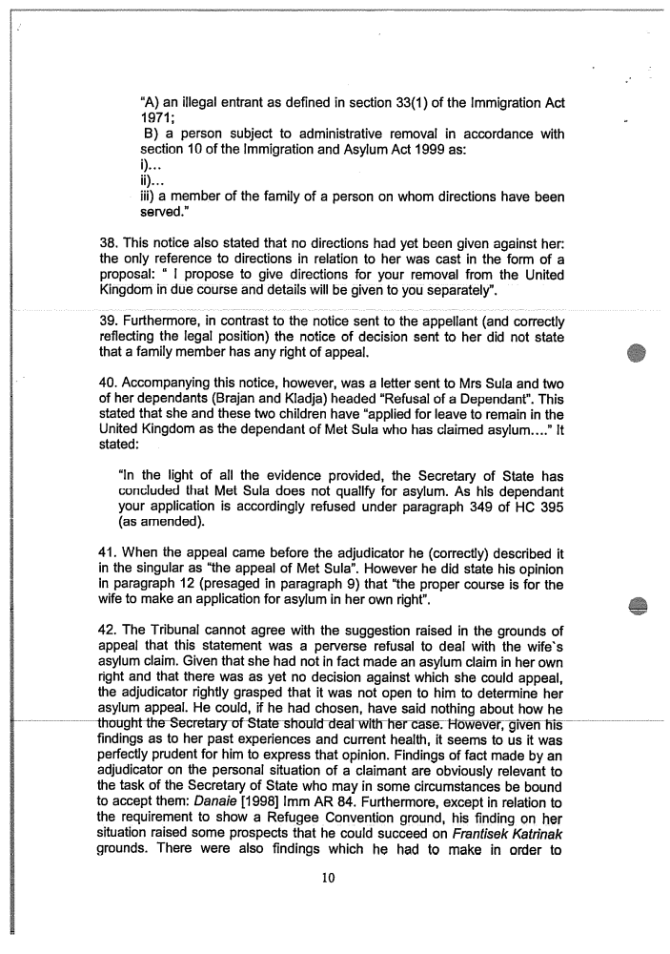
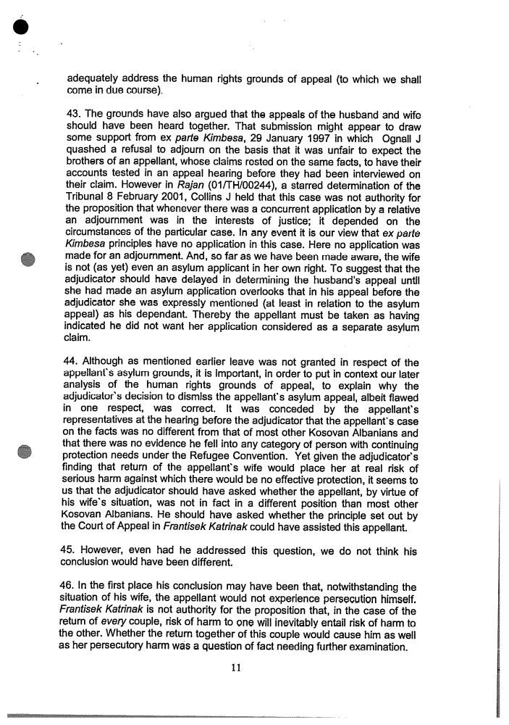

Ravichandran [1996] Imm AR 97

