

Upper Tribunal
(Immigration and Asylum Chamber) Appeal Numbers PA/02071/2020

THE IMMIGRATION ACTS

Heard at Manchester Civil Justice Centre | Decision and Reasons Promulgated
On 22 June 2021 | On 13 July 2021

Before

Upper Tribunal Judge Bruce
Deputy Upper Tribunal Judge Sills

Between

MR AAJ
ANONYMITY DIRECTION MADE
Appellant
and

SECRETARY OF STATE FOR THE HOME DEPARTMENT
Respondent

DECISION AND REASONS

Representation:
For the Appellant: Mr Malik
For the Respondent: Mr Bates

Introduction
- This is an appeal against the determination of Judge Bannerman, promulgated on 23 November 2020.
Factual Background
- The Appellant (A) is a national of Iraq from Kirkuk, born on 18 February 1997. A first claimed asylum in October 2015. A claimed that in 2007 a friend had been killed while crossing a road with him. His friend’s family were powerful and influential and had blamed A, threatening to kill him. A was hit by a car in 2009, in 2012 shots were fired at A, and in 2013 there was an attempt to kidnap him. After this A fled Iraq and came to the UK.
- The Respondent refused the claim and A’s appeal to the First Tier Tribunal (FTT) was dismissed. The FTT found A’s account was not credible and that A could return to Kirkuk. A appealed to the UT. The UT found that the FTT had erred in failing to apply or explain why they were departing from, the country guidance case of AA (Article 15c) Iraq CG [2015] UKUT 544 and failing to give adequate reasons in relation to internal relocation. The UT preserved the FTT’s findings aside from the findings that A faced no risk for any reason in Kirkuk and that he could reasonably relocate. On 7 December 2017 the UT remade the decision. The UT found that A would not be at risk of serious harm in his home area and that he could safely return there via Baghdad or the IKR.
- A then made further submissions leading to the decision under appeal dated 29 November 2019. A’s appeal came before Judge Bannerman on 12 October 2020. The Judge noted the medical evidence stating that A had ‘multiple issues with low mood, anxiety and PTSD.’ The format of the hearing is not clear from the determination. Para 30 states that the hearing was listed for 10am, and by 12 noon neither A nor his representative had attended the hearing or provided any explanation for this. Several phone calls were made to A’s representative Mr Malik by the Tribunal without success. Contact was made with A’s representative’s office who confirmed they were aware of the hearing, but did not know where Mr Malik was. At 12 noon, Judge Bannerman heard submissions from R’s representative. In the determination promulgated on 23 November 2020 the Judge dismissed the appeal on all grounds.
Application for permission to appeal
- A appealed on 2 grounds. The first ground is procedural unfairness. A stated the appeal had been via Cloud Video Platform (CVP) but that the hearing could not be accessed on the day. The representatives informed the Tribunal ‘via phone email’ that they were having difficulties in accessing the CVP. The determination made no reference to the email from A’s representatives explaining the difficulties they were having. The hearing should not have been listed via CVP given that the Appellant could not attend his solicitor’s office and had inadequate Wi-Fi in his accommodation. Second, A argued that the FTT had erred in applying the case of N v SSHD [2005] UKHL 31 instead of Paposhvili v Belgium (Application No 41738/10) and AM Zimbabwe [2020] UKSC 17.
- FTT Judge Nightingale granted permission to appeal on 24 February 2021 on the basis that if A contacted the Tribunal on the day of the hearing to indicate difficulties a clear arguable procedural unfairness arises. A’s representatives were instructed to supply evidence of all communications with the Tribunal on the day of the hearing. Permission was granted on all grounds.

The Hearing
- On the day of the hearing, A filed an additional bundle. This contained email correspondence between the Tribunal and Mr Malik, A’s representative. The Tribunal emailed A at 10.11 on 12 October 2020 to ask, ‘Are you trying to get on and connect to todays hearing?’ Mr Malik replied at 12.52 as follows:
Tried in vain to connect but a series of issues did not allow me,
beginning with my computers anti-virus programme not allowing me to connect due
to CVP source/server being high risk.
My client could not log-in either as his internet proved unreliable due to the
fact that he is living in NASS hotel accommodation shared by many others.
- Mr Malik explained that this had been his first CVP hearing. His phone had been on airplane mode when initially he tried to connect to the hearing. After being unable to connect in his home, he went to the local Starbucks to try to connect there. He managed to break his mobile phone in the car park while there. After sending the email he simply waited for a response.
- Mr Bates adopted a neutral position but queried why it took Mr Malik so long to inform the Tribunal of difficulties.
Findings
- We make the following criticisms of Mr Malik at the outset. Given the hearing was listed for 10am, Mr Malik should have contacted the Tribunal by email or telephone well before the email at 12.52pm. He should also have made further contact with the Tribunal after this initial email of 12.52pm. That email explains the connection difficulties but does not set out what Mr Malik wanted the Tribunal to do.
- Notwithstanding these criticisms, we accept that neither Mr Malik nor A were able to connect to the CVP hearing. In our experience it is not uncommon for representatives, particularly when attempting for the first time, to have difficulties connecting to CVP. Nor is it uncommon for appellants in asylum appeals to have difficulty connecting to CVP, particularly where they are in NASS accommodation with multiple users accessing the Wi-Fi. We accept that they both attempted to but were unable to attend the hearing on 12 October 2020. Further, in view of the fact that there is no reference to the email from Mr Malik of 12 October 2020, it is clear that Judge Bannerman was not provided with this email and so was unaware of these connection difficulties.
- In view of the fact that neither A nor his representative were able to attend the hearing, we are satisfied that the subsequent determination was the result of an unfair procedure. Whether or not A would have given oral evidence is irrelevant as oral evidence is only one part of an oral hearing. As the determination was the result of an unfair procedure, we are satisfied that the determination of Judge Bannerman contains a material error on a point of law and must be set aside. As the email of Mr Malik of 12 October 2020 was not before Judge Bannerman, Judge Bannerman cannot be criticised for the procedural unfairness.
- As A was denied a fair hearing, we are satisfied that the appeal should be remitted to the FTT with no findings of fact preserved. In view of the medical evidence, the appeal should be listed for a face-to-face hearing not before FTT Judges Chapman or Bannerman.
- It follows that we need not address in any detail the second ground, which is that the Tribunal impermissibly applied the test in N v UK rather than the less exacting test in AM (Zimbabwe). In any consideration of a health claim, it is uncontroversially the latter approach which should be taken and to that extent the First-tier Tribunal erred in law. We are not however satisfied that absent the procedural fairness point this error would have been sufficient to justify setting the decision aside: on the evidence presented, A was unable to meet this still high threshold.

Notice of Decision
The FTT determination involved the making of an error on a point of law.
The FTT determination is set aside.
The appeal is remitted to the FTT with no findings of fact preserved. The appeal should be listed for a face-to-face hearing not before Judges Bannerman or Chapman.
Signed 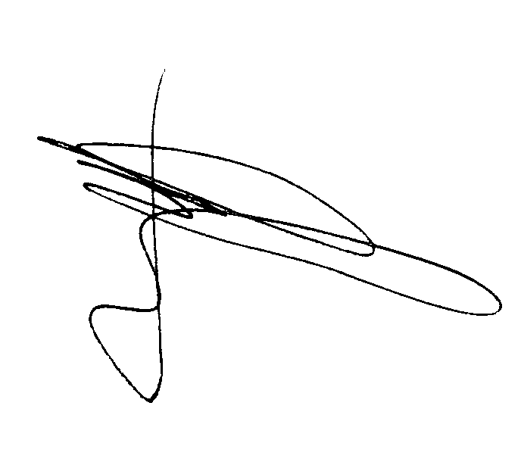 Date 5 July 2021
Deputy Upper Tribunal Judge Sills
Direction regarding anonymity – Rule 14 of the Tribunal Procedure (Upper Tribunal) (Immigration and Asylum Chamber) Rules 2008
Unless and until a tribunal or court directs otherwise, the Appellant is granted anonymity. No report of these proceedings shall directly or indirectly identify them or any member of their family. This direction applies both to the Appellant and the Respondent. Failure to comply with this direction could lead to contempt of Court proceedings.
Signed Date 5 July 2021
Judge of the First-tier Tribunal Sills
Deputy Upper Tribunal Judge Sills

