

Upper Tribunal
(Immigration and Asylum Chamber) Appeal Number: PA/02799/2017

THE IMMIGRATION ACTS

Heard at Birmingham | Decision & Reasons Promulgated
On 8 October 2018 | On 26 October 2018

Before

DEPUTY UPPER TRIBUNAL JUDGE McCARTHY

Between

rizgar [m]
(anonymity direction NOT MADE)
Appellant
and

THE SECRETARY OF STATE FOR THE HOME DEPARTMENT
Respondent

Representation:
For the Appellant: Mr M Brooks, instructed by Braitch RB Solicitors, Wolverhampton
For the Respondent: Mr S Whitwell, Senior Home Office Presenting Officer

DECISION AND REASONS
- On 23 August 2018, my decision finding there was legal error in the decision and reasons statement of FtT Judge Chapman was issued.
- At that time, with the agreement of the parties, I decided the decision should be remade in the Upper Tribunal because the issue centred on the proper application of country guideline decisions in respect of whether it would be unduly harsh to expect the appellant to relocate to the KRG.
- In preparation for the resumed hearing, I gave the parties liberty to provide further evidence if it was received 14 clear calendar days before the resumed hearing.
- The appellant has provided further evidence. His witness statement of 21 September 2018 changes his protection claim in two ways. First, he claims his mother and brother who were living in Kirkuk have been displaced as a result of the Kurdish independence referendum that took place in September 2017, which is after the First-tier Tribunal determined his appeal. If the appellant has no one in Kirkuk who can help him obtain a CSID, then his claim regarding undue hardship may be strengthened.
- Second, the appellant claims that instability in the KRG means those whom he fears might locate him if he were to relocate to that part of Iraq. The instability of the KRG and the risks facing the appellant in that region is a new factor and is not related solely to the issue of internal relocation.
- Mr Whitwell was concerned that to proceed on this revised factual matrix in the Upper Tribunal would be contrary to the Senior President’s practice directions on when to remit an appeal because of the need to make substantive factual findings. He added that the Secretary of State was at a disadvantage because the country expert report was not submitted in accordance with directions and it would be appropriate to have some time for a presenting office to review the case in light of the new evidence so as to properly prepare the case.
- Mr Brooks accepted his instructing solicitors had not complied with my directions. He accepted they only wrote requesting more time a week after the deadline and provided no reasonable explanation for the failure. He acknowledged what Mr Whitwell said regarding remitting this appeal to the First-tier Tribunal.
- Having listened to the application and arguments, I decided to revisit my decision not to remit the appeal to the First-tier Tribunal. Given the further evidence now available, it is no longer appropriate to retain this case in the Upper Tribunal. Although I do not condone the failure of the appellant’s solicitors in not complying with directions, the evidence presented has to be admitted given it is material to the future conduct of the appeal. Looking at the case in the round, it is necessary to remit this appeal to the First-tier Tribunal.
- However, I do so with the following directions. The findings of Judge Chapman at paragraph 40 are preserved. For that reason, it is appropriate that the remitted appeal is heard by me sitting in my capacity as a First-tier Tribunal. I indicated that I would arrange for a listing on the first available date after 28 days to give the respondent to consider the expert report and prepare the remitted appeal.

Notice of Decision
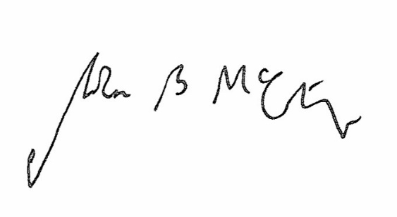
The appeal is remitted to the First-tier Tribunal subject to the directions in paragraph 9 above.

Signed Date 8 October 2018

Judge McCarthy, A Deputy Judge of the Upper Tribunal

