

Upper Tribunal
(Immigration and Asylum Chamber) Appeal Numbers PA/10504/2018

THE IMMIGRATION ACTS

Heard at Manchester | Decision and Reasons Promulgated
On 22 June 2021 | On 09 September 2021

Before

Upper Tribunal Judge Bruce
Deputy Upper Tribunal Judge Sills

Between

HB
(ANONYMITY DIRECTION MADE)
Appellant
and

SECRETARY OF STATE FOR THE HOME DEPARTMENT
Respondent

DECISION AND REASONS

Representation:
For the Appellant: Mr Royston, of counsel instructed by Broudie Jackson Canter
For the Respondent: Mr Bates, Senior Home Office Presenting Officer
Introduction
- On 26 April 2019, the Upper Tribunal (UT) found an error of law in relation to the earlier decision of the First Tier Tribunal (FTT) dated 3 October 2018. UT Judge Coker found that the FTT failed to make a lawful determination of the question of whether A could obtain a Civil Status Identity Document (CSID). This is the issue we must consider.
Factual Background
- A is an Iraqi national, born on 1 January 1990. He arrived in the UK on 22 July 2015 and claimed asylum. The basis of his asylum claim was as follows. He claimed his father was a Major in the Ba’ath Party and involved in the Anfal Operation against Kurds. He was killed in 2003. He was granted asylum in Italy in 2006 but returned to Iraq in 2010 on the promise that someone called Sheik Abdullah Zubaidi was able to protect him. When this person passed away A began to receive threats from groups including Asa’ib Ahl Al-Haq (AH). He fled Jalawla in June 2014 on the approach of ISIS and went to a camp in Jabara. A was kidnapped by AH and tortured. He was able to flee Iraq in July 2014. He feared return to Iraq due to his father’s role in the Ba’ath Party and as someone who had converted to Christianity.
- The FTT found A’s claims to have been targeted because of his father’s activities with the Ba’ath Party, to have been kidnapped by AH, and the manner of his departure, not to be credible. The FTT also rejected his claims to be a Christian and not to have contact with his family.
- The FTT accepted that A was from Jalawla, which is in the Diyala Governate. In line with the applicable country guidance at the time, the FTT accepted that as Jalawla was a contested area, A would not be safe there as per Article 15(c) of the Qualification Directive.
- The FTT then considered the matter of internal relocation and accepted that a CSID was essential for A to be able to survive on return. The FTT accepted that A did not presently have a CSID in his possession and seemed to accept this had been taken by the agent who had facilitated his journey to Europe. The FTT accepted that A could not safely return to Jalawla to renew his CSID. The FTT however found that A likely knew the relevant book and page number that would enable his civil registration details to be found, and thus for a CSID to be obtained through the Iraqi Embassy in London. The FTT found that he could alternatively obtain a CSID by proxy from Iraq with the assistance of his family there. A could thus obtain a CSID, and safely and reasonably relocate to the Iraqi Kurdish Region (IKR).
- A was granted permission to appeal and UT Judge Coker found as follows. The FTT had erred in its analysis of whether A could obtain a CSID through the Iraqi Embassy or in Iraq by use of a proxy. The FTT had failed to take a material matter into account, namely the uncontested evidence of Dr Fatah, accepted in the country guidance case of AAH (Iraqi Kurds – internal relocation) (CG ) [2018] UKUT 212, about the difficulties of obtaining a CSID, in particular from the embassy in London. Judge Coker concluded that the FTT’s assessment on this point was thereby flawed and set aside the decision insofar as it related to A’s ability to obtain a valid CSID.

The Hearing
- I kept a detailed note in the hearing in the record of proceedings. The parties agreed that events have moved on since Judge Coker’s decision of 26 April 2019. The current guidance case is SMO, KSP & IM (Article 15(c); identity documents) Iraq CG [2019] UKUT 00400 (IAC). The findings in that case indicated that A’s home area is no longer contested, but also found that as a general matter, it was necessary for an individual to have either a CSID or an Iraqi Nationality Identity Document (INID) in order to live and travel within Iraq without encountering treatment or conditions which are contrary to Article 3 ECHR. This meant that the first issue for the Tribunal to determine remained whether A could obtain a CSID or INID prior to return, and if not, whether his return would result in a breach of his ECHR Article 3 rights. If the Tribunal found that any absence of documents would not lead to a breach of his ECHR Article 3 rights, it was agreed that the Tribunal would need to revisit the issue of generalised violence in his home area.
- Mr Bates applied for an adjournment on the basis that there was a further country guidance case pending before the UT which will once again consider the issue of the CSID and the INID in Iraq. The Tribunal refused the application for the following reasons. First, there has already been very significant delay in A’s appeal. The error of law hearing took place in April 2019, so over two years and two months ago. Second, the final hearing for the country guidance had not yet been listed. Hence, the date of promulgation was unclear and likely to be some months away. Such further delay was not in the interests of justice.
- A relied upon an additional bundle of 28 pages. Mr Royston relied on written submissions and sought to rely on a document in Arabic which appeared to be from the Iraqi government website. It was accompanied by some form of automated translation which he stated showed that the INID system had been in operation in A’s home area since 16 April 2019. If that were the case, it would mean that A would have to attend in person to obtain an INID. He would not be able to obtain a replacement CSID. Mr Bates understandably objected to the admission of this translation in the form provided. He did not however object to a translation being carried out by a suitably qualified professional after the hearing. In the circumstances, the Tribunal directed that A file and serve a certified translation within 14 days of the hearing, with the Respondent having a further 7 days after that to file and serve any response to the translation. A filed a two-page translation in compliance with directions. As far as the panel is aware, no further submissions were made by the Respondent.
- It was agreed that the following relevant findings from the FTT had been preserved. A’s account of risk arising from his father’s Ba’ath Party activities was not credible. A was from Jalawla. A knew the volume and page reference from the Family Book in Iraq. A had given his CSID to the agent whilst travelling to the UK and so no longer had it. A’s claim to have no contact with his family was not credible.
- We heard oral evidence from A principally on the issue of his contact with his family in Iraq. The parties’ positions can be summarised as follows. Mr Bates accepted that to obtain an INID, A would have to attend in person. He submitted that A was not a credible witness and was in contact with family in Iraq who could assist him to obtain a CSID if they were still being issued in his home area. In the alternative, while the Iraqi Embassy would not issue a CSID, with his family’s assistance he could obtain a Registration Document (1957) from the Embassy. He could use this to travel through roadblocks to his home area and then obtain his INID there.
- Mr Royston argued that the additional documents submitted showed that the INID was now operational in A’s home area and so A would need to attend in person to obtain an INID and would not be able to obtain a CSID even if he had family assistance. In the alternative, A had lost contact with his family in Iraq and so they would not be able to assist him to obtain a replacement CSID in Iraq. R’s own CPIN accepted that A would not be able to obtain a replacement CSID in the UK. There was no evidence to suggest that A would be able to use a Registration Document (1957) to travel safely to his home area. Hence A could not obtain a CSID or INID prior to returning to his home area and could not safely travel to his home area without one of these documents.
- Both representatives relied on the country guidance of SMO in relation to the risk of generalised violence in A’s home area and the issue of internal relocation to the IKR if it were to be found that A was not at risk on return due to the absence of documentation.
Legal Framework
- The appeal before us now relates only to A’s claim for humanitarian protection. Paragraph 339 of the Immigration Rules state that a person will be granted Humanitarian Protection if the provisions of that paragraph apply. The burden of proof is upon the appellant. The standard of proof is the same as in an asylum claim, a reasonable degree of likelihood, which can also be expressed as a reasonable chance or a serious possibility. In assessing whether an applicant is a person entitled to Humanitarian Protection we must take into consideration the relevant provisions of the Qualification Regulations and the Immigration Rules.
Findings
- We consider first whether A could obtain a CSID from the Iraqi Embassy in the UK. In view of the position taken by R in the Country Policy and Information Note Iraq: Internal relocation, civil documentation and returns of June 2020 (CPIN) that it was ‘highly unlikely’ that an individual would be able to obtain a CSID from the Iraqi Embassy (para 2.6.16), we find that it is reasonably likely that A would not be issued with a CSID by the Iraqi Embassy.
- We next consider whether A could obtain a CSID with the assistance of family in Iraq. The first matter we must consider is whether the CSID has been replaced by the INID in A’s home area. The headnote of SMO states:
The likelihood of obtaining a replacement identity document by the use of a proxy, whether from the UK or on return to Iraq, has reduced due to the introduction of the INID system. In order to obtain an INID, an individual must attend their local CSA office in person to enrol their biometrics, including fingerprints and iris scans. The CSA offices in which INID terminals have been installed are unlikely – as a result of the phased replacement of the CSID system – to issue a CSID, whether to an individual in person or to a proxy. The reducing number of CSA offices in which INID terminals have not been installed will continue to issue CSIDs to individuals and their proxies upon production of the necessary information.
- We have considered the documents filed and served by A after the hearing in accordance with directions. They consist of two translations by a suitably qualified translator. They both appear to be translations of pages from the Iraqi government website. The first document is titled ‘The inauguration National Card for the Habhab Department of Status in Diyala province’. We understand the first document as stating that on 14 March 2018 the unified National Card terminal was opened within the Habhab Civil Status Department in Diyala governorate. The original in Arabic does not appear to have been provided at the hearing or subsequently. The second document is titled ‘The province of Diyala commenced using the system of National Card in Jalawla Civil Status Department’. It clearly states that on 16 April 2019 the ‘Department of National Card’ was opened in Jalawla, Diyala province and that people’s applications would now be processed according to electronic booking. We are satisfied that the original in Arabic of this second document was provided at the hearing as it contains reference to the same date, namely 16 April 2019. We are satisfied that this second document, that specifically refers to Jalawla, establishes that the INID is now in operation in A’s home area. As a result, we accept that CSID’s will no longer be issued in A’s home area, and that A can only obtain an INID by attending the ‘Department of National Card’ in his home area in person.
- The guidance from SMO at para 11 of the headnote is that, as a general matter, it is necessary for an individual to have either a CSID or an INID in order to live and travel within Iraq without encountering treatment or conditions which are contrary to Article 3 ECHR. As noted, Mr Bates submitted that A could obtain a Registration Document (1957) from the Embassy in the UK and use this to travel to his home area and obtain an INID. SMO does not suggest that the Registration Document (1957) can be used to safely travel through Iraq. Mr Bates relied upon R’s CPIN on civil documentation referred to above. We have considered what the CPIN states about the Registration Document (1957). It appears the Embassy will issue this document, and this can then be used to apply for other documents (see 2.6.15 and Annex I). The CPIN does not suggest that the Registration Document (1957) would assist A in passing through checkpoints, or mean that A would be able to travel safely from his point of return to his home area in Jalawla where he would need to apply for his INID. We therefore find that as per SMO, A requires either a CSID or INID to travel safely from his point of return, whether Baghdad or the IKR, to his home area. He has neither of these documents at present. As A cannot obtain a CSID, and can only obtain the INID in person in his home area, he cannot travel from his point of return to his home area without a risk of serious harm and a breach of his ECHR Article 3 rights. We therefore allow his appeal on humanitarian protection grounds.
Notice of Decision
The Appellant’s appeal against the refusal of his protection claim is allowed on humanitarian protection grounds.
Signed 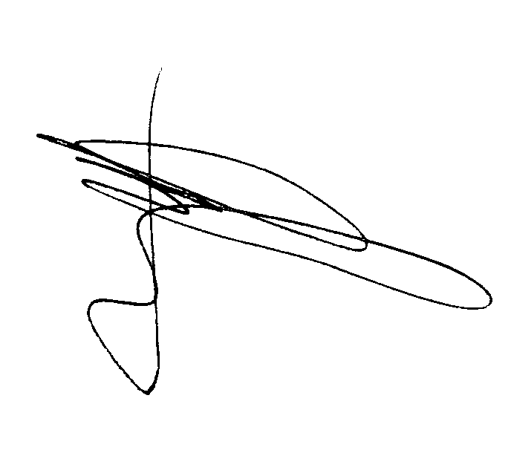 Date 31 August 2021
Deputy Upper Tribunal Judge Sills

Direction regarding anonymity – Rule 14 of the Tribunal Procedure (Upper Tribunal) (Immigration and Asylum Chamber) Rules 2008
Unless and until a tribunal or court directs otherwise, the Appellant is granted anonymity. No report of these proceedings shall directly or indirectly identify them or any member of their family. This direction applies both to the Appellant and the Respondent. Failure to comply with this direction could lead to contempt of Court proceedings.
Signed Date 31 August 2021
Deputy Upper Tribunal Judge Sills

