
IAC-FH-CK-V1

Upper Tribunal
(Immigration and Asylum Chamber) Appeal Number: DA/02512/2013

THE IMMIGRATION ACTS

Heard at Field House | Decision & Reasons Promulgated
On 12th October, 2015 | On 29th January, 2016

Before

Upper Tribunal Judge Chalkley

Between

THE SECRETARY OF STATE FOR THE HOME DEPARTMENT
Appellant
and

Wlodzimierz Umaniec
(ANONYMITY DIRECTION NOT MADE)
Respondent

Representation:
For the Appellant: Mr I Jarvis, Senior Home Office Presenting Officer
For the Respondent: Ms Keelin McCarthy

DECISION AND REASONS
1. The appellant was born on 28th March, 1986 and is a citizen of Poland.
2. On 16th October, 2012 he pleaded guilty to and was convicted of causing criminal damage by Camberwell Magistrates’ Court and on 13th December, 2012 he was sentenced by His Honour Judge R Chapple at Inner London Crown Court to two years’ imprisonment.
3. The appellant first arrived in the United Kingdom in February, 2009 to live, work and study and build professional connections. He had previously obtained an arts degree in Poland.
4. Following his conviction the respondent believed that the appellant would pose a genuine, present and sufficiently serious threat to the interests of public policy were he to be allowed to remain in the United Kingdom and concluded that his deportation was justified under Regulation 21 of the Immigration (European Economic Area) Regulations 2006. The respondent concluded that under Regulation 19(3)(b) he should be removed and made an order in accordance with Regulation 24(3) requiring him to leave the United Kingdom and prohibiting him from re-entering while the order was in force.
5. The appellant appealed the respondent’s decision and his appeal was heard by a panel of the First-tier Tribunal (Judge M P Keane sitting with Judge S J Clarke).
6. The panel very clearly took some considerable time and effort over the appeal and in their determination, promulgated on 8th June, 2015, allowed his appeal.
7. Curiously, in paragraph 44 of their determination, the panel said that they allowed the appeal under the Immigration Rules and “human rights”. However, it is clear from paragraphs 42 and 43 (see below) that the panel actually allowed the appeal under the 2006 Immigration (European Economic Area) Regulations 2006 (“the Regulations”).
8. Dissatisfied with that decision, the respondent submitted lengthy grounds of appeal. Those grounds of appeal are set out in full at Appendix A of this determination.
9. Deputy Upper Tribunal Judge Archer granted permission to appeal on 7 September, 2015 and in doing so said this:-
“I find that it is arguable that the First-tier Tribunal did not make findings in relation to key issues arising from cross-examination, the police and prison evidence and the pre-sentence and OASys Reports (paragraphs 9 – 19 of the grounds). In addition, the decision incorrectly states at paragraph 30 that the appellant was released in February 2012 and at paragraph 44 the appeal is incorrectly allowed under the Immigration Rules. Permission is granted on all grounds.”
10. As paragraph 1 of the grounds suggests, the date of the appellant’s plea and sentence was 2012, not 2013. This is an unfortunate error but I do not believe that it is in any way material to the outcome of the appeal. Mr Jarvis argued that it was material but for the reasons which follow below, I am satisfied that it was not.
11. I believe that the error was in fact a typing error.
12. In respect of the first ground Mr Jarvis suggested that at paragraph 30 the panel made an error by concluding that the appellant had been exercising his treaty rights since his release from prison in 2012. He argues that the appellant was in fact not released until 2014 and this is material because of the period of time since the appellant’s release. However, it is clear from the determination that the judge did very clearly take careful note of the judge’s sentencing remarks. They were aware that he was sentenced to a term of two years’ imprisonment. They also had regard to the NOMS1 assessment and the presentence report of 6th December, 2012 and also for the respondent’s letter of 6th December, 2013 (“the reasons for deportation letter”) as well as the appellant’s bundle which in various places refers to the appellant’s release from prison. For example, at paragraph 29 of the appellant’s statement on page 5 of his bundle the appellant starts to give details of his work history since leaving prison in February, 2014. On page 11 of the appellant’s bundle in paragraph 3 of his statement Mr Che Jeffrey speaks of only having known the appellant since his release from prison in February, 2014 and at pages 38 and 39 is a copy of an article written by the appellant for The Guardian newspaper published on 15th May, 2014 in which he refers to having spent a year and a half in prison. It is clear from the determination that the Tribunal have paid close attention to the evidence of the witnesses and in paragraph 28 of the determination they point out that they have also noted the written skeleton arguments relied on by each of the representatives. The respondent’s skeleton argument makes it clear in the chronology in Section B that the appellant was released on conditional release on 11th February, 2014.
13. Mr Jarvis suggests that a material misunderstanding of the length of time since the appellant’s release lies at the heart of the alleged positive impact that the appellant’s recent living circumstances and work have had on his attitude towards the public and the threat that he poses.
14. I do not believe that to be the case. The Tribunal could not possibly have thought that the appellant was released from custody any earlier than February, 2014 if, as they have paid careful attention to the witness statements and skeleton argument as indeed they indicate that they have. I believe that the reference in paragraph 30 of the determination to February, “2012” is again a typing error. I do not believe that it has had any material effect on the outcome of the decision. Counsel suggested that the error in the date referred to in ground 1 was a typing error and I agree with her.
15. The second challenge suggests that the panel’s approach to the legal questions at stake was confused. Mr Jarvis pointed out that the appeal was purported to be allowed by reference to the Immigration Rules and human rights although neither was raised by the appellant. He points out that the First-tier Tribunal specifically limit themselves to allowing the appeal on the basis that the appellant does not pose a “sufficiently serious threat to the interests of public policy”. He pointed out that there were no findings made by the panel to justify the conclusion that the appellant did not represent a sufficiently serious threat and that was a material error of law.
16. As Counsel suggested, a close examination of the determination discloses that the panel were not confused at all.
17. At paragraph 33 the Tribunal remind themselves of Regulation 21(5)(e) and considered, as they were invited to by Mr Jarvis, who appeared before the First-tier Tribunal as well as before me, to R v Pierre Bouchereau [1977] EUECJ R-30/77 and noted the reference by the court at paragraph 27 to the provisions of Article 3(2) of the Directive 2004/38. They also note in paragraph 28 which suggests that the existence of previous criminal convictions can only be taken into account insofar as the circumstances which gave rise to that conviction are evidence of personal conduct constituting a present threat to the requirements of public policy. They noted Mr Jarvis’ submissions that the appellant had not told the truth and had given inconsistent accounts to the Prison Service. Mr Jarvis pointed out to the Tribunal that the appellant had not shown credible evidence of remorse or changed his associations. Reliance was placed on Twitter account evidence but the Tribunal make it clear at paragraph 34 that they accepted the explanation given by the appellant of what he had said to the Prison Service and the testimony of one of his witnesses, Miss Piottrowska, regarding the housing arrangements of the appellant.
18. At paragraph 35 of the determination they took account fully of the very serious nature of the offence. The appellant had caused criminal damage to a painting worth between £5,000,000 and £9,000,000 having entered the Tate Modern Gallery with the premeditated intention of damaging a painting. He took with him pen and ink which he applied to the canvas of Mark Rothko having written “Vladimir Umainets, A Potential Piece of Yellowism”. They noted that the sentencing judge took the diminution in value as being £1,000,000, being 20% of the lower valuation of £5,000,000 on which the appellant was sentenced. They noted that restoration of the painting had been undertaken at considerable cost and that now a proximity allowance had been installed at an additional cost of some £6,000 a year.
19. The panel record at paragraph 38 of their determination that they were impressed by the evidence of Mr Joffrey, who is also an artist and uses the same agent as the appellant. Mr Joffrey was appalled at the commission of the offence and stated that his view represents that of the London artistic community. He does not know anyone who has condoned what the appellant had said. Mr Joffrey is not a member of the yellowist movement and made it clear that it has nothing to do with vandalism. A website he was referred to is apparently a “spoof site”.
20. Mr Joffrey expressed the opinion that it was 100% not likely that the appellant would ever undertake a similar action in the future. The appellant had lived with Mr Joffrey in his own home for a year now during which time they had met every day and had daily discussions. Even on an intellectual level the appellant would not commit the offence again. At paragraph 39 the Tribunal make it clear that they place no weight on the Twitter accounts, which had nothing to do with the appellant. The police officer who gave evidence made it clear that no investigation was carried out as to who was using the accounts and none of the websites with which this appellant was directly associated support or promote attacks on art in any way.
21. I believe that those findings do justify the panel’s conclusion that the appellant does not represent a sufficiently serious threat.
22. The third challenge suggests that the findings which the Tribunal made ignore the fact that the “@freeyellowism” Twitter account was owned by the appellant’s own agent. The challenge suggests that there was no evidence from or attendance by the appellant’s fellow founder of yellowism, Marcin Lodyga, nor the appellant’s agent, two people with whom the appellant is still involved and who represent the “artistic milieu that the appellant would immerse himself into again”.
23. Ground 3 asserts that the panel failed lawfully to engage with the prime part of the respondent’s case, namely that the associations with the appellant prior to his criminal offence from which both Marcin Lodyga and Cheryl Tulloch (the appellant’s agent) derive some benefit through infamy and press attention are still his associations now and in the absence of any contemporary evidence from either of them it was a highly material matter.
24. There was no evidence before the panel that the appellant’ associates Marcin Lodyga and Cheryl Tulloch in any way conspired with the appellant in the commission of the offence or encouraged it or indeed that they condoned it. Cheryl Tulloch is an artistic agent and also acts as an agent for Mr Jeffrey. The appellant himself says that he has little contact with Marcin Lodyga or Cheryl Tulloch. The “yellowism movement” does not, as far as I understand it, suggest that our great works of art should be damaged.
25. I have concluded that ground 3 does not disclose any material error of law on the part of the Tribunal.
26. The fourth challenge suggests that it was plainly unlawful for the First-tier Tribunal to find that the respondent had not discharged the burden in respect of the police evidence. The grounds assert that the First-tier Tribunal misunderstood or unlawfully ignored evidence. I have to say that I find there to be no merit at all in this challenge either. At paragraphs 40 to 43 the panel said this:-
“40. We accept that the letter written by the appellant to The Guardian newspaper and published by them on 15 May 2014 and found at pages 38 to 39 of the appellant’s bundle is unambiguous. The appellant repeats how it was wrong to deface the work of Rothko and it was a mistake. He shows insight into the consequences of his vandalism because it heaped ridicule upon him and turned the public against yellowism. The appellant acknowledges that the British public paid huge restoration costs. The appellant understands that he may write articles as a medium to comment upon the current state of the art world. The article ends with an apology to the Rothko family, to art enthusiasts and the British public and he is pleased the restoration project has finished and visitors can enjoy the Rothko masterpiece again.
41. It was submitted by Mr Jarvis that the appellant never challenged the NOMS as containing inaccurate evidence before the hearing itself. The appellant’s evidence has changed and there are only two witnesses at the hearing itself. The respondent also relies upon the inconsistent answers given by the appellant to the offender manager. The appellant explains that this resulted from a misunderstanding at the interview and we accept that he did not commit the offence in order to be housed. We find it implausible for the appellant to have committed the offence to obtain housing benefit because of the likelihood of imprisonment. The explanation given by the appellant at the time of the offence was that he was making an artistic statement and we accept this was the reason for his actions, and it was not to obtain housing benefits. We note in any event that the appellant is in receipt of stable housing.
42. It was submitted by Mr Jarvis that even taken at its lowest i.e. a low risk of reoffending of 17% because of the seriousness of the risk involved is very high. We were referred to the case of JZ (Colombia) v Secretary of State for the Home Department [2008] EWCA Civ 517. That case concerns a non-EEA national and the decision to deport under Article 33(2) of the Refugee Convention. Tuckey LJ emphasised that whether an appellant remains a ‘danger to the community’ is a question of fact and the word ‘danger’ permits the conclusion that although the risk may be low it is of something very serious. We have taken this into account when considering whether the appellant poses a sufficiently serious threat to the interests of public policy.
43. We note that the appellant is living in a stable arrangement with Mr Joffey and he has the support of the witness Ana Piotrowska. The appellant is continuing to work for the same restaurant. We accept his remorse. We have not placed weight upon the Twitter accounts which have not been shown to be linked to the appellant. When looking at the evidence relied upon by the respondent we do not conclude that the burden of proof has been discharged, and we find that the evidence advanced on behalf of the appellant permits us to conclude that he does not pose a sufficiently serious threat to the interests of public policy.”
27. The appellant cannot be held responsible for the actions of other individuals and, in any event, there was no evidence before the panel that Marcin Lodyga or Cheryl Tulloch have any criminal convictions. The panel noted at paragraphs 40 and 43 of their determination, that the appellant has completely distanced himself from yellowism and there was simply no evidence of there having been any similar attacks on works of art since. Neither of the witnesses were available to attend the hearing before the panel and the appellant made it clear in his statement that he has not seen either regularly.
28. In respect of the fifth challenge, I deal first with the fact that the appellant contributed work while he was in HM Prison Maidstone to an art show which advertised itself with reference to the appellant’s criminal damage. As Counsel pointed out, the appellant had no responsibility for the publicity of the exhibition; at the time he was serving his sentence in HMP Maidstone. He merely contributed a piece of his work. It was not shown whether or not the appellant became aware of the publicity material during the art show but he had no influence over it at all. Again, I do not believe that this discloses any error on a point of law. It might have been different had the respondent been in a position to demonstrate that the appellant had in some way been responsible for the publicity material used by the exhibition but that was not the case.
29. With regard to the presentence report I believe that paragraphs 40 and 41 deal with the issues raised. The panel were entitled to examine all the evidence and take a view on the overall risk posed by the appellant. They were clearly impressed by his article written for The Guardian and his acknowledgement as to the consequences of his vandalism. The comments made in the NOMS report were explained by the appellant as resulting from a misunderstanding of the interview and the panel accepted this. In any event they were entitled to find as they did.
30. I do not believe that the panel of the First-tier Tribunal made any material error of law in its determination and I therefore uphold it.
Notice of Decision
The appellant’s appeal is allowed under the Immigration (European Economic Area) Regulations 2006.
No anonymity direction is made.

Richard Chalkley
Upper Tribunal Judge Chalkley

Appendix A

Grounds of Appeal
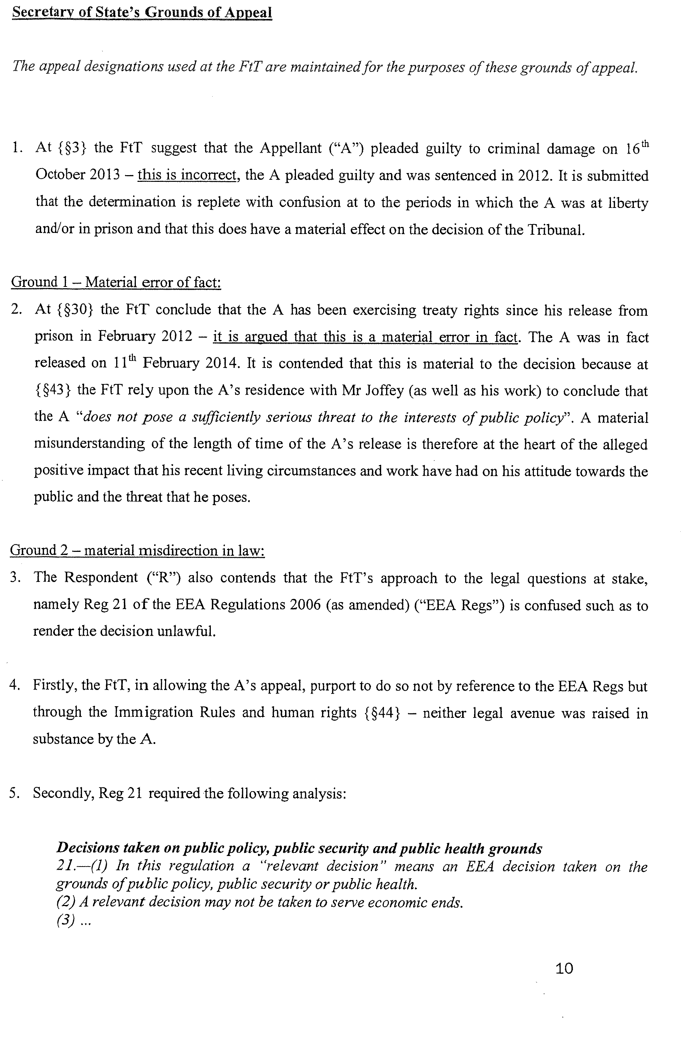
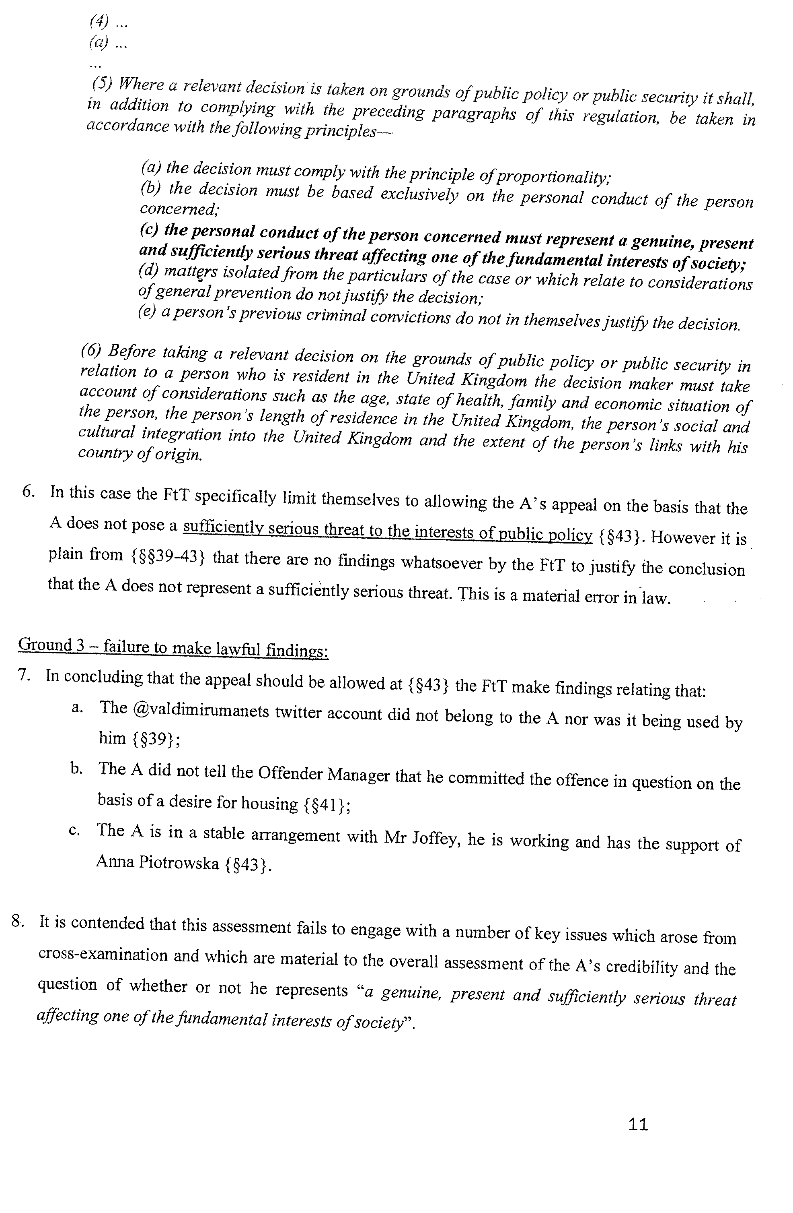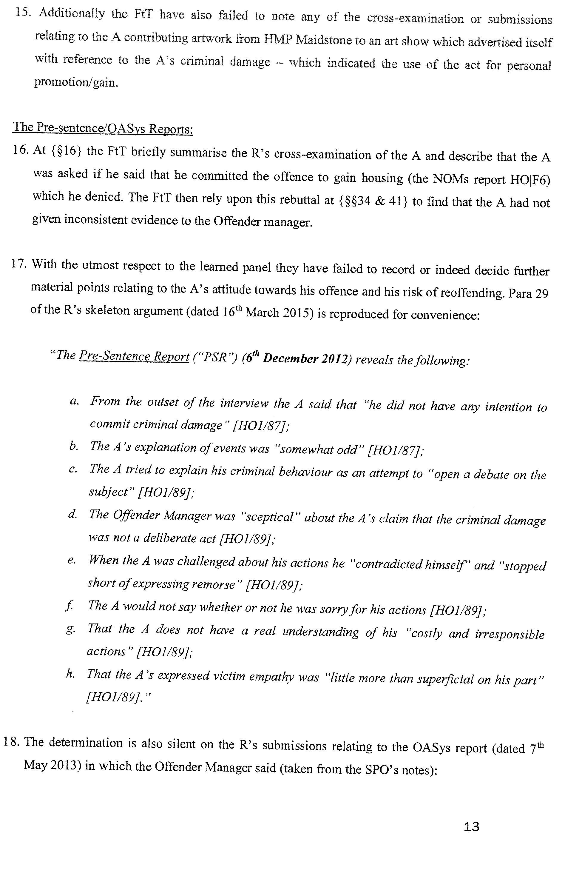
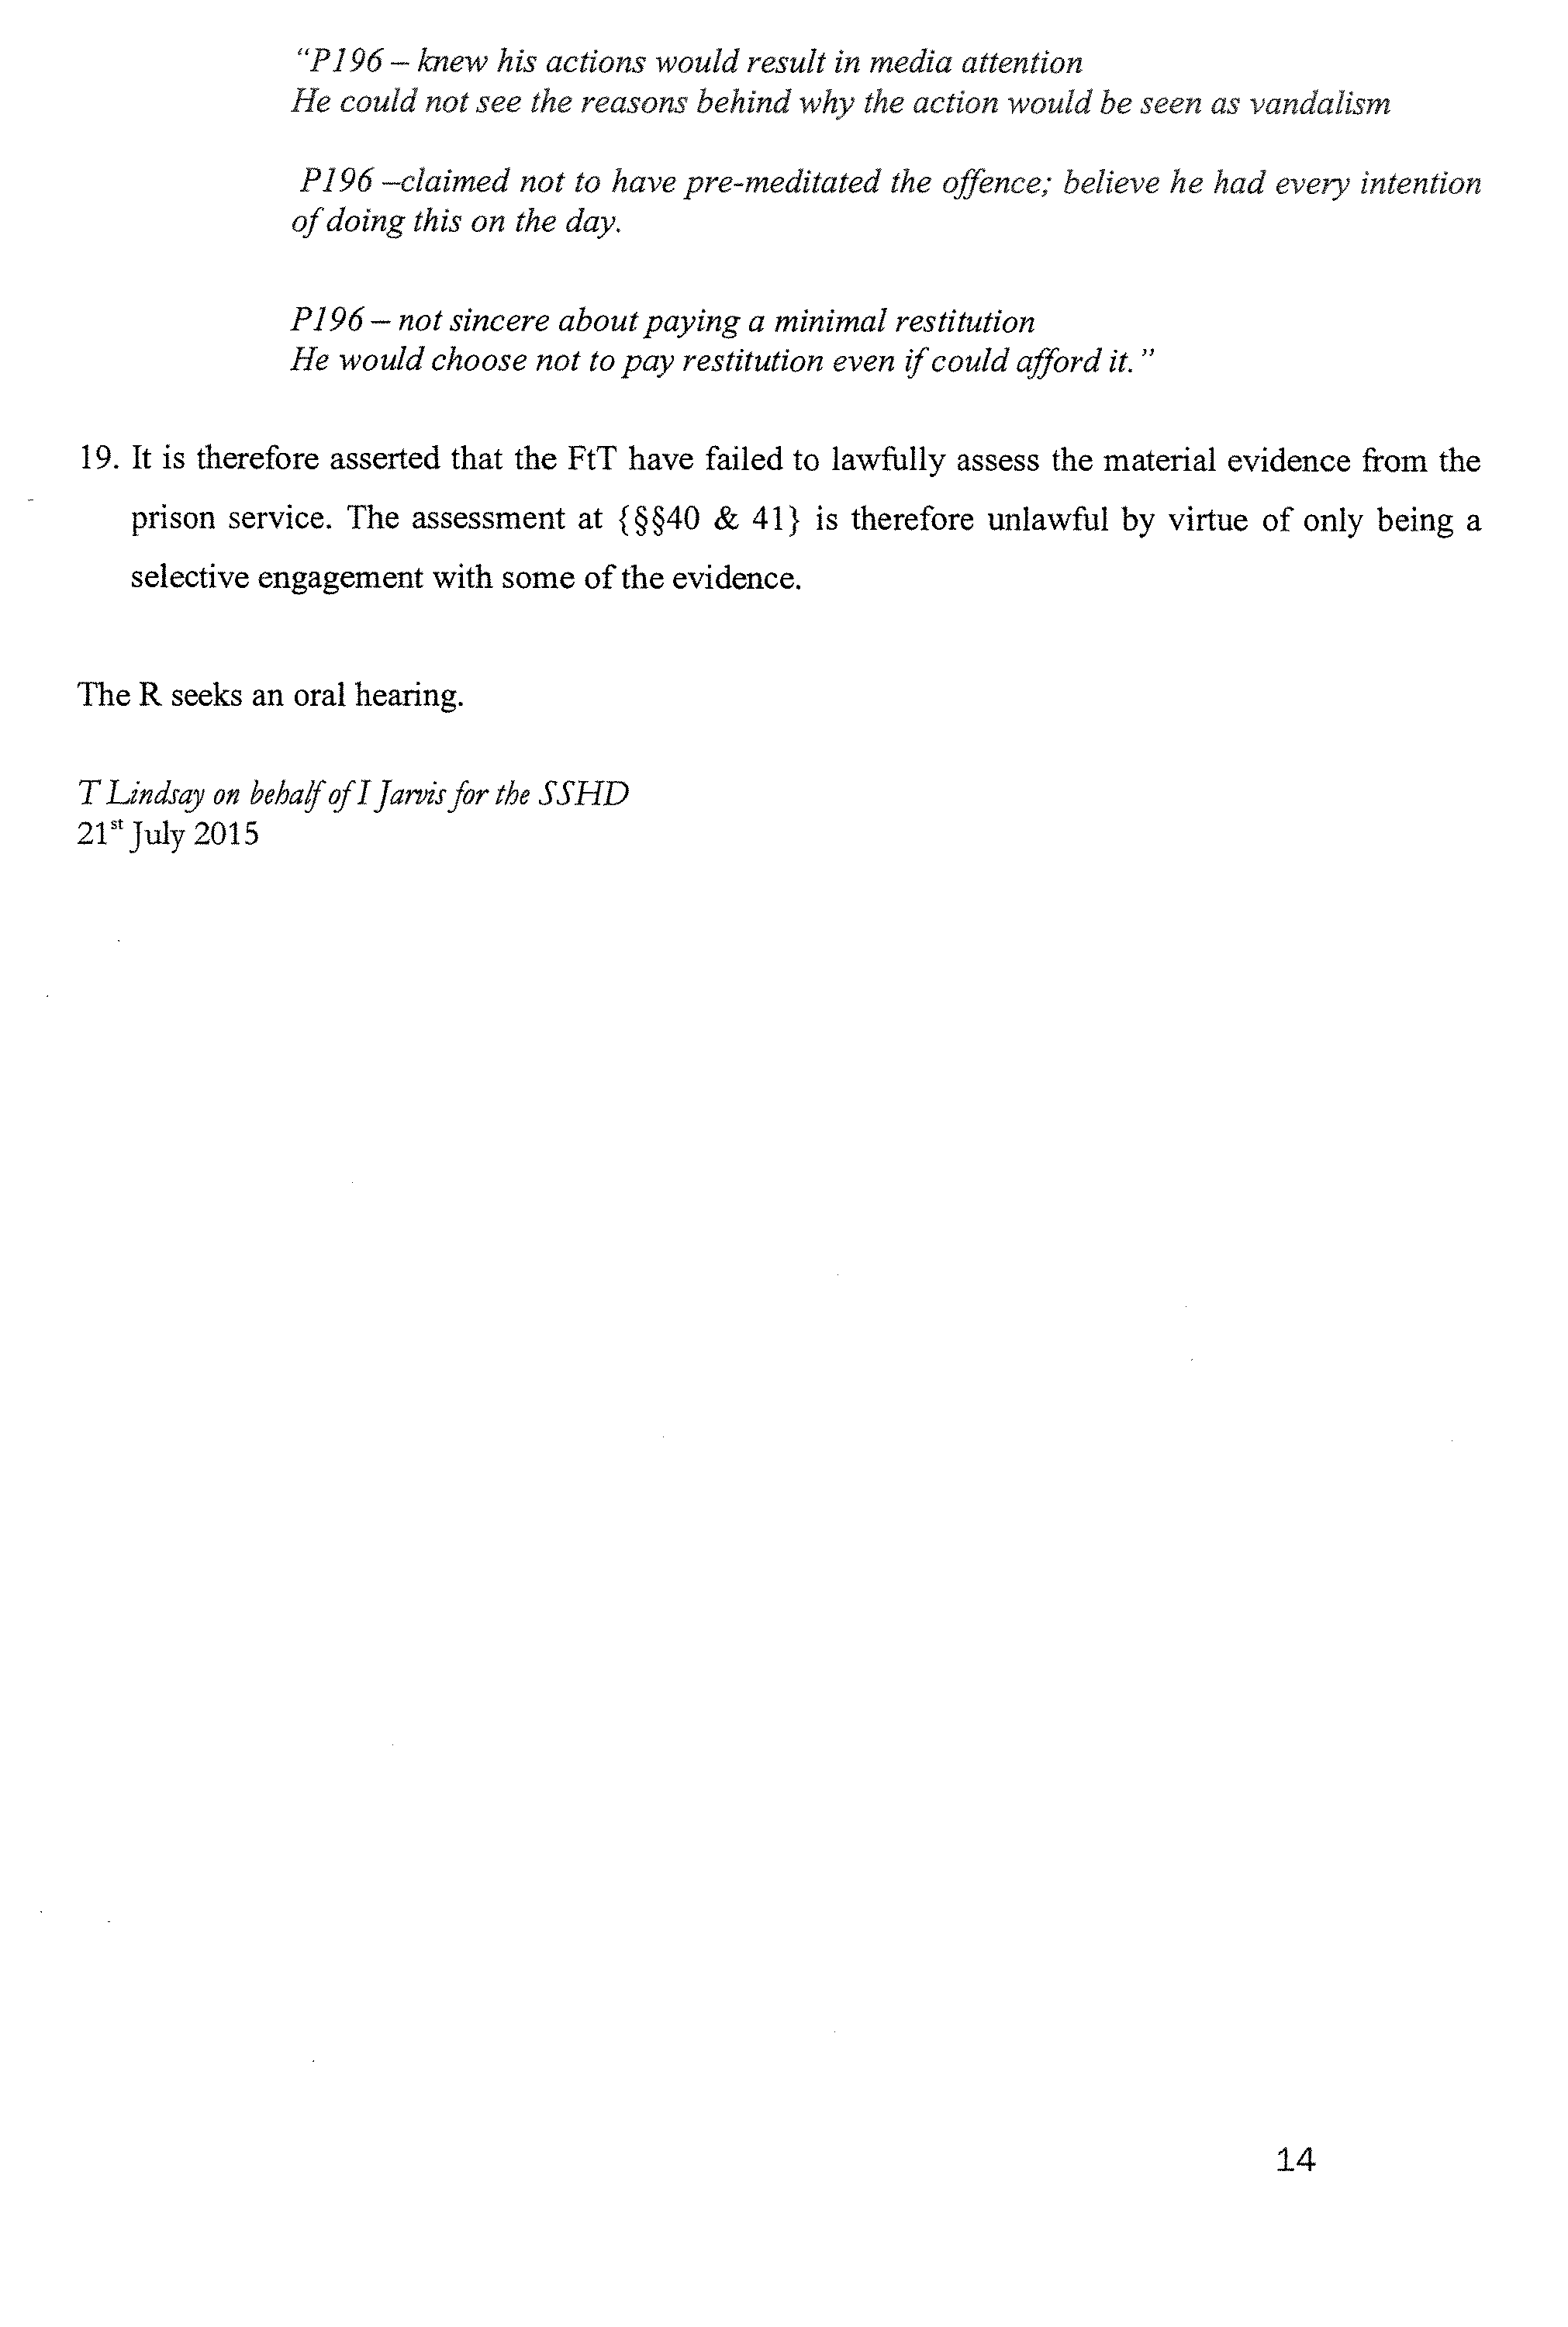
Richard Chalkley
Upper Tribunal Judge Chalkley

