

Upper Tribunal
(Immigration and Asylum Chamber) Appeal Number: EA/13648/2016

THE IMMIGRATION ACTS

Heard at: Manchester Civil Justice Centre | Decision and Reasons Promulgated
On: 4th June 2019 | On: 17th June 2019

Before

UPPER TRIBUNAL JUDGE BRUCE

Between

Dragan Planinic
(no anonymity direction made)

Appellant
And

The Secretary of State for the Home Department

Respondent

For the Appellant: Mr Wood, Immigration Advice Service (Manchester)
For the Respondent: Mr McVeety, Senior Home Office Presenting Officer

DECISION AND REASONS
- The Appellant is a national of Bosnia and Herzegovina born on the 10th August 1960. He appeals with permission the decision of the First-tier Tribunal (Judge D Alty) to dismiss his appeal under the Immigration (European Economic Area) Regulation 2016.
- This appeal is settled by consent. Following the decision of the European Court of Justice in Banger v United Kingdom C89/17 the Secretary of State accepts that the Appellant is entitled to a residence card confirming his right of residence as a Surinder Singh partner. The First-tier Tribunal erred in finding otherwise. Following the decisions in Khan v Secretary of State for the Home Department [2017] EWCA Civ 1755 and SM (Algeria) v ECO [2018] UKSC 9 the Secretary of State further accepts that the First-tier Tribunal was wrong to find, in the alternative, that it did not have jurisdiction to consider whether the Appellant qualified as an ‘extended family member’.
Decision
- The determination of the First-tier Tribunal contains a material error of law and it is set aside.
- The decision in the appeal is: “the appeal is allowed”.
- There is no order for anonymity.

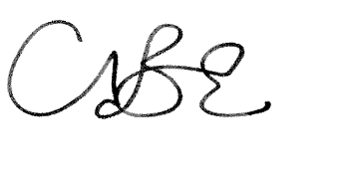

Upper Tribunal Judge Bruce
Dated 4th June 2019

