

Upper Tribunal
(Immigration and Asylum Chamber) Appeal Number: HU/00161/2018

Decision and Reasons Promulgated
On 21st December 2018

RANA ABDUL ALEEM
(ANONYMITY DIRECTION NOT MADE)
Applicant
v

SECRETARY OF STATE FOR THE HOME DEPARTMENT
Respondent

CONSENT ORDER, RULE 39

UPPER TRIBUNAL JUDGE O’CONNOR

Upon both parties agreeing, it is ordered that,
- the decision of the First-tier Tribunal is set aside for the reasons given in the grant of permission decision dated 21 November 2018 by First Tier Tribunal Judge Grant-Hutchinson;
- the appeal is remitted to the First-tier Tribunal to be heard afresh;
- the hearing on 10 January 2019 is vacated.

Signed Date 11 December 2018
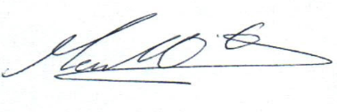
Upper Tribunal Judge O’Connor

Sent to the applicant, respondent and any interested party / the applicant’s, respondent’s, and any interested party’s solicitors on (date):

Hard copy sent:

