

Upper Tribunal
(Immigration and Asylum Chamber) Appeal Numbers: HU/00871/2017
HU/00876/2017

THE IMMIGRATION ACTS

Heard at Birmingham Justice Centre | Decision & Reasons Promulgated
On 13th May 2019 | On 16th May 2019

Before

DEPUTY UPPER TRIBUNAL JUDGE McCARTHY

Between

SECRETARY OF STATE FOR the HOME DEPARTMENT

Appellant
and

SURESH KHAN KHAND (1)
SHILA MALLA KHAND (2)

(anonymity order NOT MADE)

Respondent

Representation:

For the Appellant: Mr A Jesurum, Counsel instructed by Everest Law Solicitors
For the Respondent: Mr D Mills, Senior Home Office Presenting Officer

DECISION AND REASONS

- The Secretary of State appeals (with permission of Designated FtT Judge Woodcraft) against the decision and reasons statement of FtT Judge Ferguson that was issued on 21 June 2018.
- Although the original grounds were relatively numerous, Mr Mills conceded several points. He conceded that there had been no challenge to Judge Ferguson’s findings that the appellants enjoyed family life with the father of the first appellant, who had served in the Gurkha Battalion, and in this context accepted that the judge had been correct to consider historic injustice as a central factor when assessing proportionality under article 8 ECHR. Mr Mills focused on whether the alleged deception in the use of deception in relation to obtaining a necessary English language qualification was sufficient to outweigh the historic injustice arguments.
- I asked Mr Mills to explain in what ways Judge Ferguson had erred in assessing the evidence relating to deception. Mr Mills said it was a matter for me to decide and did not present any arguments although he did not concede the issues.
- I had no need to hear from Mr Jesurum because having had sight of his skeleton argument, and having consider the Secretary of State’s case as set out in the grounds and Mr Mills’s submissions, I was able to conclude that there is no legal error in Judge Ferguson’s decision and reasons statement. Judge Ferguson had regard to all the evidence relating to deception and carefully decided what weight to give it. He was entitled to his view and mere disagreement with his view does not reveal legal error. There has been no allegation any of Judge Ferguson’s findings or reasoning is perverse and, having examined it, I can see why; no such allegation would be sustainable.
- Because Judge Ferguson’s findings are sound, I am satisfied he was correct to find the allegation of deception is not sustainable. Therefore, the issue of deception is not a factor that adds to the public interest. The only conclusion I can reach, therefore, is that his decision is correct in law and there is no legal error because his proportionality assessment is more than adequate.
Decision
There is no legal error in the decision and reasons of Judge Ferguson.
I uphold his decision.
The Secretary of State’s appeal to the Upper Tribunal is dismissed.

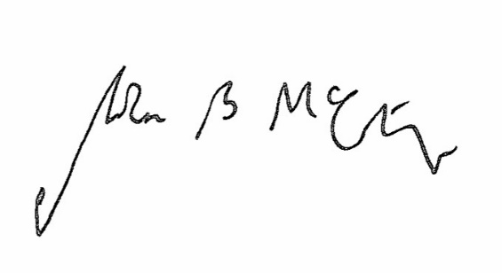

Signed Date 13 May 2019

Judge McCarthy
Deputy Judge of the Upper Tribunal

