

Upper Tribunal
(Immigration and Asylum Chamber) Appeal Number: HU/08667/2015

THE IMMIGRATION ACTS

Heard at Birmingham Employment Tribunal | Decision & Reasons Promulgated
On 12 January 2017 | On 24 January 2017

Before

DEPUTY UPPER TRIBUNAL JUDGE SYMES

Between

THE SECRETARY OF STATE FOR THE HOME DEPARTMENT
Appellant
and

DANIELLE SMITH
(ANONYMITY ORDER NOT MADE)
Respondent

Representation:
For the Appellant: Mr I Richards (Home Office Presenting Officer)
For the Respondent: Mr M Singh (One Immigration (Leicester))

DECISION AND REASONS
- This is the appeal of the Secretary of State against the decision of the First-tier Tribunal of 6 September 2016 allowing the appeal of Danielle Smith, a citizen of Ghana born 23 October 1990, against the Home Office refusal, dated 6 October 2015.
- The Respondent’s application of 26 June 2016 was based on her relationship with Kwaku Asiamah Adumatta: she argued that although she lacked immigration status to qualify for the five year route under Appendix FM, she could meet the “ten year” criteria as there were insurmountable obstacles to their relocation abroad, and as their son, Jedidah, born on 15 July 2014, was a British citizen, it would be unreasonable for him to relocate to Ghana. The immigration history supplied by the Secretary of State sets out that she entered the country as a visitor on 30 April 2007.
- The application was refused because it was not accepted that there was evidence establishing two years of cohabitation sufficient to qualify for consideration under the partner route within Appendix FM, and accordingly it was not accepted that she had established a parental relationship with a child. Given the length of time she had resided in Ghana before coming to the UK and her family and cultural ties in her country of origin, where she spoke the language, it was not accepted that there were any significant obstacles to her integration there.
- In her witness statement the Respondent explained that she had first entered the UK with her uncle in 2006, aged 16, her father having previously separated from her mother. She lived here with her uncle and his family in Kent, but following problems there, she moved out in 2008, aged 18, when she became homeless, until Gloria Banahene, who she described as a Good Samaritan, took her in. She first met her husband-to-be in March 2010 when he was studying at Coventry University; their relationship developed quickly and she moved in with him in May 2010, since when they had consistently cohabited at various addresses, and she moved to Leicester to live with Kwaku, and his mother and sister, in October 2013.
- The First-tier Tribunal did not accept the couple’s evidence of consistent cohabitation due to vagueness and discrepancies between and within their accounts, although it accepted that their relationship was genuine, given their evidence on this front was plausible, and that they had a British citizen child. The Judge found that there were no very significant obstacles to Ms Smith’s integration in Ghana, where she would be familiar with the country, traditions, culture and languages, but that the child’s potential loss of the benefits of its citizenship rendered the immigration decision unreasonable.
- Grounds of appeal by the Secretary of State argued that the First-tier Tribunal had erred in law by finding that the couple did not qualify for consideration under Appendix FM via the partner route, but nevertheless considering whether or not their son’s relocation to Ghana would be reasonable. The mother had no claim under the parent route.
- Judge Dineen granted permission to appeal for the First-tier Tribunal to the Upper Tribunal on 25 November 2016 because the Judge had arguably not properly considered the requirements of the Immigration Rules.
- Before me, the parties were agreed that the appeal should be remitted for hearing afresh, on the basis that the Judge had wrongly approached the Rules: he had considered the parent route rather than the partner route, for which the Appellant did not qualify.

Findings and reasons
- I accept that the parties were correct in their own view of the case. This is an appeal where the First-tier Tribunal, in an overly succinct passage of reasoning, apparently considered that the Appellant was eligible for consideration under the parent route. However she was not so eligible, as she was in an extant relationship with her partner, the child’s father. Her claim was that she qualified under the ten-year route within Appendix FM for partners because it would not be reasonable to expect her British citizen child to relocate abroad.
- That error in itself might not have been determinative of the appeal, as the question of reasonableness arises under the partner ten-year route under Appendix FM just as it does on an assessment of the claim outside the Rules by reference to the statutory criteria set out in the Nationality Immigration and Asylum Act 2002. However, the single-line conclusion that relocation would be unreasonable because it would deprive the child of the benefits of nationality is insufficient to justify the appeal being allowed: as is clear from MA (Pakistan) [2016] EWCA Civ 705, wider public interest considerations than simply the best interests of the child must be taken into account when applying the reasonableness test, either within the exception under Appendix FM or outside the Rules having regard to section 117B(6 of the 2002 Act.
- The appeal of the Secretary of State is allowed. As there are no lawful relevant findings upon which to build, the matter is suitable for re-hearing in the First-tier Tribunal. I accordingly remit the appeal to that forum.
Decision
The decision of the First-tier Tribunal contains a material error of law. The appeal is remitted to the First-tier Tribunal.

Signed Date 12 January 2017

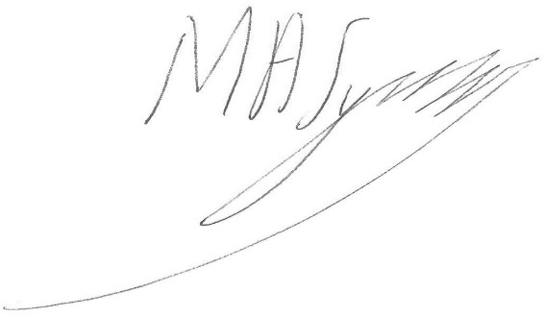

Judge Symes
Judge of the Upper Tribunal

