
Upper Tribunal
(Immigration and Asylum Chamber) Appeal Number: IA/01966/2015

THE IMMIGRATION ACTS

Heard at Glasgow | Determination issued
on 19 December 2016 | on 20 December 2016

Before

UPPER TRIBUNAL JUDGE MACLEMAN

Between

NAVEED ALAM
Appellant
and

THE SECRETARY OF STATE FOR THE HOME DEPARTMENT

Respondent

For the Appellant: Mr C McGinley, of Gray & Co, Solicitors
For the Respondent: Mr M Matthews, Senior Home Office Presenting Officer

Notification of no valid appeal
- The appellant appeals against a determination by First-tier Tribunal Judge McGavin, dismissing his appeal against refusal of a residence card as an extended family member under the “EEA Regulations”.
- In light of Sala (EFMs: Right of Appeal) [2016] UKUT 00411 (IAC), the outcome of these proceedings is as follows. The appellant had no right of appeal. The FtT had no jurisdiction to hear the appeal, and erred in law by purporting to do so. Its decision is set aside. The decision substituted is that there was no valid appeal before the FtT.

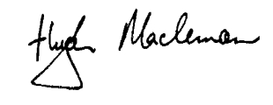

19 December 2016
Upper Tribunal Judge Macleman

