

Upper Tribunal
(Immigration and Asylum Chamber) Appeal Number: IA/03751/2013

THE IMMIGRATION ACTS

Decision made without a hearing at Field House | Determination Promulgated
on 5 September 2013 | on 23 September 2013

Before

UPPER TRIBUNAL JUDGE DAWSON

Between

VENERANDUS AMAUZOCHUKWU ELOKE

Appellant
and

THE SECRETARY OF STATE FOR THE HOME DEPARTMENT

Respondent

DETERMINATION AND REASONS

- Permission to appeal has been granted to the appellant a national of Nigeria born 26 April 1978 against the decision of First-tier Tribunal Judge Snape who for reasons given in her determination dated 7 May 2013 dismissed the appellant’s appeal under the Immigration Rules and on human rights grounds.
- The decision by the Secretary of State was a combined decision to refuse to vary leave to enter or remain and a decision to remove dated 16 January 2013.
- The grant of permission to appeal is limited to extent that the Secretary of State’s decision to make removal directions under section 47 of the 2006 Act was not in accordance with the law. By way of response dated 14 June 2013 to that grant (which had been on 31 May 2013) the Secretary of State indicated that the appellant’s application was not opposed on the section 47 ground only and invited the tribunal to determine the appeal on the papers.
- In a memorandum and directions dated 19 June 2013 Upper Tribunal Judge O’Connor expressed his provisional view that subject to any representations to the contrary to be received by 26 June, the determination of the First-tier Tribunal should be set aside and the appellant’s appeal should thereafter be allowed to the limited extent that the Secretary of State’s decision to remove him is found to have been otherwise in accordance with the law. For the avoidance of doubt it was explained in that memorandum that the decision of the First-tier Tribunal made in relation to the appeal against the Secretary of State’s decision to refuse a variation of leave would stand.
- In a fax dated 21 June 2013 the appellant’s advisors indicated that they had no representations to make to the contrary and invited the Tribunal to set aside the determination of the First-tier Tribunal in accordance with the view expressed in the memorandum and directions.
- I therefore do so. I set aside the determination of the First-tier Tribunal insofar as the Tribunal failed to reach a decision on the Secretary of State’s decision to remove the appellant. I remake the decision and allow the appeal by the appellant against that decision.

Signed Date 23 September 2013
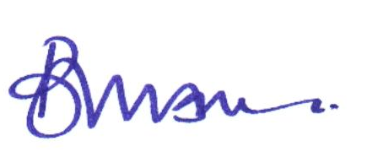

Upper Tribunal Judge Dawson

