

Upper Tribunal
(Immigration and Asylum Chamber) Appeal Number: IA/31526/2014

THE IMMIGRATION ACTS

Heard at Field House | Decision & Reasons Promulgated
On 17 June 2015 | On: 1 July 2015

Before

MR JUSTICE GREEN
(sitting as a Judge of the Upper Tribunal)

UPPER TRIBUNAL JUDGE LINDSLEY

Between

BATYR AMANOV
(ANONYMITY DIRECTION NOT MADE)
Appellant
and

THE SECRETARY OF STATE FOR THE HOME DEPARTMENT

Respondent

Representation:

For the Appellant: Mr Z Nasim, for the Appellant
For the Respondent: Mr L Tarlow, Home Office Presenting Officer

DECISION AND REASONS
1. The issue arising on this appeal is a short point of construction of the Immigration Rules 321A. In order to set the point into context it is necessary briefly to set out certain facts. The appellant entered the United Kingdom on 3 December 2010 as a Tier 4 (General) Student to undertake an English language course in London between January 2011 and January 2012. He undertook that course. It is alleged, however, that the TOEIC English test that he says he took on 24 February 2012 was in fact taken by a proxy and that the appellant therefore obtained that particular qualification by deception.
2. The appellant was then granted further extensions of leave to remain as a student. In September 2013 the appellant applied for leave to remain to enable him to attend a BSc (Hons) course at BPP University (“BPP”). This was granted on 24 October 2013 valid until 6 September 2016 as a Tier 4 Student. In 2014 he left the United Kingdom in order to return to his home country to obtain a replacement passport which had been stolen. He returned on 6 August 2014 and at the border was refused entry upon the basis that it had been found that the educational institution conducting the TOEIC course had been engaged in fraudulent procurement of certificates.
3. The notice of refusal of leave reads as follows:
“You hold a current UK residence permit ... as a Tier 4 (General) Student but I am satisfied that either false representations were employed or material facts were not disclosed for the purpose of obtaining the UKRP or a change of circumstances since it was issued has removed the basis of your claim to admission. The UKRP is not therefore effective. This is because despite your assertion that you took an English test on 22 February 2012 and the BPP College subsequently assessed your level in English themselves to enrol you for your current course in BSc Hons in business management and finance. Following an in depth investigation into activities at the test centre in question the Home Office have secured sufficient evidence for us to be able to conclude that your English test was taken by a substitute or proxy test taker. You have not sought entry under any other provision of the Immigration Rules. I therefore refuse you leave to enter the United Kingdom. I therefore cancel your continuing leave. If your leave was conferred by an entry clearance this will also have the effect of cancelling your entry clearance. The cancellation of your leave will be treated for the purposes of the Immigration Act 1971 and the Nationality, Immigration and Asylum Act 2002 as a refusal of leave to enter at a time when you were in possession of a current entry clearance.”
4. An appeal was lodged. It challenged the correctness of the factual allegation that the appellant had obtained a false certificate. However it also raised the point of law concerning the scope and effect of paragraph 321A of the Immigration Rules. The relevant parts of that rule are in the following terms:
“Grounds on which leave to enter or remain which is in force is to be cancelled at port or while the holder is outside the United Kingdom
321A. The following grounds for the cancellation of a person’s leave to enter or remain which is in force on his arrival in, or whilst he is outside, the United Kingdom apply:
(1) …
(2) false representations were made or false documents were submitted (whether or not material to the application, and whether or not to the holder’s knowledge), or material facts were not disclosed, in relation to the application for leave; or in order to obtain documents from the Secretary of State or a third party required in support of the application”.
5. In a nutshell the proposition of law which has been raised may be summarised as follows. For the purposes of Immigration Rules 321A(2) is leave to enter to be cancelled if false documents were submitted in relation to any application for leave or only if those documents were submitted in relation to the last application for leave to remain? The point is pivotal to the present appeal because the First-tier Tribunal found as a fact that if and insofar as the appellant did obtain a false certificate it was not relevant to or used in the context of either (a) the decision of BPP to admit the appellant to the degree course, or (b) the leave to remain granted on 24 October 2013.
6. Before considering the relevance of the point of law we should say something about the factual basis of the Secretary of State's decision. In the First-tier Tribunal’s judgment at paragraph [23] the following is stated:
“It is unclear from the above which application for further leave to remain is it is claimed that the TOEIC certificates were submitted in support of. I have not been provided with the CAS details or application form relating to that application. It may be that it was used in connection with the application which resulted in a grant of leave until 2 September 2013, although there is insufficient information or evidence before me to support such a finding.”
7. In consequence in paragraph [24] of the judgment the Tribunal proceeded to analyse the case in effect in the alternative upon the hypothesis that a false document had perhaps at some point been submitted to the respondent. It seems to us that there is real doubt as to whether the alleged false certificate was in fact used to obtain any leave to remain by this appellant at all as there was no such evidence before the First-tier Tribunal or us. However as to the legal point, the First-tier Tribunal stated in paragraph [24] as follows:
“In my view, paragraph 321A(2) relates to ‘the application’ which resulted in the current grant of leave, which the appellant is intended to entry the UK as a consequence of, not earlier applications resulting in previous grants of leave. Had the respondent intended the paragraph to have a broader reach then she could have substituted ‘an application’ for ‘the application’. As the appellant did not submit the TOEIC certificate concerned with his most recent application for leave, or rely upon it in any way in order to raise his CAS, paragraph 321A(2) cannot apply.”
7. We agree with the judge. We can summarise our reasons shortly.
8. First, the overarching context is evident from the heading to paragraph 321 of the Immigration Rules. The heading states “Refusal of leave to enter in relation to a person in possession of an entry clearance”. It is in our view clear that the context is a person who holds an extant or valid entry clearance. The same may be said to apply to the heading to paragraph 321A which states “Grounds on which leave to enter or remain which is in force is to be cancelled at port or while the holder is outside the United Kingdom”. The reference to “in force” is a reference to an extant or valid leave. All that follows in both of those paragraphs is being directed towards that specific extant leave.
9. Secondly, as the Judge observed, subparagraph (2) uses a definite article “the” not the indefinite article “a” or “an”. As such the application for leave must be “the “ leave which is extant at the relevant point in time and the false document must be used in connection with that leave.
10. Thirdly, elsewhere in Part 9 of the Immigration Rules in relation to refusals of entry clearance or leave to enter the United Kingdom the draftsperson has deployed the indefinite article “an”. Thus in paragraph 320(11) of the Immigration Rules the following is stated:
“11. Where the applicant has previously contrived in a significant way to frustrate the intention of the Rules by:
(iv) using deception in an application for entry clearance leave to enter or remain or in order to obtain documents from the Secretary of State through a third party required in support of the application (whether successful or not); and there are other aggravating circumstances such as absconding, not meeting temporary admission/reporting restrictions or bail conditions, using an assumed identity or multiple identities/switching nationality/making frivolous applications or not complying with the re-documentation process. “
(Emphasis added)
11. The use of the phrase “an application for entry clearance” is in context a reference to an application whenever made. This is in our judgment significant because it demonstrates that the word “the” in paragraph 321A of the Immigration Rules is deliberate and intended to be different to “an” because in the latter it is intended to refer to “an” application whenever made and in the former to the application which led to “the” leave in issue.
12. Fourthly, we note that in the judgment of the Upper Tribunal in Khaliq (Entry clearance – para 321) Pakistan [2011] UKUT 00350 (IAC) the Upper Tribunal made clear that under paragraph 321A of the Immigration Rules there had to be causality between the false document and the application for entry clearance: see paragraphs 20, 21 and 22. The judgment only makes sense if the false document was tendered in order to procure the extant leave which is at risk of being revoked.
13. For all these reasons we uphold the reasoning of the First-tier Tribunal judge and we reject this appeal.

Notice of Decision

The appeal is therefore dismissed.

No anonymity direction is made.

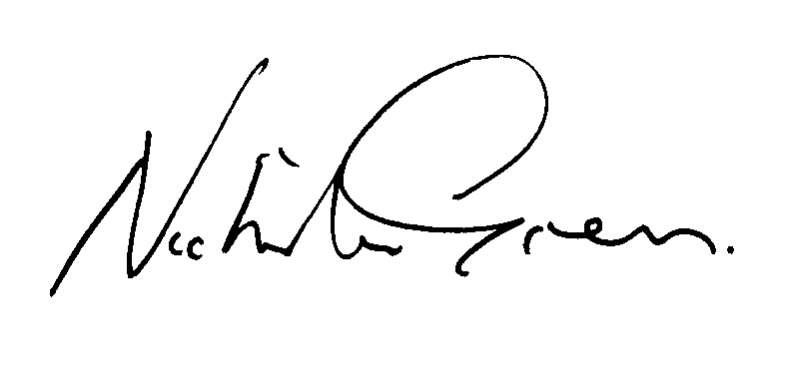

Signed Date 1st July 2015

Mr Justice Green

