

Upper Tribunal
(Immigration and Asylum Chamber) Appeal Number: IA/34725/2015

THE IMMIGRATION ACTS

At Field House | Decision Promulgated
On 20 March 2018 | On 21 March 2018

Before

UPPER TRIBUNAL JUDGE BRUCE

Between

Rana Muhammad Usman
(no anonymity direction made)

Appellant
And

Secretary of State for the Home Department

Respondent

DECISION AND REASONS
- The Appellant is a national of Pakistan born on the 28th September 1989. On the 8th June 2017 his appeal was dismissed by the First-tier Tribunal on human rights grounds.
- Permission was granted by Upper Tribunal Grubb on the 15th February 2018. Judge Grubb considered it arguable that there had been a procedural unfairness in the hearing before the First-tier Tribunal. It appeared from the file that unbeknownst to the Judge, the Appellant had made an application for an adjournment on the grounds of ill-health.
- By way of Rule 24 response dated the 13th March 2018 the Respondent indicated that she accepted that there had been a procedural irregularity. She invited the Upper Tribunal to set the decision of the First-tier Tribunal aside and to remit the matter for hearing de novo before a differently constituted First-tier Tribunal.
- The decision of the First-tier Tribunal (Judge J Bartlett) is therefore set aside by consent. The matter shall be remitted to the First-tier Tribunal for hearing de novo before a judge other than Judge Bartlett.
- I was not asked to make an order for anonymity and on the facts I see no reason to do so.

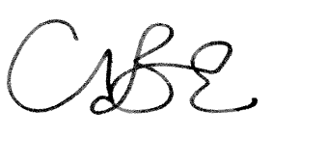
Upper Tribunal Judge Bruce
20th March 2018

