

Upper Tribunal
(Immigration and Asylum Chamber) Appeal Number: IA/39648/2014

THE IMMIGRATION ACTS

Upper Tribunal Bradford | Decision Promulgated
On 23 August 2015 | On 26 August 2015

Before

UPPER TRIBUNAL JUDGE CLIVE LANE

Between

SUKHWANT SINGH
Appellant
and

Secretary of State for the Home Department
Respondent

DECISION AND REASONS
- The first appellant is a citizen of India. I made directions in the following terms on 4 August 2015:
- It is arguable that the exercise of discretion to grant indefinite leave to remain in this instance lay with the respondent and not the First-tier Tribunal judge.
Directions
- I propose to set aside the First-tier Tribunal determination and to remake the decision allowing the appellant’s appeal to the limited extent that the matter is remitted to the Secretary of State for her to consider whether to grant the appellant indefinite leave to remain. If either party objects to that course of action, they must notify the Upper Tribunal in writing no later than 1600 hours on 21 August 2015.
2. I have received no response from either party.
NOTICE OF DECISION
The First-tier Tribunal decision is set aside. I have remade the decision. I allow the appellant’s appeal to the limited extent that the matter is remitted to the Secretary of State for her to consider whether to grant the appellant indefinite leave to remain.

Signed 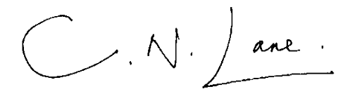
Upper Tribunal Judge CLIVE LANE

23 August 2015

