

Upper Tribunal
(Immigration and Asylum Chamber) Appeal Number: IA/46893/2013

THE IMMIGRATION ACTS

Before

UPPER TRIBUNAL JUDGE HANSON

Between

VICKY RUIZ FAMA
(anonymity direction not made)

Appellant
and

THE SECRETARY OF STATE FOR THE HOME DEPARTMENT

Respondent

NOTICE OF STATUTORY ABANDONMENT
- The determination of the First-tier Tribunal in relation to this matter was set aside on 22nd May 2014. A number of directions and interims hearing have occurred since in relation to the evidence.
- On 5th January 2015 the Respondent requested further time to consider the additional evidence following which a letter was written to the Appellants solicitors. A copy of the material parts of the letter is set out below.
- As a period of leave as been granted the appeal must be treated as abandoned. Section 104 (4A) Nationally, Immigration and Asylum Act 2002 stating:
“ An appeal under section 82(1) brought by a person whilst he is in the United Kingdom shall be treated as abandoned if the appellant is granted leave to enter or remain in the United Kingdom.”

- As the appeal must be treated as abandoned by the effect of the statutory provisions there is no longer an outstanding matter before the Upper Tribunal upon which a decision can or needs to be made. The matter is concluded.

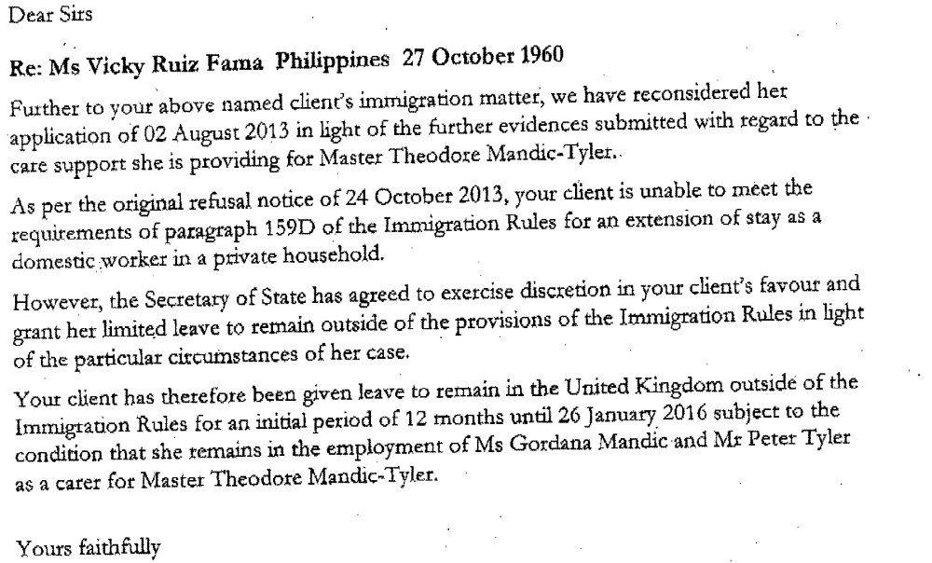

Decision

- The appeal is abandoned. There remains no extant matter upon which the Upper Tribunal is required to make a decision.

Signed……………………………………………….
Upper Tribunal Judge Hanson

Dated the 18th March 2015

