

Upper Tribunal
(Immigration and Asylum Chamber) Appeal Number: PA/02355/2018

JUDE [F]
Applicant
v

SECRETARY OF STATE FOR THE HOME DEPARTMENT
Respondent

CONSENT ORDER, RULE 39

UPPER TRIBUNAL JUDGE O’CONNOR

Upon both parties agreeing, it is ordered that,
- the decision of the First-tier Tribunal is set aside for the reasons given in the grant of permission decision dated 12 July 2018 by Upper Tribunal Judge Hanson;
- the appeal is remitted to the First-tier Tribunal;
- the hearing on 10 December 2018 is vacated.

Signed Date 5 December 2018

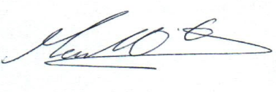
Upper Tribunal Judge O’Connor

Sent to the applicant, respondent and any interested party / the applicant’s, respondent’s, and any interested party’s solicitors on (date):

Hard copy sent:

