

Upper Tribunal
(Immigration and Asylum Chamber) Appeal Number: PA/02385/2018

THE IMMIGRATION ACTS

Heard at Birmingham Justice Centre | Decision & Reasons Promulgated
On 13 May 2019 | On 16 May 2019

Before

DEPUTY UPPER TRIBUNAL JUDGE McCARTHY

Between

ksa

(anonymity order continued)

Appellant
and

SECRETARY OF STATE FOR the HOME DEPARTMENT

Respondent

Representation:

For the Appellant: Mr M Uddin, Counsel instructed by Braitch RB Solicitors
For the Respondent: Mr D Mills, Senior Home Office Presenting Officer

DECISION AND REASONS

- The appellant appeals (with permission of FtT Judge Cruthers) against the decision and reasons statement of FtT Judge O’Brien that was issued on 9 May 2018.
- The First-tier Tribunal directed anonymity and because of the nature of the appeal and the vulnerability of the appellant it is appropriate to continue to order anonymity. The full terms of my order appear at the end of the decision and reasons statement.
- After hearing from Mr Uddin, Mr Mills conceded that the decision and reasons statement of FtT Judge O’Brien contained errors of law that requires it to be set aside.
- Given this concession, there is no need to go into detail about the legal errors that are present. It is sufficient to say that Judge O’Brien did not properly approach the evidence of the appellant’s social worker, foster carer and church minister, when considering his activities, bearing in mind: (i) the appellant was a child at the date his appeal was heard in the First-tier Tribunal, and therefore a vulnerable person, and it was unclear whether Judge O’Brien had proper regard to the relevant Presidential guidance; and (ii) the guidance about evidence of conversion given by the Inner House of the Court of Session in TF and MA v SSHD [2018] ScotCS CSIH 58, which although not binding on the Upper Tribunal sitting in England, is nevertheless persuasive.
- Because of the concession, I set aside the decision and reasons of Judge O’Brien. None of his findings are preserved.
- I considered whether I could remake the decision in the Upper Tribunal. Mr Uddin referred to new evidence, which will have to be assessed. That evidence is likely be relevant to the assessment of the appellant’s credibility, which Mr Mills says remains in issue.
- I decided, with the agreement of both representatives, that the appeal should be remitted to the First-tier Tribunal, to be heard by a judge other than Judge O’Brien.
Decision
There is legal error in the decision and reasons statement of FtT Judge O’Brien.
His decision is set aside.
The appeal is remitted to the First-tier Tribunal for a fresh hearing on all matters before any judge other than Judge O’Brien.

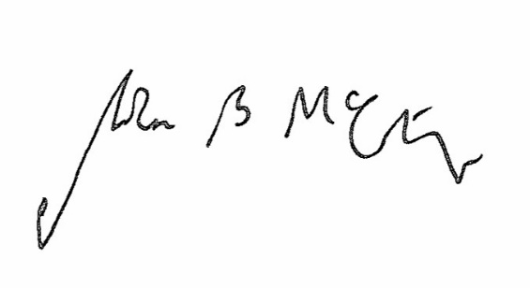

Signed Date 13 May 2019

Judge McCarthy
Deputy Judge of the Upper Tribunal

Order regarding anonymity
I make the following order. I prohibit the parties or any other person from disclosing or publishing any matter likely to lead members of the public to identify the appellant. The appellant can be referred to as “KSA”.

Signed Date 13 May 2019

Judge McCarthy
Deputy Judge of the Upper Tribunal

