

Upper Tribunal
(Immigration and Asylum Chamber) Appeal Number: PA/08998/2017

THE IMMIGRATION ACTS

Heard at Birmingham Employment Centre | Decision & Reasons Promulgated
On 8 October 2018 | On 25 October 2018

Before

DEPUTY JUDGE OF THE UPPER TRIBUNAL McCARTHY

Between

FEO
(anonymity direction MADE)
Appellant
and

THE SECRETARY OF STATE FOR THE HOME DEPARTMENT
Respondent

Representation:
For the Appellant: Ms E Rutherford, instructed by Braitch RB Solicitors
For the Respondent: Mr S Witwell, Senior Home Office Presenting Officer

DECISION AND REASONS
- It is appropriate to maintain the anonymity direction made by the First-tier Tribunal and I do so but by reference to rule 14(1) of the 2008 Upper Tribunal Procedure Rules. No person shall disclose the identity of the appellant without consent of the Tribunal.
- On 25 April 2018, the appellant was granted permission to appeal to the Upper Tribunal against the decision and reasons statement of First-tier Tribunal Judge Hawden-Beal that was issued on 22 March 2018. Judge Hawden-Beal decided the appellant was not a refugee from Cameroon or otherwise in need of international protection.
- The grounds of appeal raised two interrelated issues. First, whether Judge Hawden-Beal adequately dealt with the question of whether the appellant would be associate with people opposed to the Cameroonian regime because the father of her child was such a person. The grounds allege that Judge Hawden-Beal failed to consider the likelihood of the Cameroonian authorities asking questions about the father of her child, the father’s name appearing on the birth certificate, and thereby identifying the appellant’s relationship to him.
- As I announced at the hearing, this issue fails for two reasons. First, there is no clear evidence that Ms Rutherford canvassed this argument before Judge Hawden-Beal. The argument does not appear in the skeleton argument Ms Rutherford submitted to the First-tier Tribunal or in her submissions as recorded at paragraph 22 of Judge Hawden-Beal’s decision and reasons statement. Ms Rutherford said she could not recall exactly what she submitted at the hearing but her notes indicate that she intended to make submissions on this issue. Of course, Ms Rutherford acknowledges she could not give evidence about what happened at the hearing.
- Ms Rutherford submitted that, even if the argument had not been made, it was incumbent on Judge Hawden-Beal to have regard to the country information provided by the appellant. She argued that the country information revealed that it was reasonably likely the appellant would be questioned about her identify and such questions might include questions about the father of her child. This takes me to the second reasons why the appeal to the Upper Tribunal fails. Mr Witwell rightly took me to the background country information regarding the likelihood of the appellant being questioned. The strongest evidence is found in the US Department of State report from 2016. It describes how police and gendarmes often extorted bribes at roadblocks and checkpoints and harassed travellers. There were regular identification checks for security purposes. The evidence did not support the assertion that the appellant would face questioning about the paternity of her child. It follows, that the evidence Ms Rutherford claims was present before Judge Hawden-Beal was not in fact present.
- As the grounds are not made out, there is no legal error and I uphold the decision of First-tier Tribunal Judge Hawden-Beal.
Notice of Decision
The appeal to the Upper Tribunal is dismissed and I uphold the decision of Judge Hawden-Beal.
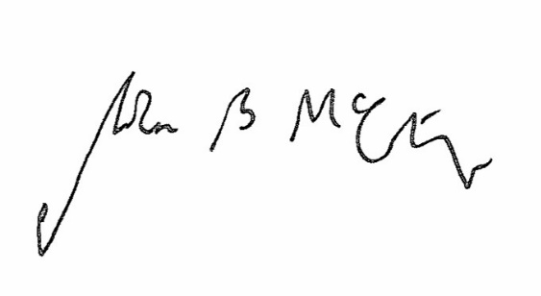

Signed Date 8 October 2018

Judge McCarthy
Deputy Judge of the Upper Tribunal

