

**Upper Tribunal**

**(Immigration and Asylum Chamber) Appeal Number: DA/00544/2017**

**THE IMMIGRATION ACTS**

|  |  |
| --- | --- |
| **Heard at Hatton Cross** | **Decision & Reasons Promulgated** |
| **On 26 April 2018** | **On 17 May 2018** |
|  |  |

**Before**

**UPPER TRIBUNAL JUDGE PERKINS**

**Between**

**SECRETARY OF STATE FOR THE HOME DEPARTMENT**

Appellant

**and**

**Arturas Zilinskas**

(ANONYMITY DIRECTION NOT MADE)

Respondent

**Representation:**

For the Appellant: Mr I Jarvis, Senior Home Office Presenting Officer

For the Respondent: The Respondent did not appear and was not represented.

**DECISION AND REASONS**

1. This is an appeal by the Secretary of State against the decision of the First-tier Tribunal allowing the appeal of the Respondent, hereinafter “the Claimant” against a decision of the Secretary of State to make him a subject of deportation as an EEA national.
2. The Claimant did not appear before the First-tier Tribunal. The hearing of the First-tier Tribunal was on 6 December 2017 and the Claimant had already been removed. He was removed on 3 October 2017. I do not know if he knew about the hearing before the First-tier Tribunal. I do not know if he actually knows about the hearing before the Upper Tribunal but there is a note on file that he has been served by e-mail on 22 March 2018 and Rule 13(2) of the Tribunal Procedure (Upper Tribunal) Rules 2008 provides that where a person has provided an e-mail address then service at that address is good service unless the person receiving the document had indicated that service by that method was not acceptable. It follows therefore that I am satisfied on the information before me that the Claimant knows about these proceedings and I decided that it was just to go ahead in his absence.
3. The First-tier Tribunal’s decision to allow the appeal is surprising. The First-tier Tribunal seems to have been satisfied that the Claimant, as an EEA national, enjoyed the higher level of protection that comes when a person has established a right of residence in the United Kingdom.
4. I think that the appeal may very well have been allowed correctly if that premise had been established but, in my judgment, it was not established. There are various reasons for that. It is not clear when the Claimant actually arrived in the United Kingdom. He says he came before any records can be traced. He says he came before he was entitled to and the basis on which he is said to have entered the United Kingdom is not known. The Secretary of State says that the Claimant ought to have registered under the Accession (Immigration and Worker Registration) Regulations 2004. As far as I can see there is no evidence that he did. It is not something that the Claimant ever said that he had done and how the judge came to the conclusion that he did is something of a mystery. The finding is, I have to say, perverse.
5. The finding that he was exercising treaty rights throughout that time whether registered or not is also, I find, perverse. There is very good evidence that since between 2005 and 2014 the Claimant did lawfully work. The evidence is in the form of records of National Insurance contributions and it is very difficult to see how these records can be compiled other than by a person making payments or payments being made on that person’s behalf from their wages. However, the sums are low ranging from £27.84 at the lowest to £947.05 at the highest but in other years are in the order of a few hundred pounds. I do not see how those sums could have been paid if the Claimant had been in full-time work paid at at least the minimum wage. Far higher payments would have been necessary. I am therefore satisfied that the evidence of employment, which is perfectly satisfactory, is not evidence of exercising treaty rights throughout the period.
6. We do not know what happened when the Claimant was not in work but I am not prepared to assume he was exercising treaty rights by looking for work in the absence of any evidence to that effect. It is a gap that the Claimant needed to address and has not addressed.
7. It follows that I further find that the First-tier Tribunal’s finding that he was exercising treaty rights is wrong on its own facts as well as flawed by the absence of any evidence to find that he had the necessary registration.
8. It follows therefore that I set aside the decision of the First-tier Tribunal. The Tribunal’s conclusions were not open to it.
9. I then have to decide what to do.
10. This is not a case where there has been any attempt by the Claimant to re-enter the United Kingdom as he was probably entitled to do (subject to various conditions) to present his appeal.
11. I must make the decision on the evidence that I have and the evidence that I have is that the Claimant was lawfully removed even though he is an EEA national because he has become a persistent criminal.
12. It is a rather sad feature of this case that there are reasons to think that the Claimant has been in the United Kingdom for some time working industriously but something happened in his life that has made him turn to drink and his addiction to drink is such that, rather than leaving it alone (which is no doubt what he needs to do and may very well be what he wants to do) he steals to continue his habit. Typically, he steals from shops but as the Secretary of State’s decision letter makes plain, although this is hardly controversial, stealing from shops is not somehow acceptable. We all end up paying one way or another and the Secretary of State, in my judgment, was absolutely entitled to find the Claimant an unsuitable person to be in the United Kingdom because of his persistent bad behaviour which shows no sign whatsoever of abating.
13. Once the issue of the appropriate level of protection is resolved against the Claimant then there is no possible basis for criticising the Secretary of State’s decision and therefore I substitute a decision dismissing the Claimant’s appeal against the decision complained of.

Signed

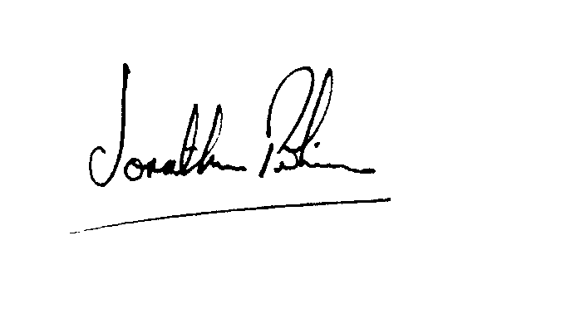

|  |  |
| --- | --- |
|  |  |
| Jonathan Perkins, Upper Tribunal Judge | Dated: 11 May 2018 |