

**Upper Tribunal**

**(Immigration and Asylum Chamber)** Appeal Number: EA/00013/2018

**THE IMMIGRATION ACTS**

|  |  |
| --- | --- |
| **Heard at Field House** | **Decision & Reasons Promulgated** |
| **On 12 September 2018** | **On 13 September 2018** |
|  |  |

**Before**

**UPPER TRIBUNAL JUDGE GRUBB**

**Between**

**CHRISTIANA QUARTEY**

Appellant

**and**

**THE SECRETARY OF STATE FOR THE HOME DEPARTMENT**

Respondent

**Representation:**

For the Appellant:       Mr R Khosla, instructed by D J Webb Solicitors    

For the Respondent:    Ms A Fijiwala, Senior Home Office Presenting Officer

**NOTICE OF DECISION**

1. Both subparagraphs of rule 40(3) apply to this decision.
2. The decision of the First-tier Tribunal sent out on 9 April 2018 is erroneous in law. I set it aside.
3. The appeal is remitted to be determined by the First-tier Tribunal *de novo* at an oral hearing.

Signed

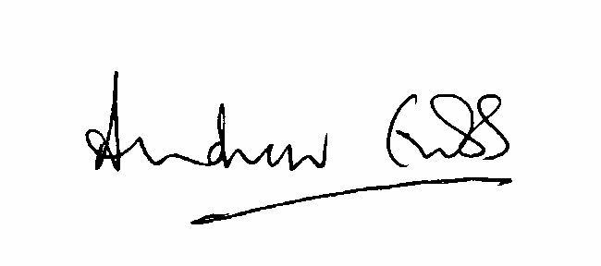

A Grubb

Judge of the Upper Tribunal 12, September 2018