

**Upper Tribunal**

**(Immigration and Asylum Chamber)** Appeal Number: EA/01667/2017

**THE IMMIGRATION ACTS**

|  |  |
| --- | --- |
| **Heard at Field House** | **Determination Promulgated** |
| **On 8 August 2018** | **On 10 August 2018** |
|  |  |

**Before**

**UPPER TRIBUNAL JUDGE SMITH**

**Between**

**ANTONIO [J]**

Appellant

**and**

**SECRETARY OF STATE FOR THE HOME DEPARTMENT**

Respondent

**Representation:**

For the Appellant: Not in attendance nor represented

For the Respondent: Mrs N Willocks-Briscoe, Senior Home Office Presenting Officer

**DECISION AND REASONS**

**Background**

1. The Appellant appeals against a decision of First-Tier Tribunal Judge Skehan promulgated on 8 September 2017 (“the Decision”) dismissing his appeal against the Respondent’s decision dated 18 January 2017 giving directions for his removal to Portugal on the basis of an abuse of rights under regulation 21B of the Immigration (European Economic Area) Regulations 2006 because the Appellant was rough sleeping. The Judge accepted that the Respondent’s case was made out and dismissed the appeal for that reason.
2. Permission to appeal was refused by First-tier Tribunal Judge Birrell on 27 February 2018 but granted by Upper Tribunal Judge Plimmer on 14 June 2018 in the following terms:

“1. It is arguable that there has been a mistake of fact giving rise to an error of law given the tenancy agreement dated 20 January 2017, which was not available to the FTT.

2. In addition, it is arguable that the approach to rough sleeping is not in accordance with Gureckis v SSHD [2017] EWHC 3298 Admin”

1. The matter comes before me to decide whether the Decision contains a material error of law and, if so, to re-make the decision or remit the appeal for rehearing to the First-Tier Tribunal.

**ERROR OF LAW DECISION**

1. Prior to the hearing, the Tribunal was notified by Norwich City Council (who are supporting the Appellant) that his MP had been told that the Respondent was no longer proposing to remove the Appellant and that the removal decisions were being withdrawn.
2. By letter dated 7 August 2018, the Respondent served a response to the appeal under Rule 24 as follows (so far as relevant):

“…2. The respondent does not oppose the appellant’s application for permission to appeal.

3. In light of the case of Gureckis [2017] EWHC 3298, the Secretary of State has withdrawn the removal decisions dated 18 January 2017 and wishes to withdraw his case under Rule 17 (1) (a) of the Upper Tribunal Procedure Rules 2008”

1. Mrs Willocks-Briscoe confirmed that the reference to the Appellant’s “application for permission to appeal” should be read as “the Appellant’s appeal” (as permission has already been granted). I therefore indicated that, for the reasons given in the grant of permission and the Respondent’s Rule 24 statement, I intended to find that the Decision disclosed an error of law and to set that aside.
2. Whilst the Respondent is right to point out that Rule 17 (1)(a) does permit either party to withdraw its case, the appeal remains that of the Appellant. The Appellant had not responded to the Rule 24 statement prior to the hearing, indicating a consent to withdrawal of the appeal (once the Decision was set aside) and the Appellant was unrepresented at the hearing. Accordingly, I decided that the better course of action was to re-make the decision, allowing the Appellant’s appeal by consent on the basis that the decision under appeal has been withdrawn.
3. I therefore allow the Appellant’s appeal.

**DECISION**

**I am satisfied that the Decision contains a material error of law. The decision of First-tier Tribunal Judge Skehan promulgated on 8 September 2017 is set aside.**

**I re-make the decision. I allow the Appellant’s appeal.**

Signed 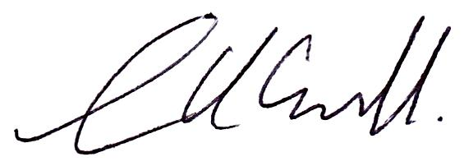 Dated: 8 August 2018

Upper Tribunal Judge Smith