

IAC-FH-LW-V2

**Upper Tribunal**

**(Immigration and Asylum Chamber)** Appeal Number: EA/02190/2017

**THE IMMIGRATION ACTS**

|  |  |
| --- | --- |
| **Heard at Field House** | **Decision & Reasons Promulgated** |
| **On 5 September 2018** | **On 18 September 2018** |
|  |  |

**Before**

**UPPER TRIBUNAL JUDGE ALLEN**

**Between**

**THE SECRETARY OF STATE FOR THE HOME DEPARTMENT**

Appellant

**and**

**alvan ifeakachukwu nduka**

**(anonymity direction not made)**

Respondent

**Representation:**

For the Appellant: Ms N Willocks-Briscoe, Senior Home Office Presenting Officer

For the Respondent: In person together with the Sponsor Miss Francesca Cortonovis

**DECISION AND REASONS**

1. The Secretary of State of State appeals with permission to the Upper Tribunal in this case against the decision of the First-tier Tribunal Judge promulgated on 18 May 2018 in which the judge directed that the respondent conduct an examination of the documentation from HMRC and consider the grant of a residence card.

2. The essential point of challenge is that the judge, contrary to what was said in Greenwood (No 2) [2015] UKUT 00629 (IAC) and Charles [2018] UKUT 00089 (IAC) failed to allow or dismiss the appeal which were the only options open to her but instead made the direction set out above.

3. As noted above, Mr Nduka appeared in person together with his wife, and they both made it clear that they were happy to proceed despite not having legal representation. They clearly understood the issues in the case, making the point that although Ms Cortonovis’ earnings were not great, she was genuinely self-employed doing work she loved and that there was no requirement to earn a large income. They also made the point that she had a child for whom she is responsible which limits her number of available working hours. She pays national insurance and declares her tax and the judge had believed she was economically active on the basis of the evidence provided.

4. All the points made by and on behalf of Mr Nduka are perfectly fair ones. The difficulty is that the judge did not decide the case as the law requires her to do. A judge in the First-tier Tribunal must either allow or dismiss an appeal. The law no longer allows for remittal to the Secretary of State to make a decision on the basis of findings by a judge. Accordingly, as I explained in court and set out again now, the appropriate disposal of this case is for the Secretary of State’s appeal to be allowed to the extent that the matter goes back for a hearing before a different judge at Hatton Cross for findings to be made on the evidence and a decision to be made as to whether to allow or dismiss Mr Nduka’s application for permanent residence.

**Notice of Decision**

The appeal is allowed to the extent set out above.

No anonymity direction is made.

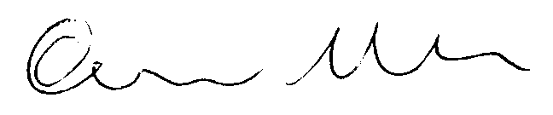

Signed Date 10 September 2018

Upper Tribunal Judge Allen