

**Upper Tribunal**

**(Immigration and Asylum Chamber) Appeal Number: EA/05274/2017**

**THE IMMIGRATION ACTS**

|  |  |
| --- | --- |
| **Heard at Field House** | **Decision Promulgated** |
| **On 2 July 2018** | **On 10 July 2018** |
|  |  |

**Before**

**DEPUTY UPPER TRIBUNAL JUDGE DOYLE**

**Between**

**DORAN ANTHONY WARREN**

(ANONYMITY DIRECTION NOT MADE)

Appellant

**and**

**SECRETARY OF STATE FOR THE HOME DEPARTMENT**

Respondent

**Representation:**

For the Appellant: Mr J Karim (counsel) instructed by SLA solicitors

For the Respondent: Ms N Willocks-Briscoe, Senior Home Office Presenting Officer

**DECISION AND REASONS**

1. I have considered whether any parties require the protection of an anonymity direction. No anonymity direction was made previously in respect of this Appellant. Having considered all the circumstances and evidence I do not consider it necessary to make an anonymity direction.

2. This is an appeal by the Appellant against the decision of First-tier Tribunal Judge Pooler promulgated on 23 February 2018, which dismissed the Appellant’s appeal against the respondent’s decision to revoke a permanent residence card.

Background

3. The Appellant was born on 20 October 1977 and is a national of Jamaica. On 21 May 2017 the respondent revoked a permanent residence card issued to the appellant on 27 April 2016.

The Judge’s Decision

4. The Appellant appealed to the First-tier Tribunal. First-tier Tribunal Judge Pooler (“the Judge”) dismissed the appeal against the Respondent’s decision. Grounds of appeal were lodged and on 16 April 2018 Judge E M Simpson gave permission to appeal.

The Hearing

5.(a) For the appellant Mr Karim moved the grounds of appeal. He took me to [21] of the decision and told me that the Judge was wrong to find there that he need not consider whether the appellant had retained a right of residence and that the Judge should have considered regulation 10(5) of the 2006 regulations, counting back five years from the date of hearing in February 2018. Mr Karim relied on Samsam (EEA; revocation and retained rights) Syria [2011]UKUT 00165(IAC).

(b) Mr Karim told me that the Judge was wrong to place reliance on HMRC records. He told me that there is a clear conflict in the evidence, which the Judge fails to resolve. He told me that there was DWP evidence which showed that the appellant’s ex-wife had not been claiming benefits during the period when HMRC said that she had. He told me that the Judge does not grapple with that inconsistency and fails to resolve it. He told me that the Judge gives inadequate reasons for accepting one strand of evidence and implicitly rejecting another.

(c) Mr Karim told me that the Judge rejects the evidence of P60s and gives no consideration to the crucial passages of the appellant’s evidence at all; that the Judge did not make findings in relation to credibility nor did he consider “innocent explanations”

(d) Mr Karim told me that the Judge did not explore the suggestion that the appellant’s ex-wife’s details have been recorded incorrectly by HMRC and failed to take account of the low-level of the appellant’s ex-wife’s income. He told me that the Judge unquestioningly accepted unreliable evidence from HMRC and did not give adequate consideration to reliable evidence which supported the appellant’s claim. He urged me to set the decision aside.

6 (a) Ms Willocks-Briscoe told me that the decision does not contain errors of law. She told me that the Judge was entitled to prefer evidence from HMRC to other sources of evidence, and that the weight to be given to strand of evidence was a matter for the Judge at first instance. She told me that if the Judge had looked beyond the documentary evidence he would have entered into speculation, which would, of course, be wrong.

(b) Ms Willocks-Briscoe told me that the HMRC evidence is to be preferred to the DWP evidence because there is an error in the DWP evidence (the appellant’s ex-wife’s date of birth is incorrectly recorded). Ms Willocks-Briscoe took me through the documentary evidence and told me that the decision that the Judge reached was well within the range of reasonable decisions available to the Judge. She urged me to dismiss the appeal and allow the decision to stand.

Analysis

7. In [Samsam (EEA: revocation and retained rights)Syria [2011] UKUT 00165 (IAC)](http://www.ait.gov.uk/Public/Upload/j2364/00165_ukut_iac_hs_syria.doc) the Tribunal said that regulation 10 of Immigration (EEA) Regulations 2006 requires the applicant to demonstrate that: a genuine marriage has lasted three years and the couple have spent one year together in the United Kingdom and that the EEA national spouse was exercising treaty rights at the time he ceased to be a family member.

8. In Baigazieva v SSHD [2018] EWCA Civ 1088the Court of Appeal (in a judgment after the parties had agreed a consent order) accepted that in order for the applicant to retain a right of residence at the point of divorce, it was necessary to show that the EEA spouse was a qualified person when divorce proceedings were commenced, but not necessary to show that the EEA spouse exercised treaty rights until decree absolute.

9. At [15] of the decision the Judge quite clearly sets out where a conflict of evidence lies. On the one hand, HMRC say that the appellant’s ex-wife claim benefits, on the other, the DWP said that they have no record of a claim for benefits by the appellant’s ex-wife. The Judge does not resolve the identified conflict in the evidence. Instead, at [16], he simply says the appellant’s evidence is undermined by the HMRC evidence. At [17] the Judge says that P60s for the tax year to 2012 are unreliable, but does not say why.

10. In MK (duty to give reasons) Pakistan [2013] UKUT 00641 (IAC), it was held that (i) It was axiomatic that a determination disclosed clearly the reasons for a tribunal’s decision. (ii) If a tribunal found oral evidence to be implausible, incredible or unreliable or a document to be worth no weight whatsoever, it was necessary to say so in the determination and for such findings to be supported by reasons. A bare statement that a witness was not believed or that a document was afforded no weight was unlikely to satisfy the requirement to give reasons.

11. At [21] the Judge decides that the preceding 20 paragraphs of the decision are enough. The record of proceedings clearly discloses that submissions were made in relation to regulation 10(5) of the 2006 regulations, but at [21] the Judge declares

That is an issue which I do not have to decide.

12. Reg 10(5) deals with Family members who have retained a right of residence. It was one of the central issues in the appeal & is clearly a matter for the Judge to decide.

13. The inadequacy of fact finding and the failure to fully considered the relevant regulations are material errors of law. I set the decision aside.

14. I consider whether I can substitute my own decision but find that I cannot because one of the errors of law relates to failing to resolve a conflict in the evidence. Further fact-finding is necessary.

Remittal to First-Tier Tribunal

15. Under Part 3 paragraph 7.2(b) of the Upper Tribunal Practice Statement of the 25th of September 2012 the case may be remitted to the First-tier Tribunal if the Upper Tribunal is satisfied that:

(a) the effect of the error has been to deprive a party before the First-tier Tribunal of a fair hearing or other opportunity for that party’s case to be put to and considered by the First-tier Tribunal; or

(b) the nature or extent of any judicial fact finding which is necessary in order for the decision in the appeal to be re-made is such that, having regard to the overriding objective in rule 2, it is appropriate to remit the case to the First-tier Tribunal.

16. In this case I have determined that the case should be remitted because a new fact-finding exercise is required. None of the findings of fact are to stand and a complete re hearing is necessary.

17. I remit the matter to the First-tier Tribunal sitting at Birmingham to be heard before any First-tier Judge other than Judge Pooler.

**Decision**

**18. The decision of the First-tier Tribunal is tainted by material errors of law.**

**19. I set aside the Judge’s decision promulgated on 23 February 2018. The appeal is remitted to the First-tier Tribunal to be determined of new.**

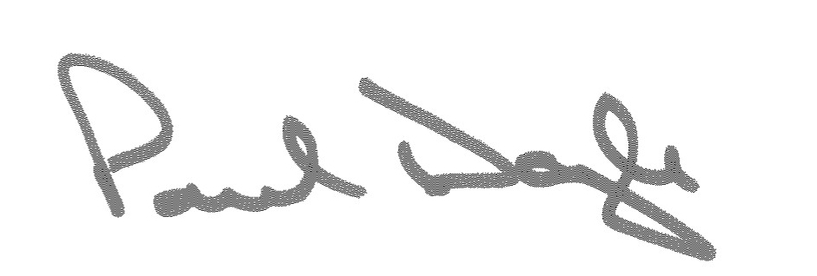Signed Date 9 July 2018

Deputy Upper Tribunal Judge Doyle