

**Upper Tribunal**

**(Immigration and Asylum Chamber)** Appeal Number: EA/05463/2016

**THE IMMIGRATION ACTS**

|  |  |
| --- | --- |
| **Heard at Manchester Civil Justice Centre** | **Decision & Reasons Promulgated** |
| **On 3 July 2018** | **On 21 August 2018** |
|  |  |

**Before**

**UPPER TRIBUNAL JUDGE GRUBB**

**UPPER TRIBUNAL JUDGE PLIMMER**

**Between**

**Farrukh Raoof**

Appellant

**and**

**THE SECRETARY OF STATE FOR THE HOME DEPARTMENT**

Respondent

**Representation:**

For the Appellant: Mr C Bloomer, instructed by Mamoon Solicitors

For the Respondent: Mr A Tan, Senior Home Office Presenting Officer

**DECISION AND REASONS**

1. The appellant is a citizen of Pakistan who was born on 15 February 1989.
2. On 17 September 2015, he applied for a residence card, based upon a retained right of residence under reg 10(5) of the Immigration (EEA) Regulations 2006 (SI 2006/1003 as amended), following divorce from his EEA national spouse on 24 August 2015.
3. On 17 March 2016, the Secretary of State refused the appellant’s application.
4. The appellant appealed to the First-tier Tribunal. In a decision promulgated on 21 August 2017, Judge Malik dismissed the appellant’s appeal.
5. The First-tier Tribunal (Judge Pedro) granted the appellant permission to appeal the Upper Tribunal on 5 February 2018.
6. The grounds of appeal raise, in essence, two points.
7. First, it is contended that the judge’s decision is vitiated by procedural impropriety, in particular apparent bias. The basis of that allegation, as supported by the appellant’s then representative, his solicitor Ms Hashmi in a statement of truth dated 4 September 2017, is that, in effect, the judge failed to allow the appellant’s representative to make an application to adjourn the hearing because a key witness had had to leave the hearing centre as a result of her two children (who were at home) being unwell.
8. As a result of a grant of permission, the views of Judge Malik on the allegation were sought and were served on both parties in a memorandum from PRJ O’Connor dated 21 May 2018. There is some uncertainty as to what occurred prior to and at the hearing.
9. Secondly, it is contended that the judge erred in law in assessing whether, in order to establish a retained right of residence under reg 10(5), in requiring the appellant’s marriage to be “genuine and subsisting” up to the date of divorce.
10. Before us, Mr Bloomer who represented the appellant, relied upon both grounds of appeal and he made oral submissions in support of setting aside the First-tier Tribunal’s decision and remitting it for a *de novo* rehearing.
11. Having heard Mr Bloomer’s submissions, Mr Tan who represented the Secretary of State, after a short adjournment to consider the respondent’s position, accepted that the judge had been wrong to require the appellant to establish that his marriage was “genuine and subsisting” prior to the divorce. He accepted that that was not a requirement of the Regulations. Further, he accepted that, having reached that finding, the judge’s conclusion tainted his approach to the evidence concerning the employment of the appellant’s spouse and whether she was a “qualified person” during the relevant time prior to the divorce. Mr Tan invited us, on that basis, to allow the appeal and remit it to the First-tier Tribunal for a rehearing.
12. Mr Bloomer indicated that the appellant was content that the appeal should be allowed and remitted on the basis of ground 2 and that it was, in those circumstances, unnecessary for us to decide the merits of ground 1.
13. We agree with that course of action. There is no requirement in reg 10(5) of the 2006 Regulations, nor in reg 10 of the more recent Immigration (EEA) Regulations 2016 (SI 2016/1052), that the marriage prior to the divorce should be “genuine and subsisting”. It is clear from the jurisprudence of the CJEU that it suffices in order to establish the non-EEA spouse’s right of residence that he remains married to the EEA national even if they are not living together (see, Singh (Case C-218/14)) or, as in the case of Ogieriakhi (Case C-244/13), the couple have separated and living with new partners.
14. Consequently, the judge erred in law in that respect and, as is clear from her reasoning in paras 15 and 16, her venture into the genuineness of the relationship tainted her conclusion as to whether the appellant had established that his former spouse was a qualified person.
15. For that reason, therefore, we conclude that the judge materially erred in law and that her decision cannot stand and we set it aside.
16. As was accepted before us, it is therefore unnecessary for us to resolve the issues arising under ground 1 including reaching any factual findings on what occurred prior to and at the hearing before Judge Malik.
17. The appeal is, therefore, remitted to the First-tier Tribunal for a *de novo* rehearing before a judge other than Judge Malik.

Signed

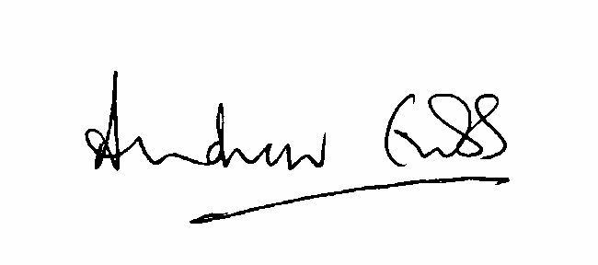

A Grubb

Judge of the Upper Tribunal

13 August 2018