

**Upper Tribunal**

**(Immigration and Asylum Chamber)** Appeal Number: EA/05823/2017

EA/06659/2017

**THE IMMIGRATION ACTS**

|  |  |
| --- | --- |
| **Determined at Field House without a hearing** | **Decision and Reasons Promulgated** |
| **On 24 August 2018** | **On 04 September 2018** |
|  |  |

**Before**

**UPPER TRIBUNAL JUDGE RINTOUL**

**Between**

**HAFIZ NASIR HUSSAIN BUTT**

**HAFIZ NASIR HUSSAIN BUTT**

**(NO ANONYMITY ORDER MADE)**

Appellant

**and**

**THE SECRETARY OF STATE FOR THE HOME DEPARTMENT**

Respondent

**DECISION AND REASONS**

1. On 26 July 2018 I gave the following directions:-
2. Having had regard to the decision of the First-tier Tribunal, and that it now transpires that the appellant was unable to attend the hearing as he was in police custody, it is my preliminary view that the decision of the First-tier Tribunal involved the making of an error of law in that the judge proceeded to determine the appeal without considering the request to withdraw the appeal.
3. It is therefore my preliminary view that the decision of the First-tier Tribunal should be set aside and that the appropriate course of action would be to remit the appeal to the First-tier Tribunal for a fresh hearing on all issues.
4. Unless within ten working days of the issue of these directions there is any written objection to this course of action, supported by cogent argument, the Upper Tribunal will proceed to determine the appeal without an oral hearing and will remit it to the First-tier Tribunal.
5. In the absence of a timely response by a party, it will be presumed that it has no objection to the course of action proposed
6. There has been no response to these directions by either party. Accordingly, I am satisfied that neither party objects to the matter being determined without a hearing and has nothing further to say. I am satisfied that that the determination of the First-tier Tribunal did involve the making of an error of law for the reasons set out above, and must therefore be set aside.

**Summary of conclusions**

1. The determination of the First-tier Tribunal did involve the making of an error of law and I set it aside.
2. I remit the decision to the First-tier Tribunal for a fresh decision on all issues.

Signed Date: 24 August 2018

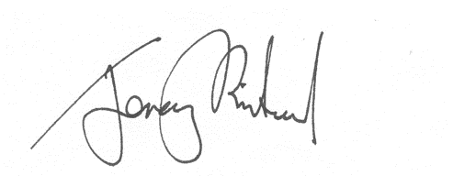

Upper Tribunal Judge Rintoul