

**Upper Tribunal**

**(Immigration and Asylum Chamber) Appeal Number: EA/05881/2016**

**THE IMMIGRATION ACTS**

|  |  |
| --- | --- |
| **Heard at Field House** | **Decision & Reasons Promulgated** |
| **On 14 February 2018** | **On 17 May 2018** |

**Before**

**UPPER TRIBUNAL JUDGE ALLEN**

**Between**

**Rakhi Rani Dash**

(anonymity direction not made)

Appellant

**and**

**THE SECRETARY OF STATE FOR THE HOME DEPARTMENT**

Respondent

**Representation:**

For the Appellant: Ms S Iqbal, Counsel instructed by Taj Solicitors

For the Respondent: Mr D Clarke, Home Office Presenting Officer

**DECISION AND REASONS**

1. This is the appeal of Mrs Dash against a decision of the Secretary of State refusing to grant her a residence card as an extended family member of her sponsor. The matter came before a judge in May 2017 and she concluded in light of Sala [2016] UKUT 00411 (IAC) that there was no statutory right of appeal against the decision to refuse to grant a residence card to an extended family member. We now know in light of the decision of the Court of Appeal in Khan [2017] EWCA Civ 1755 that Sala was wrong and there is a right of appeal in such a case and accordingly the judge, there is no criticism of her,she was simply following reported authority, erred in law and the matter will therefore require to be heard by a different judge at Hatton Cross.

**Notice of Decision**

The appeal is allowed to the extent that it is remitted for a full hearing in the First-tier Tribunal.

No anonymity direction is made.

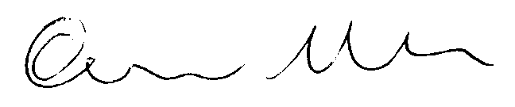

Signed Date 11 May 2018

Upper Tribunal Judge Allen