

**Upper Tribunal**

**(Immigration and Asylum Chamber) Appeal Number:** **EA/07172/2017**

**THE IMMIGRATION ACTS**

|  |  |  |
| --- | --- | --- |
| **Heard at Field House** | **Decision & Reasons Promulgated** | |
| **On 13 June 2018** | **On 5 July 2018** | |
|  | |  |

**Before**

**UPPER TRIBUNAL JUDGE PERKINS**

**Between**

**kenan ulusan**

(ANONYMITY DIRECTION not made)

Appellant

**and**

**SECRETARY OF STATE FOR THE HOME DEPARTMENT**

Respondent

**Representation:**

For the Appellant: The Appellant appeared in person

For the Respondent: Ms A Everett, Senior Home Office Presenting Officer

**DECISION AND REASONS**

1. The application made by the Appellant was for a permanent residence card under Regulation 15(1) of the Immigration (European Economic Area) Regulations 2016. The application was refused by the Secretary of State and at the appeal the judge resolved the issue that had led to refusal in favour of the appellant.
2. One might have thought that would have led to the appeal being allowed but the judge did not allow it because the judge spotted another problem and dismissed the appeal because of a failure to produce certain documents. The problem is that the appellant was under no obligation to produce those documents because they had been seen by the Secretary of State earlier and had been found to be satisfactory. It was not an oversight on the part of the Secretary of State. There was a finding that the documentary requirements had been met.
3. The problem is that the judge took a point that was not in issue and wrongly found against the appellant on that point. Miss Everett accepts that should not have been done and accepts that the proper decision is to rule that the First-tier Tribunal erred in law. The error of law is taking a point that was not in dispute.
4. I substitute a decision allowing the appeal because the area that was in dispute has been resolved in the appellant’s favour.

**Notice of Decision**

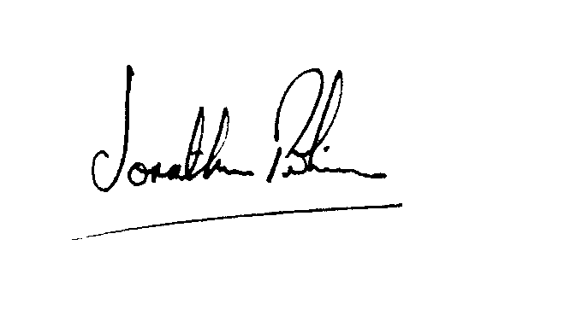It follows therefore I set aside the decision of the First-tier Tribunal and allow the appellant’s appeal against the decision of the Secretary of State.

|  |  |
| --- | --- |
| Signed |  |
| Jonathan Perkins, Upper Tribunal Judge | Dated: 4 July 2018 |