

**Upper Tribunal**

**(Immigration and Asylum Chamber) Appeal Number: EA/09358/2016**

**THE IMMIGRATION ACTS**

|  |  |
| --- | --- |
| **Determined at Field House without a hearing**  **On 20 June 2018** | **Decision & Reasons Promulgated**  **On 22 June 2018** |
|  |  |
|  |  |

**Before**

**UPPER TRIBUNAL JUDGE RINTOUL**

**Between**

**MUHAMMAD BILAL**

(NO ANONYMITY ORDER MADE)

Appellant

**and**

**THE SECRETARY OF STATE FOR THE HOME DEPARTMENT**

Respondent

**DECISION AND REASONS**

1. On 30 May 2018, the Upper Tribunal directed that in the light of Khan v Secretary of State for the Home Department [2017] EWCA Civ 1755 and SM (Algeria) [2018] UKSC 9, it was minded to find that the First-tier Tribunal erred in law in concluding that it did not have jurisdiction to hear the appeal and to remit it to the First-tier Tribunal for a fresh hearing. No objection to the proposed course of action has been received. Accordingly, I am satisfied that I can proceed to determine the appeal in accordance with the directions made and without an oral hearing.
2. I am satisfied that that the determination of the First-tier Tribunal did involve the making of an error of law for the reasons set out above, and must therefore be set aside. Given the nature of the error, I remit the appeal to the First-tier Tribunal for a fresh determination on all issues.

**Summary of conclusions**

1. The determination of the First-tier Tribunal did involve the making of an error of law and I set it aside.
2. I remit the decision to the First-tier Tribunal for a fresh decision on all issues
3. The appeal must not be before First-tier Tribunal Judge Lambert

Signed Date: 20 June 2018

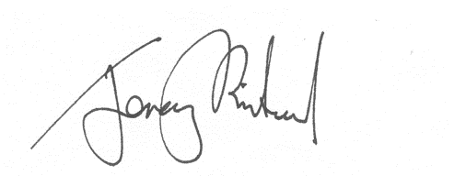

Upper Tribunal Judge Rintoul