

**Upper Tribunal**

**(Immigration and Asylum Chamber)** Appeal Number: EA/10324/2016

**THE IMMIGRATION ACTS**

|  |  |
| --- | --- |
| **Heard at Field House** | **Decision & Reasons Promulgated** |
| **On 3 September 2018** | **On 6 September 2018** |
|  |  |

**Before**

**UPPER TRIBUNAL JUDGE RINTOUL**

**UPPER TRIBUNAL JUDGE JACKSON**

**Between**

**IRFAN AHMED**

**(ANONYMITY ORDER NOT MADE)**

Appellant

**and**

**THE SECRETARY OF STATE FOR THE HOME DEPARTMENT**

Respondent

**Representation:**

For the Appellant: Ms Saifolahi, instructed by ATM Law Solicitors

For the Respondent: Mr I Jarvis, Senior Home Office Presenting Officer

**DECISION MADE PURSUANT TO RULES 34, 39 & 40 (3) OF THE**

**TRIBUNAL PROCEDURE (UPPER TRIBUNAL) RULES 2008**

1. When the appeal came before us, the parties were agreed that the decision of the First-tier Tribunal involved the making of an error of law as averred in the grounds. It was accepted also that on the basis of the evidence before the First-tier Tribunal and on the basis of the concessions made that the appeal should be allowed as it had been shown that the appellant had acquired the right of permanent residence.
2. Rule 40 (1) of the Tribunal Procedure (Upper Tribunal) Rules 2008 provides that the Upper Tribunal may give a decision orally at a hearing. Rule 40 (3) provides that the Upper Tribunal must provide written reasons for its decision with a decision notice unless the parties have consented to the Upper Tribunal not giving written reasons. We are satisfied that the parties have given such consent as both representatives agreed to the appeal being disposed of under Rule 40(3)

**Notice of Decision**

1. The decision of the First-tier Tribunal involved the making of an error of law and is set aside.
2. We remake the decision allowing the appeal under the Immigration (European Economic Area) Regulations 2016.

Signed Date: 3 September 2018

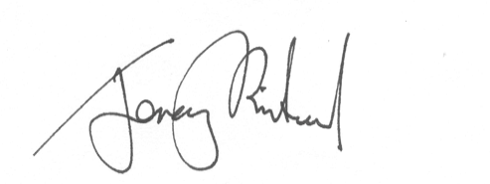

Upper Tribunal Judge Rintoul