

**Upper Tribunal**

**(Immigration and Asylum Chamber) Appeal Numbers: ea/10328/2016**

**ea/10330/2016**

**THE IMMIGRATION ACTS**

|  |  |  |
| --- | --- | --- |
| **Heard at Field House** | **Decision & Reasons Promulgated** | |
| **On 16 May 2018** | **On 11 June 2018** | |
|  | |  |

**Before**

**UPPER TRIBUNAL JUDGE ALLEN**

**Between**

**Ms Misbah Noreen**

**ms sughran bibi**

(anonymity direction not made)

Appellants

**and**

**THE SECRETARY OF STATE FOR THE HOME DEPARTMENT**

Respondent

**Representation:**

For the Appellants: Mr Z Raza, instructed by Dawn Solicitors

For the Respondent: Ms J Isherwood, Senior Home Office Presenting Officer

**DECISION AND REASONS**

1. This is an appeal by the second and third appellants in an appeal in respect of which their appeals were dismissed by the First-tier Judge and that of the first appellant was allowed. I need to say very little about these two appeals because they are Sala cases, they are decisions under the 2006 EEA Regulations in respect of appeals against refusals of residence permits for extended family members. The judge, entirely rightly as the law stood at the time, concluded that they did not have a right of appeal because of the decision in Sala and therefore dismissed their appeals on the basis of a lack of jurisdiction. We now know because of the decision of the Court of Appeal in Khan subsequent to the judge’s decision in this case, that in fact Sala was wrong and as a consequence the second and third appellants do in fact have a right of appeal which of course they are entitled to exercise in the First-tier Tribunal so as a consequence this matter will be remitted for a full hearing of their appeals in the First-tier Tribunal at Hatton Cross.

**Notice of Decision**

The appeal is allowed to the extent set out above.

No anonymity direction is made.

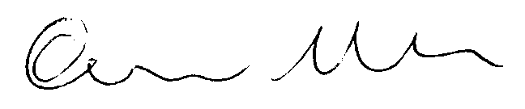

Signed Date 08 June 2018

Upper Tribunal Judge Allen