

**Upper Tribunal**

**(Immigration and Asylum Chamber)** Appeal Number: EA/10633/2016

**THE IMMIGRATION ACTS**

|  |  |
| --- | --- |
| **Determined at Field House without a hearing** | **Decision & Reasons Promulgated** |
| **On 21 May 2018** | **On 23 May 2018** |
|  |  |

**Before**

**UPPER TRIBUNAL JUDGE RINTOUL**

**Between**

**RICHARD OWUSU ADDO**

**(NO ANONYMITY ORDER MADE)**

Appellant

**and**

**THE SECRETARY OF STATE FOR THE HOME DEPARTMENT**

Respondent

**DECISION AND REASONS**

1. In the light of Khan v Secretary of State for the Home Department [2017] EWCA Civ 1755 and SM (Algeria) [2018] UKSC 9, the First-tier Tribunal erred in law in concluding that it did not have jurisdiction to hear the appeal. Accordingly, and in the light of the respondent’s policy where, as here, no findings of fact were made, I am satisfied that the appeal can fairly be determined without a hearing.
2. I am satisfied that that the determination of the First-tier Tribunal did involve the making of an error of law for the reasons set out above, and must therefore be set aside. Given the nature of the error, I remit the appeal to the First-tier Tribunal for a fresh determination on all issues.

**Summary of conclusions**

1. The determination of the First-tier Tribunal did involve the making of an error of law and I set it aside.
2. I remit the decision to the First-tier Tribunal for a fresh decision on all issues
3. The appeal must not be before Upper Tribunal Judge Martin

Signed Date: 21 May 2018

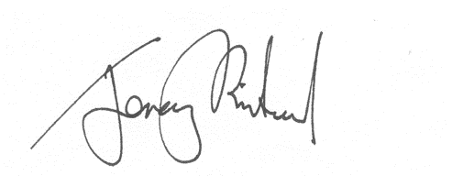

Upper Tribunal Judge Rintoul