

**Upper Tribunal**

**(Immigration and Asylum Chamber) Appeal Number: EA/14263/2016**

**THE IMMIGRATION ACTS**

|  |  |
| --- | --- |
| **Heard at Field House** | **Decision & Reasons Promulgated** |
| **On 20 August 2018** | **On 7 September 2018** |
|  |  |

**Before**

**UPPER TRIBUNAL JUDGE RINTOUL**

**Between**

**the Secretary of State for the Home Department**

Appellant

**and**

**Cabrel Cristel Foutchiawa Ngoughnou**

(ANONYMITY DIRECTION not made)

Respondent

**Representation:**

For the Appellant: Mr L Tarlow, Home Office Presenting Officer

For the Respondent: In person

**DECISION AND REASONS**

1. The Secretary of State appeals with permission against a decision of First-tier Tribunal Judge Siddall in which he allowed the appeal of Mr Ngoughnou to whom I refer to as “the respondent”. He allowed the appeal against the Secretary of State’s decision to refuse to issue the respondent with a residence card under the Immigration (European Economic Area) Regulations 2016. The Secretary of State had taken the view that the respondent and his wife had entered into a marriage of convenience. The judge found that the marriage was genuine and that all the other requirements of the Regulations were met.
2. The Secretary of State sought permission to appeal on the grounds that the decision of the judge notes that the hearing was listed but no Presenting Officer attended, but records from the Presenting Officer who was allocated the case notes that it had been adjourned due to a lack of a judge.
3. What is entirely lacking is any evidential basis on which Mr Bassi, the Presenting Officer, believed that the hearing had been adjourned. Mr Bassi does not say how he knew it was adjourned, nor is there a record of any document being given to him, nor is it provided. Having considered the file and the electronic records maintained by the First-tier Tribunal I cannot see any indication of an adjournment. I explained that to Mr Tarlow at the beginning of proceedings and he had no reason to doubt what I said. In the circumstances I am satisfied that an absence of any indication that the Secretary of State was told that the appeal had been adjourned that there was no procedural irregularity, it is well-known in this field that many appeals proceed in the First-tier without representation by the Secretary of State.
4. For these reasons I find that the Secretary of State has failed to show that the decision of the First-tier Tribunal involved the making of an error of law and I uphold that decision.

**Notice of Decision**

1. The decision of the First-tier Tribunal did not involve the making of an error of law and I uphold it.
2. No anonymity direction is made.
3. I have no power to alter the fee decision made by the First-tier Tribunal

Signed Date: 24 August 2018

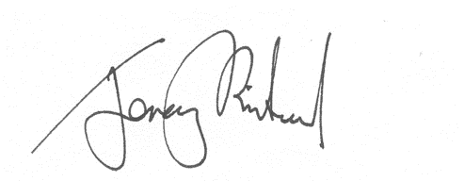

Upper Tribunal Judge Rintoul