

**Upper Tribunal**

**(Immigration and Asylum Chamber) Appeal Number: HU/01506/2018**

**THE IMMIGRATION ACTS**

|  |  |
| --- | --- |
| **Heard at** Field House | **Decision Reasons Promulgated** |
| **On** 18 September 2017 | **On 24 September 2018** |
|  |  |

**Before**

**DEPUTY UPPER TRIBUNAL JUDGE DOYLE**

**Between**

**KIRAN SHAHZADI**

**(ANONYMITY DIRECTION NOT MADE)**

Appellant

**and**

**SECRETARY OF STATE FOR THE HOME DEPARTMENT**

Respondent

**Representation:**

For the Appellant: Mr N Ahmed (counsel) instructed by Deo Volente Solicitors Llp

For the Respondent: Ms A Everett, Senior Home Office Presenting Officer

**DECISION AND REASONS**

1. I have considered whether any parties require the protection of an anonymity direction. No anonymity direction was made previously in respect of this Appellant. Having considered all the circumstances and evidence I do not consider it necessary to make an anonymity direction.

2. This is an appeal by the Appellant against the decision of First-tier Tribunal Judge Foudy promulgated on 05/06/2018, which dismissed the Appellant’s appeal

Background

3. The Appellant was born on 23/02/1983 and is a national of Pakistan. On 12/12/2017 the Secretary of State refused the Appellant’s application for leave to remain in the UK under appendix FM of the immigration rules.

The Judge’s Decision

4. The Appellant appealed to the First-tier Tribunal. First-tier Tribunal Judge Foudy (“the Judge”) dismissed the appeal against the Respondent’s decision. Grounds of appeal were lodged and on 13/07/2018 Judge Beach gave permission to appeal stating inter alia

2. The grounds of appeal assert that the Tribunal Judge erred in her assessment of article 8. The grounds state that the Judge failed to apply the 5 stage test in R (Razgar) v SSHD [2004] UKHL 27 and that she failed to take proper account of the best interests of the children and the effect of the decision on family members other than the appellant. The grounds further assert that the Judge failed to take account of all relevant factors and failed to make a finding on a relevant factor. The respondent had found that the appellant did not satisfy the suitability requirements of the Immigration Rules because it was alleged that the appellant had used fraud to obtain her TOEIC certificate. This issue was specifically raised in the reasons for refusal letter. The Judge finds that this is not an issue on which she has to make findings because a judicial review against the decision to remove the appellant from the UK on the basis of alleged TOEIC deception had previously been refused [10]. However, the issue of deception was specifically raised within the reasons for refusal letter and it was therefore arguably necessary for the Judge to make a finding with regard to the allegation of deception. It is also arguable that whether or not the appellant used deception is a relevant factor in deciding whether it is reasonable to expect the appellant’s eldest child (who is a qualifying child for the purposes of s.117B(6)) to leave the UK.

3. Permission to appeal is granted.

The Hearing

5. Mr Ahmed told me that he had discussed this case with Ms Everett, and both parties’ agents agree that the decision contains a material error of law. Mr Ahmed had prepared a skeleton argument, which he adopted as he formally moved the grounds of appeal.

6. Ms Everett told me that having had the opportunity to consider the Judge’s decision she could not insist on the terms of the rule 24 note and no longer resisted the appeal. She told me that the error of law lies in [10] of the decision.

Analysis

7. The appellant made an application for leave to remain on the basis of article 8 family and private life. The main reason the respondent refused that application is that the respondent believes the appellant cannot meet the suitability requirements of appendix FM. In the reasons for refusal letter the respondent says

In your applications dated 19 October 2012 and 28 November 2013, you submitted a TOEIC certificate from educational testing services (“ETS”)……. The SSHD is satisfied that your certificate was fraudulently obtained and that you used deception in your applications of 19 October 2012 and 28 November 2013.

8. At [10] of the decision the Judge says that she needs look no further than the appellant’s judicial review in 2016, and that

The issue of fraud by the appellant is no longer a live issue.

9. The Judge is wrong. The appellant can only appeal on ECHR grounds, but the ability to meet the immigration rules is a relevant consideration in the overall proportionality exercise. The judicial review papers were not before the Judge. On the evidence before the Judge is not possible to see what matters were considered in judicial review proceedings. An allegation of fraud is central to the respondent’s decision. The allegation of fraud is one of the core issues before the Judge.

10. Because the Judge did not deal with a material matter the decision contains a material error of law. I set the decision aside. Parties’ agents agree that none of the findings are to stand and that this case requires an entirely new fact-finding exercise.

11. A new fact-finding exercise is necessary. As a result, I cannot substitute my own decision.

Remittal to First-Tier Tribunal

12. Under Part 3 paragraph 7.2(b) of the Upper Tribunal Practice Statement of the 25th of September 2012 the case may be remitted to the First-tier Tribunal if the Upper Tribunal is satisfied that:

(a) the effect of the error has been to deprive a party before the First-tier Tribunal of a fair hearing or other opportunity for that party’s case to be put to and considered by the First-tier Tribunal; or

(b) the nature or extent of any judicial fact finding which is necessary in order for the decision in the appeal to be re-made is such that, having regard to the overriding objective in rule 2, it is appropriate to remit the case to the First-tier Tribunal.

13. In this case I have determined that the case should be remitted because a new fact-finding exercise is required. None of the Judges findings stand.

14. I remit the matter to the First-tier Tribunal sitting at Manchester to be heard before any First-tier Judge other than Judge Foudy.

**Decision**

15. The decision of the First-tier Tribunal promulgated on 5 June 2018 contains a material error of law and is set aside. I remit the appeal to the First-tier Tribunal sitting at Manchester to be heard before any First-tier Judge other than Judge Foudy.

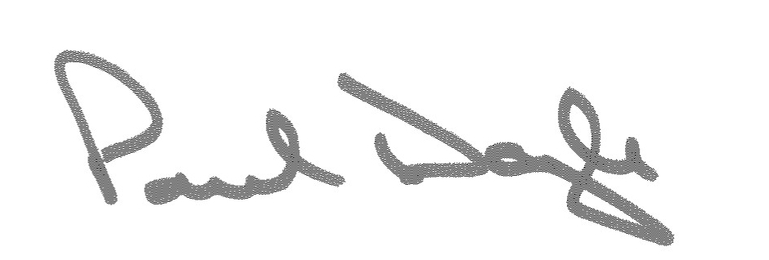

Signed Date 20 September 2018

Deputy Upper Tribunal Judge Doyle