

**Upper Tribunal**

**(Immigration and Asylum Chamber)** Appeal Number: HU/01964/2017

**THE IMMIGRATION ACTS**

|  |  |  |
| --- | --- | --- |
| **Heard at Field House** | **Decision & Reasons Promulgated** | |
| **On 29 August 2018** | **On 10 September 2018** | |
|  | |  |

**Before**

**UPPER TRIBUNAL JUDGE ALLEN**

**Between**

**Idowu Sonubi**

**(anonymity direction not made)**

Appellant

**and**

**THE SECRETARY OF STATE FOR THE HOME DEPARTMENT**

Respondent

**DECISION AND REASONS**

1. Permission to appeal in this case was granted by Judge Coker on 11 July 2018. In her decision she indicated that the case was likely to be one that was appropriate for the matter to be remitted to the First-tier Tribunal for a fresh hearing with no findings preserved. The parties were given fourteen days within which to say whether they disagreed with this course of action. In the absence of any submissions opposing the proposed outcome, the matter would be remitted to the First-tier Tribunal for a fresh hearing.

2. Notice of Judge Coker’s decision was sent out on 16 July 2018. There having been no response, I consider it is clear that neither party is opposed to the course of action proposed by her at paragraph 2 of her order.

**Notice of Decision**

3. Accordingly, for the reasons set out in the grounds of appeal, as there is an error of law in the judge’s decision, the matter is remitted for a fresh hearing at Hatton Cross before a judge other Judge Lawrence.

4. No anonymity direction is made.

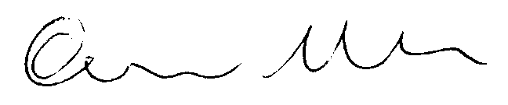

Signed Date 04 September 2018

Upper Tribunal Judge Allen