

**Upper Tribunal**

**(Immigration and Asylum Chamber)** Appeal Number: hu/04479/2017

**THE IMMIGRATION ACTS**

|  |  |
| --- | --- |
| **Heard at Field House** | **Decision & Reasons Promulgated** |
| **On 11 July 2018** | **On 18 July 2018** |
|  |  |

**Before**

**UPPER TRIBUNAL JUDGE PERKINS**

**Between**

**Imran Kakooza**

(ANONYMITY DIRECTION not made)

Appellant

**and**

**SECRETARY OF STATE FOR THE HOME DEPARTMENT**

Respondent

**Representation:**

For the Appellant: Mr J Gajjor, Counsel instructed by Kimberly Wayne & Diamond

For the Respondent: Ms A Fijiwala, Home Office Presenting Officer

**DECISION AND REASONS**

1. This is an appeal against a decision of the First-tier Tribunal dismissing the appellant’s appeal against the decision of the Secretary of State by an Entry Clearance Officer refusing him entry clearance to the United Kingdom to join his father.
2. The Decision and Reasons is unsatisfactory and Ms Fijiwala for the Secretary of State helpfully and realistically conceded at the beginning of the hearing that the First-tier Tribunal Judge was wrong to say that there was no independent evidence about the accommodation available to the child because there was. There was a report from an estate agent before the Tribunal showing that the accommodation is at least sufficient to satisfy the requirement of the relevant Rules. This established an error of law.
3. There is additional information before the Tribunal which Ms Fijiwala has been able to consider which shows the appellant’s sponsor in the United Kingdom earned sufficient money to satisfy the financial requirements of the Rules. It follows therefore that if this had been a Rules based appeal it would have been successful.
4. It is not a Rules based appeal. It is a human rights appeal and concerns the relationship between a father and child. In the circumstances Ms Fijiwala readily accepted that the appeal ought to be allowed on human rights grounds.
5. 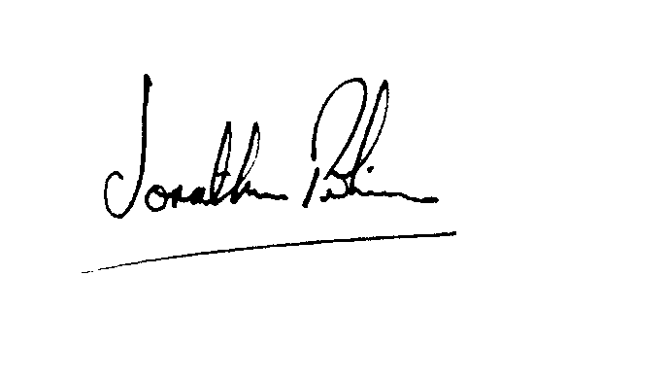It follows therefore that I set aside the decision of the First-tier Tribunal and I allow the appellant’s appeal against the decision of the Secretary of State.

|  |  |
| --- | --- |
| Signed |  |
| Jonathan Perkins, Upper Tribunal Judge | Dated: 17 July 2018 |