

**Upper Tribunal**

**(Immigration and Asylum Chamber) Appeal Number:** **HU/11942/2017**

**THE IMMIGRATION ACTS**

|  |  |
| --- | --- |
| **Heard at Field House** | **Decision & Reasons Promulgated** |
| **On 11 July 2018** | **On 13 August 2018** |
|  |  |

**Before**

**DEPUTY UPPER TRIBUNAL JUDGE I A M MURRAY**

**Between**

**MR MUHAMMAD ABBAS KHAN**

(anonymity direction not made)

Appellant

**and**

**THE SECRETARY OF STATE FOR THE HOME DEPARTMENT**

Respondent

**Representation:**

For the Appellant: Mr Sharma, Counsel for Law Lane Solicitors, Stratford

For the Respondent: Mr Wilding, Home Office Presenting Officer

**DECISION AND REASONS**

1. The appellant is a citizen of Pakistan born on 13 March 1983. He appealed the respondent’s decision of 28 September 2017 refusing him indefinite leave to remain in the United Kingdom on the basis of long residence and his human rights. His appeal was heard by Judge of the First-Tier Tribunal Suffield-Thompson on 13 March 2018 and was dismissed on all grounds in a decision promulgated on 22 March 2018.
2. An application for permission to appeal was lodged and permission was granted by Judge of the First-Tier Tribunal Parker on 30 April 2018. The permission states that it is arguable that the Judge’s failure to apply ***Razgar*** [2004] UKHL 27 and to find that the interference with the appellant’s human rights was not in accordance with the law amounts to an arguable error of law. The permission goes on to state that it is arguable that the appellant’s ability to meet the requirements of the Immigration Rules has not been given adequate weight in the decision, particularly having regard to the public interest factor at Section 117B of Part 5 of the 2002 Act and that this amounts to an arguable error.
3. There is a Rule 24 response which states that the respondent notes that the First-Tier Tribunal found the appellant met the ten-year long residence requirement of the Immigration Rules, but also found that this was not determinative of the human rights appeal. The First-Tier Tribunal had regard to the appellant’s ties to the United Kingdom and Pakistan, his lack of a partner or family in the United Kingdom and the limited evidence of any private life in the United Kingdom, and the response states that the First-Tier Tribunal’s conclusions are sustainable on the evidence.

**The Hearing**

1. The Presenting Officer submitted that this application meets the terms of paragraph 276ADE of the Immigration Rules and the respondent accepts that that is the case. He submitted that the First-Tier Tribunal Judge should have allowed the appeal and that the application is fully compliant under the Article 8 private life route and the Judge was wrong to continue, after finding that this was the case. He submitted that there is no general suitability point and that means that no further analysis is required. He submitted that he is conceding this claim on behalf of the respondent and the appeal should be allowed.
2. Counsel for the appellant accepted this.

**Decision and Reasons**

1. The respondent has conceded his position in this claim. The Judge found that Article 8 is engaged at paragraph 54 of the decision and the First-Tier Judge should then have considered Article 8 using the Rules as a starting point but failed to do so. If an appellant can show that on an application he could make immediately, he would have to succeed, there is no justification for dismissing his claim. This appellant is entitled to indefinite leave to remain which is what he applied for. His removal would not be in accordance with the law and cannot be justified as necessary or proportionate.
2. There is a material error of law in the First-tier Tribunal Judge’s decision and I direct that his decision be set aside and the appeal be allowed.
3. Anonymity has not been directed.

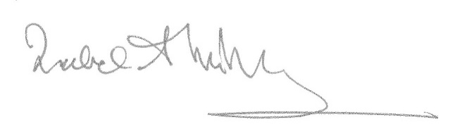Signed Date 8/08/2018

Deputy Upper Tribunal Judge Murray