

**Upper Tribunal**

**(Immigration and Asylum Chamber)** Appeal Number: HU/12805/2016

**THE IMMIGRATION ACTS**

|  |  |
| --- | --- |
| **Heard at Field House** | **Decision & Reasons Promulgated** |
| **On 6 August 2018** | **On 21 August 2018** |
|  |  |

**Before**

**UPPER TRIBUNAL JUDGE PERKINS**

**Between**

**THE SECRETARY OF STATE FOR THE HOME DEPARTMENT**

Appellant

**and**

**F--- R---**

(ANONYMITY DIRECTION made)

Respondent

**Representation:**

For the Appellant: Mr S Kandola, Senior Home Office Presenting Officer

For the Respondent: Mr K Alin, counsel instructed by direct public access

**DECISION AND REASONS**

1. Pursuant to rule 14 of the Tribunal Procedure (Upper Tribunal) Rules 2008 I make an order prohibiting the disclosure or publication of any matter likely to lead members of the public to identify the Respondent F--- R---. Breach of this order can be punished as a contempt of court. I make this order because of his involvement with a child whose particular circumstances make privacy more than usually desirable.
2. This is an appeal by the Secretary of State against the decision of the First-tier Tribunal dismissing the appeal of the respondent, hereinafter “the claimant”, against the decision of the Secretary of State on 5 May 2016 to refuse him leave to remain on human rights grounds.
3. The claimant’s conduct has been discreditable. He claims to have entered the United Kingdom in 2003 but he was removed and returned unlawfully in 2010. He has misbehaved. He has been sent to prison at the Crown Court for documents offences in November 2007 and he has been discharged for an offence of dishonesty in the Magistrates’ Court in March 2006. He did not disclose that in a later application for leave to remain. These matters are serious and entirely justify the Secretary of State’s view that the claimant’s presence is not conducive to the public good. That said, this is not an appeal deportation. The Secretary of State has not taken the view that the claimant’s misconduct is that seriously wrong.
4. Nevertheless, if this is all there was to the case I do not see any reason at all on which the appeal against the refusal of leave on human rights grounds could possibly have been allowed. However that is not all there is to the case. There is a very important additional element. The claimant has a child in the United Kingdom. The child was born as the result of sperm donation. The claimant assisted two women who live together and it is clear law that his act of donating sperm would not give him any particular relationship with the child in law but this is a case where there is a relationship with the child. The relationship is recognised by the Family Courts because there is a child arrangement order. Under the terms of that order the child is entitled to see the father a minimum of once a fortnight. It is very important to emphasise that that is a minimum requirement and it is clear on the face of the order that it was for the parties in those proceedings to arrange further contact if that was desirable. Further contact has been arranged.
5. There was clear evidence before the Tribunal that the claimant plays a significant part in the life of the child.
6. At paragraph 18 the judge noted in the following terms:

“A retains access to C. He saw her three to four times a week and looked after her at W’s home whilst W was out at work between 8 a.m. and 6 p.m. A takes C to the clinic for regular checkups and C loved him. W and J both agreed that A should play a full part in C’s life as her father”.

1. This evidence was not only before the First-tier Tribunal, it was before the Secretary of State in a bundle that had been served well before the hearing, but the Secretary of State chose not to attend the hearing.
2. In those circumstances it is very hard to see how the judge could have done other than believe the evidence that was before him. It was disclosed evidence. It was apparently credible. It was supported to some extent from independent evidence from a medical practitioner. It was inevitable the judge would conclude that the claimant plays a big part in the life of the child.
3. It does not follow from that that the appeal ought to have been allowed, but the judge did allow the appeal and it is plain that he allowed the appeal because he found removal would have had a disproportionate impact on the rights of the child which he is required by Parliament to regard as a paramount consideration.
4. The grounds are carefully drawn but do not show a proper appreciation of what has happened here. For example, there is criticism of the judge for not having more regard for the Human Fertilisation and Embryology Act of 2008, but that, with respect, is not a point at all. All that establishes is, as is indicated above, that the claimant does not necessarily have any right to any involvement in the life of the child, but this case does not depend on his biological paternity but on his involvement in the life of the child which is well recognised by the courts. That criticism really goes nowhere.
5. The other points go essentially to matters of weight and balance. It may be that a different judge would have been more concerned by the bad behaviour, although it is right to note that his most recent criminal offence was in 2007, but this is the sort of area where occasionally there is going to be disagreement between Tribunals. There is no irrationality or perversity here.
6. The grounds also criticise the judge for not doing a more carefully analysed balancing exercise. There is some merit in that criticism in that because more could have been said usefully about the operation of Section 117B(6) of the Nationality, Immigration and Asylum Act 2002, but the salient points the judge has plainly acknowledged, particularly the legitimate interest in maintaining effective immigration control for the economic wellbeing of the United Kingdom. The judge has acknowledged the positive and negative points in the claimant’s character and has made a decision that he was entitled to reach.
7. I do not see any error of law in this case and I dismiss the Secretary of State’s appeal and I dismiss the Secretary of State’s appeal.
8. I give this decision as an extempore judgment.
9. Mr Alin asked for the claimant’s costs and asked to be allowed to serve after the hearing recent guidance on the issue of costs. I agreed to reserve the issue of costs. If Mr Alin had been able to have presented the documents before I had finished the list I would have heard his representations. He was not able to do that (this is not a rebuke, simply a fact) and I received them later in the day after Mr Kandola had left the building.
10. I received a copy of the Presidential Guidance Note No 1 of 2014, the Presidential Guidance Note No 1 of 2015, and Presidential Guidance Note No 2 of 2018. They do not assist. The First-tier Tribunal did not make a fee award because the decision depended on evidence that was not before the Secretary of State. There was no cross-appeal against this decision. The Upper Tribunal’s powers are essentially to make an order that the First-tier Tribunal could have made (see rule 10(1)(b) of the Tribunal Procedure (Upper Tribunal) Rules 2008. I do not find the conduct of the Secretary of State to be “unreasonable”. The Secretary of State has not misled the Tribunal. I found the Secretary of State’s case unimpressive but that is not same as being unreasonable to rely on it. The facts are unusual and the claimant’s own behaviour is unimpressive. I decline to make a wasted costs order.

Notice of Decision

1. The Secretary of State’s appeal is dismissed. I make no order for costs.

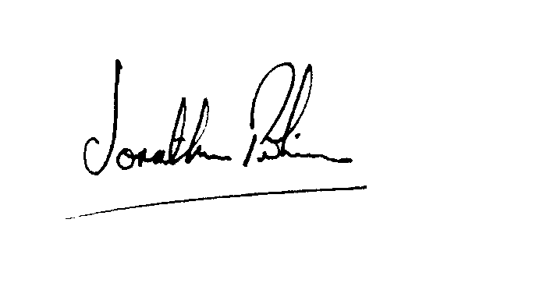

|  |  |
| --- | --- |
| Signed |  |
| Jonathan Perkins, Upper Tribunal Judge | Dated: 13 August 2018 |